Simulation of Gravitational Fields

Computer Science A-Level – Non-Exam Assessment Project

***Analysis***

*Introduction*

One of the most difficult topics in Whitburn C. of E. Academy Sixth form for A2 physics students to understand is the topic of gravitational fields. Dr. Corrigan is a physics teacher at this sixth form and she has also noticed this confusion among her students when she first begins to teach this topic. This is due to the relatively complex mathematics and algebra manipulation involved that is required to tackle exam questions. This problem is especially present in students who no longer take mathematics at A-Level – they have limited experience in rearranging equations as it was only needed at the highest level at GCSE. My project aims to rectify these issues by providing an interactive educational simulation which demonstrates the effects of an object’s gravitational field on the objects around it, and therefore explains the topic with a visual aid to assist in the understanding of it.

I aim to create a simulation which will show and update different values for an object as it is moved around, and I also aim to help students understand how these equations can be linked together and how things such as proportionality and inverse proportionality work when using these equations. This will be done through the values that are changed and will hopefully greatly assist Dr. Corrigan when teaching her students this topic.

*Problem background*

The problem I am going to be tackling in this project is the creation of a simulation demonstrating the principles of the physics topic of gravitational fields. Both me and Dr. Corrigan have noticed that a lot of students seem to struggle with the topic of fields – in particular gravitational fields, as this is the first topic that is covered in the syllabus and is therefore the topic in which they learn the mathematical methods needed for the rest of the fields topic. This makes it difficult for the students to grasp the subject at first glance as there is a lot of theory elements that have to be linked together – for example, there are 6 different equations which can be linked together if needed in exam questions. I will be using most if not all of these equations in my project as they will all be useful to display in the table of values while the simulation is running to show the students how changing values affects other values.

This problem will also most likely involve equations from other parts of the physics A-Level syllabus – these equations may include the equations used in mechanics and circular motion as these will be very useful in calculating things such as an object’s speed/direction or an object’s acceleration. I will then be able to use these values in the calculation of where I will need to place the object in the next frame, which factors in more values than just the gravitational fields-related values, making my simulation more accurate to true observations. I will also be able to display these extra values in the table of values as they update to give extra insight to the physics students into how these other values change when certain variables change over time.

The prospective users of my simulation are the physics teacher Dr. Corrigan and the physics students that are taught this topic. I am developing this simulation for Dr. Corrigan to help her teach current and future students this topic.

*Problem Criteria*

* Initialise and display a window which contains a two-dimensional graphical user interface which hosts the objects, along with a table of values separate from the graphical interface.
* The table of values must update at regular intervals according to the simulation.
* Allow the user to input the initial values for the different relevant properties of each object.
* Run an accurate simulation from these initial values which shows the effects of the laws of gravitation on the objects.
* Translate these effects into a visual animation via the graphical interface.
* Implement pre-set values for objects.
* Allow the user to select the type of object (via a pre-set) and therefore calculate the density of the material.
* Set initial positions of objects.
* Create different graphical user interfaces for the setup, running and aftermath of the simulation.
* Allow the user to set a scenario for the simulation (e.g. change the distance by 2 each frame).
* Allow the user to set the speed at which the simulation will update (frames per second).

*Description of the Current System*

The current simulations that are used in the physics classes of this sixth for mare those provided via the internet by PhET**[A5]**. This service contains an extensive amount of interactive physics simulations which are mostly made in JavaScript. However, these simulations seem to lack when it comes to useful information that is shown when a certain variable is changed. The gravitational fields simulation especially stood out to me when we used it in class – the only values displayed were the forces acting on each object, which, due to Newton’s laws of gravitation, were equal anyway. This is severely limited in the sense of what can be understood from changing certain variables and most likely this is what limits students when they are introduced to this topic; there is no visual aid that has sufficient detail to explain it visually.

The PhET gravitational force simulation**[A22]** is shown below:

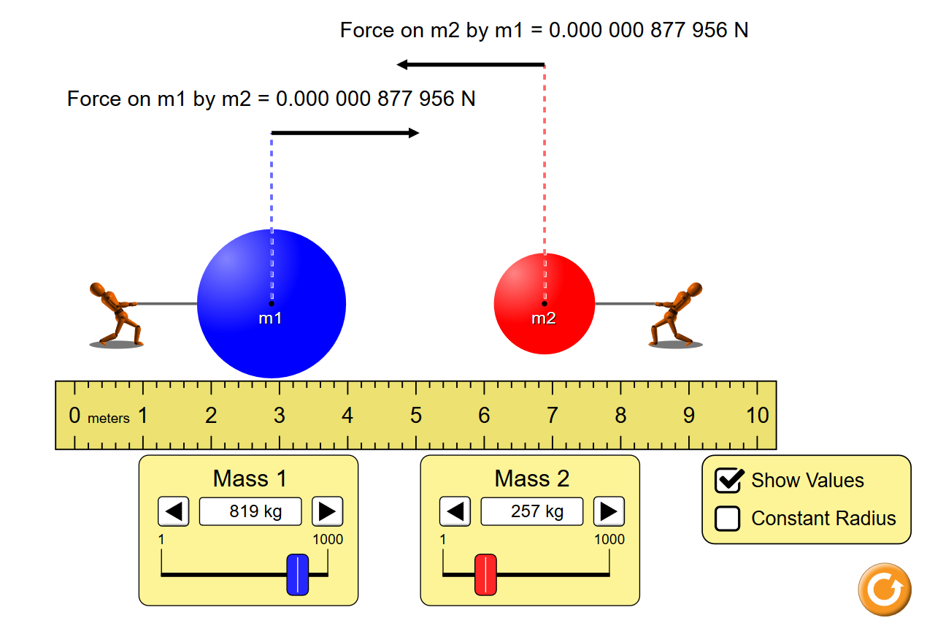

In this PhET simulation, the only values that you are able to change are the masses of each object, and the only values displayed are the masses and the gravitational forces on each object. As explained previously, despite the differences in mass, the gravitational forces of each object are equal due to Newton’s law of gravitation. The main disadvantage of this simulation is the lack of values that are displayed, especially when more values are used in the calculation of those that are shown. There is a limited ability to check the distance between each object, however it is done using a poorly represented ruler that can only be used to roughly measure the distance instead of just showing a distance.

My project will attempt to rectify this lack of detail and values shown by providing a simulation with much greater detail that can be used in current and future physics classes when covering this topic.

*Proposed Solution*

Overview

In order to create a simulation that has an effective visual explanation of gravitational fields to students, I will have to use the Python GUI module Tkinter, as this, after my research on the internet**[A1]**, has proved to be the most effective at creating a two-dimensional graphical user interface that demonstrates this topic. I intend to use object-oriented programming (using an object class in Python) to keep track of each object and its properties. This object class will be a subclass of the main window class, which hosts and initialises the window itself. The properties will include mass, distance and other variables that can be changed in order to demonstrate the effect of changing such variables via the graphical user interface. From these base values, I will use physics equations to calculate values such as the gravitational force on each object, the gravitational field strength of each object, the kinetic energy of each object, and many others. These are relatively complex mathematical equations as they include all of the A-Level knowledge needed for the gravitational fields topic combined together.

The objects in my simulation will be generated inside a simulation canvas which is created via the Tkinter Python module. These objects will be simple two-dimensional solid colour circles, which are generated using the Tkinter method “create_oval”. The generation of the shape and the calculation of the values will all be done using methods inside the object class, which can be called upon to execute from the methods in the main window class. In order to animate these objects and simulate movement, I will have to use the “.update()” and “.after(time)” to set a framerate for the canvas to update at.

The main focus of the simulation is the data that is generated from the simulation, which will be displayed in a table of values that is separate from the graphical interface, and updated at regular intervals. When the end user starts the program, they will be greeted with buttons that will let you change the values of mass and distance before the simulation starts. This will set the starting values of these variables and will then let the underlying mathematical functions come into play once the simulation is started. The changes in these values will then be translated onto the graphical user interface which will give a visual explanation of the changes. The changes will also be translated onto the table of values which will be updated with the graphical user interface.

Gravitational Fields and Mechanics Formulae

To accurately simulate such scenarios that have been mentioned, I will have to use the well-established formulae which use Newton’s laws of gravitation. These formulae are also used in the syllabus for the A-Level physics topic in question, and therefore I am very familiar with how these formulae work and how I can manipulate them in order to create a more efficient simulation. Using a mixture of gravitational fields formulae and formulae from other physics topics such as mechanics and circular motion, I can accurately mathematically simulate the effect of an object’s gravity on another object.

The first of these formulae is the formula which is used to calculate the gravitational force exerted on an object by another object. Due to Newton’s laws of gravitation, the force on the object will be equal to the force on the other object exerted by the original object. For example, the Earth exerts around 700N of force to pull an average human to its surface, and a human exerts 700N of force on the earth also. However, because of the sheer size and mass of the earth, it barely moves more than an atom’s width. The formula is as follows:

$$F= \frac{Gm_{1}m_{2}}{r^{2}}$$

Where *F* is the gravitational force; *G* is Newton’s gravitational constant; *m1*  is the mass of the object exerting the force; *m2* is the mass of the object the force is being exerted on; and *r* is the distance between the centre of mass of each object. If I have all of these values, I can work out the force exerted on an object, which, due to Newton’s laws of gravitation, are equal for each object, and therefore I will only need to list one of the two values calculated for each object as they will be the same.

The second formula I will use is the formula which is used to calculate the gravitational field strength of an object. This value is also equivalent to the acceleration of an object of any mass at the distance from the object with the gravitational field. For example, the gravitational field strength of the earth at sea level is approximately 9.81 Newtons per kilogram (Nkg-1); this is also the value for the acceleration of objects towards the earth at sea level: 9.81 metres per second squared (ms-2). The formula is below:

$$g= \frac{GM}{r^{2}}$$

Where *g* is the gravitational field strength; *G* is Newton’s gravitational constant; *M* is the mass of the object with the gravitational field; and *r* is the distance from the object’s centre of mass. I can use this equation to calculate the acceleration of an object towards another object, and also the gravitational field strength of the object. The latter value will be mostly useless however for the purpose of this simulation and therefore I will simply display it as a value which changes as the objects’ position changes. This will give extra insight into how the gravitational field strength changes as well as other values.

The third formula that I am going to use is a formula that is used to calculate the gravitational potential of an object at a distance from the object producing a gravitational field. This gravitational potential value tells us how much energy is needed to lift 1kg of mass to infinity away from the gravitational pull of the object. For example, the gravitational potential at the surface of the earth is around 62.5x106 Joules per kilogram (Jkg-1) (or 62.5 MJ [mega-Joules]). This means that it takes 62.5 million Joules of energy to lift a 1kg mass from the surface of the earth to infinity (gravity theoretically has infinite range – this is why we say to infinity as it has to have no gravitational attraction to the earth at all). This formula is written as follows:

$$V_{grav}= -\frac{GM}{r}$$

Where *Vgrav* is the gravitational potential; *G* is Newton’s gravitational constant; *M* is the mass of the object exerting the gravitational field; and *r* is the distance from this object. The equation contains a negative sign because the object in question technically has negative energy as it has not gained enough energy to reach 0 Jkg-1 – this is when the distance is infinite and therefore GM/r is 0. As the distance from the gravitational field increases, the amount of potential energy also increases, and therefore this negative value goes towards 0. If the distance decreases, then the potential energy will be transformed into kinetic energy as it accelerates towards the gravitational field, therefore there is a loss in potential energy. This value will let me demonstrate to the students how the energy required to increase the distance of a 1kg mass from the object changes as the distance increases/decreases. This means that I will simply show the value changing in the table of values as the simulation is running.

The next set of formulae that I am going to use are known as the *SUVAT* equations. These equations are used in the mechanics section of the physics syllabus and are integral to the calculation of a variety of values for objects in motion. There are four formulae that can be rearranged freely to calculate each value in them:

$$v=u+at$$

$$v^{2}= u^{2}+2as$$

$$s=\left(\frac{u+v}{2}\right)t$$

$$s=ut+ \frac{1}{2}at^{2}$$

$$s=vt- \frac{1}{2}at^{2}$$

Where *s* is the displacement from the original position (distance travelled from a point); *u* is the initial speed of the object; *v* is the final speed of the object, *a* is the acceleration of the object (if this value is negative, the object is decelerating); and *t* is the time elapsed. These four equations are very commonly used in the mechanics section of the physics syllabus as they can be used to calculate a variety of values in a variety of scenarios. For example, if a ball is falling toward the earth from a height of 100 metres, then, given some other values such as the initial speed and acceleration toward the earth, you can calculate values such as the time taken to reach the ground or the final speed just before it reaches the ground. I aim to use these equations to find the value of each object’s velocity according to the distance travelled, its acceleration and its initial speed (which will be set by the user).

I can also use this value for velocity in the next and final formula that I will be using – the formula for the kinetic energy of an object. This value is the movement of the object translated into energy – *“kinetic”* meaning *“movement”*. The equation is as follows:

$$E_{K}= \frac{1}{2}mv^{2}$$

Where *EK* is the kinetic energy of the object; *m* is the mass of the object, and *v* is the velocity of the object which can be calculated using the previously mentioned *SUVAT* equations. This equation will let me demonstrate to the students how the kinetic energy of an object will change as its velocity increases/decreases and will allow me to use this energy value to also demonstrate the effect of the previously mentioned gravitational potential energy as it is exchanged and transformed into kinetic energy as the object falls towards the object producing the gravitational field. As an object gets closer to a much larger object (e.g. a baseball and the earth), the gravitational potential energy gets transformed mostly into kinetic energy as the object accelerates towards the centre of the earth at a value equal to that of the gravitational field strength.

*Research*

Primary Research

For my primary research, I have devised a questionnaire that has been answered by my physics peers – this will provide information on what the students themselves want to see in the simulation and whether it will be useful/helpful to them or not. I have also arranged and completed an interview with the end user Dr. Corrigan. These two primary research sources will allow me to narrow down what the simulation will contain and what it will display to the students. Both primary and secondary research sources are referenced at the bottom of this document, in the Appendix section.

*Questionnaire for physics peers*

This was an online questionnaire made with the online survey creation tool SurveyMonkey**[A4]** which was then sent to my sixth for physics class via a group chat on Facebook Messenger. From this questionnaire, I found that the physics students in my physics class clearly struggle with the topic gravitational fields and the calculations involved**[A8]** and they therefore would most like to see this topic demonstrated in the simulation. The students also answered that they would most like to see a detailed table of values which is separate from the graphical interface to display the data**[A8]**. This reinforces my idea mentioned earlier in the Analysis section.

*Interview with Dr. Corrigan*

I sat with Dr. Corrigan and asked her a set of questions**[A9]** to gain more insight into the things required for this simulation. From this interview I found that Dr. Corrigan is also in favour of creating a simulation that explains gravitational fields to her students. However, she also answered that she would like to see data represented inside the graphical user interface next to each object, as a simplified summary. This idea will be considered; however, this is the type of data representation that I would like to avoid if possible as it was the thing that caused a lot of confusion among students when used in the PhET simulations. Therefore, I will be using the idea suggested by the students – a table of values separate from the graphical user interface.

*Summary*

From my primary research, I have discovered that both my end user Dr. Corrigan and the physics students would like to see a simulation of the topic of gravitational fields, and therefore I will be creating a simulation to simulation these effects, while also including mathematical functions from gravitational potential and other topics, for the sake of showing how these values also increase. The simulation will demonstrate the effect of changing the distance and masses of 2 objects on the gravitational force and other values.

Secondary Research

For my secondary research, I have used a variety of sites in order to find out more about Python’s Tkinter module and how to use it to create such a simulation. One of the sites was of course YouTube**[A7]** which provided many tutorial videos for the use of Tkinter to create graphical interfaces. One such video that particularly helped me was a video displaying a pendulum swinging via a graphical interface**[A10]**, made in Tkinter. This was very helpful as the creator of the video also provided the source code to this simulation which gives me a general idea of how to code such a simulation. I will then be able to apply what I have researched from this source into my own simulation. Another equally helpful video was a very intuitive run-through of the creation of a gravity simulation**[A12]**. This is a very detailed video and helped me understand the main concepts of using Python to create objects and apply properties to them via object-oriented programming.

A video that I found especially interesting was a university project made by a student, which simulated the orbits of the solar system’s planets and also produced graphs that updated with the simulation that displayed things such as the change in position, change in velocity, and change in gravitational potential energy of each planet. From the explanation in the video I have managed to get a general idea of how such graphs and graphical interfaces are generated and have learned how to use Python to create graphs using commands such as “.plot()” which plots a graph using the parameters as variables. These parameters are defined in the brackets.

When researching which programming language to use, I found a very useful website named Codecademy**[A6]** which teaches the basics of a variety of programming languages to its users using intuitive lessons. I have used this in the past to learn Python and have been using it along with other secondary research sources to learn how to use Python and Tkinter.

*Performance Criteria*

* Update the table of values each frame to show the students how these values change over time.
* Teacher can interact with the main window’s GUI and set values to show the students how they change.
* Students can interact with the main window’s GUI and set their own values.
* Allow the end user to adjust the different values of the objects.
* Allow the end user to select a scenario for the simulation before the simulation starts.
* Allow the end user to select different pre-set values for the simulation.
* Allow the end user to select the speed (frames per second) at which the simulation will run.

*Data Sources and Destinations*

|  |  |  |  |
| --- | --- | --- | --- |
| Data Name | Source | Description | Destination and Process |
| Objects | Object class | The __init__() method of the Object class will initialise each object according to user-set parameters when the simulation is started. | Each object is stored as an instance of the Object class. Each object will have its own set of values, which are also listed in this table. |
| Mass(es) | User | The user enters the values for the mass of the objects using the entry fields. | Set as the value for one of the two corresponding instances of the object class – used in physics calculations. Displayed in the table of values. |
| Distance | User | The user enters the value for the initial distance between each object using the entry fields. | Set as the value for the object class as a whole – it is a global variable among the two objects. Used in physics calculations and updated according to these calculations in every frame. Displayed in the table of values. |
| Velocity | Object class | A method within the object class calculates the value for velocity using the SUVAT equations, according to the distance travelled and the acceleration of the object. | Set as the value for the two corresponding instances of the object class – used in physics classes and updated according to these calculations in every frame. Also displayed in the table of values. |
| Gravitational Force | Object class | A method within the Object class calculates the value for the gravitational force using the two mass values, Newton’s gravitational constant, and the value for distance. | Set as the value for the object class as a whole as the forces on each object are equal by nature. This means that it is a global variable among the two objects. Displayed in the table of values and updates with each frame. |
| Gravitational Potential | Object class | A method within the Object class calculates the value for the gravitational potential of each object relative to the other object. Uses the values of mass and distance along with Newton’s gravitational constant. | Set as a value for each instance of the object class as they are different for each object. Values are displayed in the table of values and are updated with each frame. |
| Acceleration | Object class | A method within the Object class calculates the value for the acceleration of each object towards the other object. This is also the value for the gravitational field strength and therefore I am going to use the equation for the gravitational field strength. | Set as the value for each instance of the Object class as the values are different for each object. Values for both acceleration and gravitational field strength, although equal, will be displayed in the table of value for students to identify this equal nature. |
| Kinetic Energy | Object class | A method within the Object class calculates the value for the kinetic energy of each object using the values for mass and velocity. | Set as the value for each instance of the Object class as the values are different for each object. Values are displayed in the table of values and are updated with each frame. |
| Main window | Window class | The window and its UI elements are initialised through the __init__() method of the Window class which will act as the main class containing most of the variables to do with the window and the simulation. | An instance of the Window class generates a window for the user to interact with the simulation using Tkinter UI elements. |

*Acceptable Limitations*

* The simulation will not be able to be paused and/or changed in speed.
* The values in the table of values will simply update along with the framerate of the animation itself.
* The simulation will only be able to have two objects simulated at one time.
* The graphical interface for the simulation will be kept to two dimensions (x and y).

***Documented Design***

*Design Overview*

My project aims to complete the objectives and meet the performance criteria set in the analysis section. In doing so, my project should contain a user-friendly graphical interface; clean and efficient code; and a clear way to display data once the simulation is stopped. In this section I intend to outline the way the graphical user interface will look and how it will function, and use flow diagrams to visually represent both the flow of data through the simulation and the processes being executed while the simulation is running. I also intend to describe the different algorithms and calculations that will be carried out during the simulation, and how these are translated to the graphical user interface.

*Design of the Graphical User Interface*

The GUI of my simulation is one of the most important aspects as it will greatly increase the user-friendliness of the simulation when both Dr. Corrigan and the physics students use it. Therefore, I will be trying to create a GUI which caters to these specific users using elements such as menus and buttons that will help guide a user when using the simulation.

I plan to have a section of the window dedicated to the simulation itself, displaying the objects as they are generated. This will be on the left of the window, and will be a canvas (a Tkinter widget). The right of the window will display a list of the initial values of each object, and will contain buttons with various functions, such as to change these values, start/stop the simulation, and quit the program. The buttons to change the initial values will not be able to be used when the simulation is running. The detailed table of values that I plan on implementing will be displayed in a separate window, which opens when the user presses the start simulation button.

These functionalities are illustrated in the drawings below.

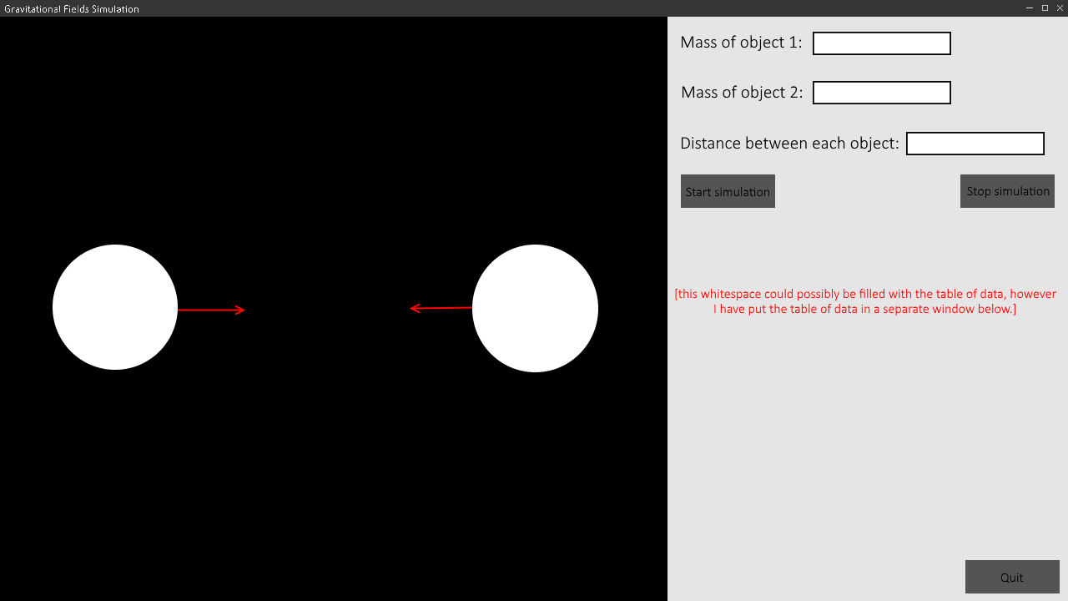

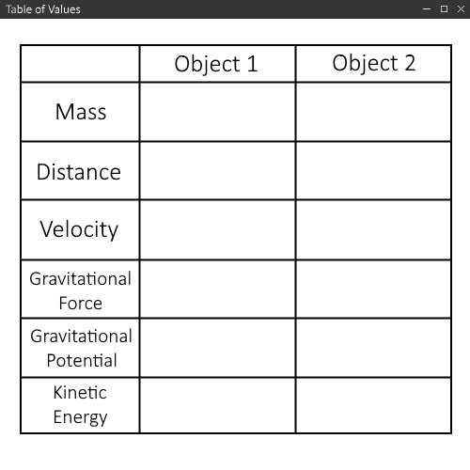

This table of values is currently planned to be displayed in a separate window, however it would be useful to fill the whitespace in the main window with this table when the simulation is running (and possibly remove the value selection buttons as well).

*Table of Planned Variables*

These are the variables that I plan on using in order to program this simulation in Python and the expected data types that I will use. These are rough estimations and may change by a large degree during the Worked Solution section, and therefore I will have another more accurate table of variables in the Worked Solution section once my program has been completed and objectives met.

|  |  |  |
| --- | --- | --- |
| Variable Name | Data Type | Description |
| mass1 | Integer | The value for the mass of object 1. |
| mass2 | Integer | The value for the mass of object 2. |
| dist | Integer | The value for the distance between the objects. |
| x1 | Integer | The value for the x-coordinate of object 1. |
| x2 | Integer | The value for the x-coordinate of object 2. |
| y1 | Integer | The value for the y-coordinate of object 1. |
| y2 | Integer | The value for the y-coordinate of object 2. |
| vel1 | Floating Point | The value for the velocity of object 1. |
| vel2 | Floating Point | The value for the velocity of object 2. |
| QuitButton | Tkinter Button Widget | Stores the quit button and its properties in the main window. |
| StartButton | Tkinter Button Widget | Stores the start simulation button and its properties in the main window. |
| QuitButton | Tkinter Button Widget | Stores the stop simulation button and its properties in the main window. |
| ChooseMass1Button | Tkinter Button Widget | Stores the button that the user presses to choose the value for the mass1 variable. |
| ChooseMass2Button | Tkinter Button Widget | Stores the button that the user presses to choose the value for the mass2 variable. |
| ChooseDistanceButton | Tkinter Button Widget | Stores the button that the user presses to choose the value for the dist variable. |
| ChooseVelocity1Button | Tkinter Button Widget | Stores the button that the user presses to choose the value for the vel1 variable. |
| ChooseVelocity2Button | Tkinter Button Widget | Stores the button that the user presses to choose the value for the vel2 variable. |
| Object 1 | Class Instance | Stores the first object and its properties inside the Object class. |
| Object 2 | Class Instance | Stores the second object and its properties inside the Object class. |
| Mass1StatusMessage | Tkinter Label Widget | A message which is displayed on the main window telling the user what the value of the mass of object 1 is before the simulation is started. |
| Mass2StatusMessage | Tkinter Label Widget | A message which is displayed on the main window telling the user what the value of the mass of object 2 is before the simulation is started. |
| Velocity1StatusMessage | Tkinter Label Widget | A message which is displayed on the main window telling the user what the value of the velocity of object 1 is before the simulation is started. |
| Velocity2StatusMessage | Tkinter Label Widget | A message which is displayed on the main window telling the user what the value of the velocity of object 2 is before the simulation is started. |
| DistanceStatusMessage | Tkinter Label Widget | A message which is displayed on the main window telling the user what the value of the distance between the objects is before the simulation is started. |
| WelcomeMessage | Tkinter Label Widget | A message at the top of the right-hand side of the main window which simply welcomes the user to the simulation when they start the program. |
| SimulationCanvas | Tkinter Canvas Widget | The canvas in which the objects will be created and updated and where the simulation will run. |

*Flow Diagram of Processes*

Made using draw.io**[A3]**.

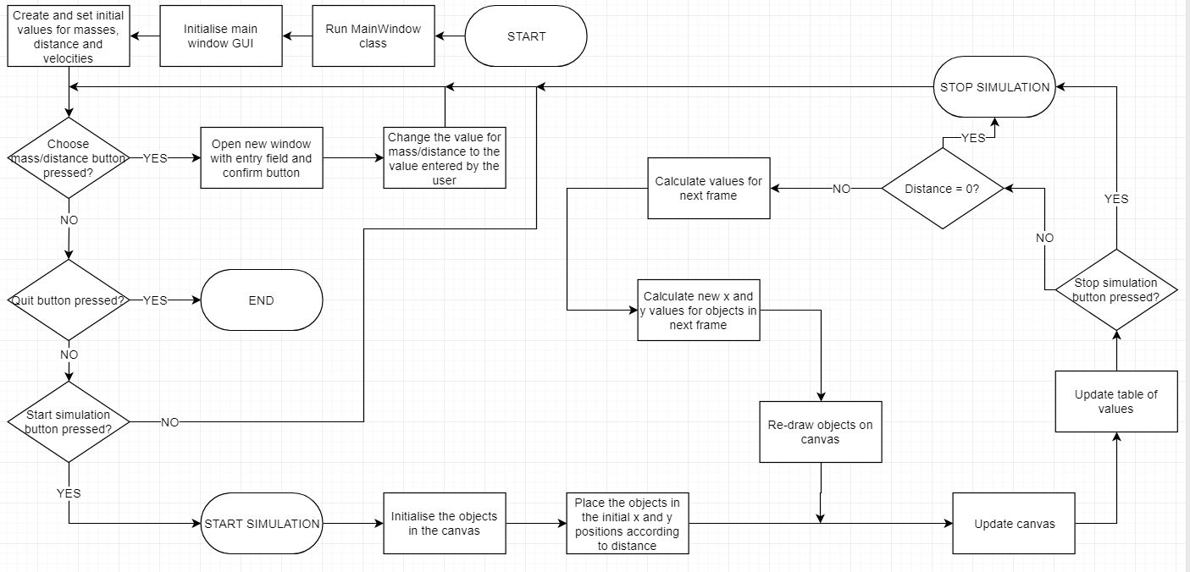

This diagram outlines the processes that the simulation will carry out when it is running. The diagram runs through the chronological order of how the program will run when it is started by the end user.

When the program is started, the first thing that happens is the MainWindow class is called. This is because it is called immediately in the main code which is executed when the program runs. Calling this class runs its *__init__* method and this contains the code which initialises the GUI for the main window. Therefore, these two steps will display the window to the user as soon as the user starts the program. The next step is to set the initial values for mass and distance. These values are simply pre-set values that the end user can use if they do not want to enter their own values, and can be overwritten by the user by pressing the button that allows them to set their own value for these variables. The remaining variables that cannot be entered by the user will all be calculated for each object when the simulation is started.

The next 3 steps check if each respective button is pressed. The first checks whether one of the buttons that allow the user to set their own value is pressed. If it is pressed, then a new window opens which contains an entry field and a confirm button; the user is able to type their own value into the entry field and press confirm to change the value of the corresponding variable to the value that they have chosen. The second check is to check whether the quit button is pressed. If it is, then the program simply stops and the window closes. The third check is to check whether the start simulation button has been pressed. If it has, then the simulation starts and it initiates the rest of the simulation-specific program that runs when the simulation is running. If it is not pressed, then the process simply loops back round to checking for each button as nothing will happen in the program until the end user presses a button.

When the simulation is started, the first step that is required is to initialise the objects in the canvas. A method in the Object class does this according to the user-set parameters, such as mass which sets the radius of the object. The simulation then has to place the objects on the canvas in the appropriate places. To do this, the program has to take into account the user-defined distance value as this will define how far away the objects are from each other on the canvas. I will most likely use some kind of scale in order to accurately place each object which is independent from the resolution scale of each pixel in the canvas; however, I will have to scale it back up to these pixels as, of course, you cannot place an object in half of a pixel.

The next steps in the diagram are to update the canvas and update the values in the table of values. This is now part of a loop, which loops around at every frame of the movement of the objects. The first part of the loop simply updates the canvas and the values so that the updated versions are displayed to the user at every frame. The third step in the frame loop is to check whether the stop simulation button has been pressed – if it has, then it stops the simulation and returns to the initial screen which allows the user to select new initial values. If it isn’t pressed in this frame, then it continues the loop on and carries out the rest of the loop. The fourth step in the now-continued loop is to check whether the distance is equal to 0. This is to check whether the objects have collided. If they have, then they cannot move anymore and the simulation ends.

The next step in the loop is to calculate the values for the different variables of each object for the next frame. This is done using the physics and mechanics formulae and will produce new values to put into the table of values which is displayed to the user in the next frame. The last step of the loop simply re-draws each object on the canvas so their position appears different to the user. The program then loops back around through this loop indefinitely until either the objects collide or the user decides to press the stop simulation button.

When the loop stops, the program goes back to the initial stage just after the main window is initialising, bringing up the initial graphical user interface and allowing the user to enter their own values again.

*Data Flow Diagrams*

Made using draw.io**[A3]**.

Object Class

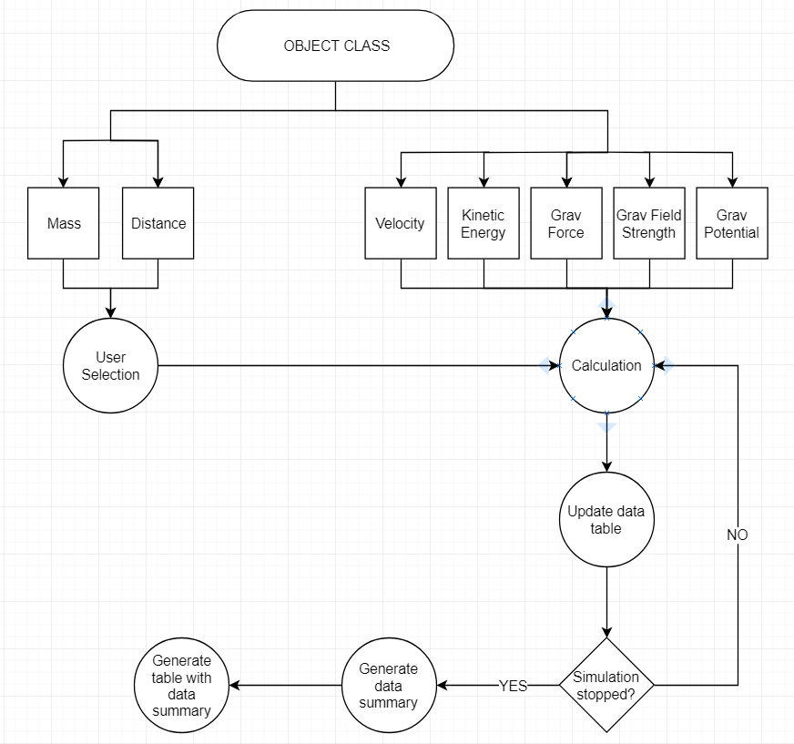

The object class will contain all of the variables that are applicable to each object – for example mass or velocity. These variables will also all be used in the physics formulae that I have described and therefore they are all key in the functional integrity of the simulation and the data that is produced in the simulation. This class will hold two instances of itself – one for each object – this allows the class to store both local and global variables between the objects inside the class. A local variable would be a variable that would only be applicable to that one object in particular, for example its mass. A global variable would be a variable that would be applicable to all of the object instances under the object class, for example the distance between the two objects.

From the object class, all 7 variables are initialised when the class is called. The variables mass and distance were both chosen by the user beforehand and are therefore simply “imported” into the class from the rest of the program for use in calculations. The variables velocity, kinetic energy, gravitational force, gravitational potential and gravitational field strength are all generated when the class is called and are then updated using the formulae as the simulation steps forward by each frame. After these 7 values are generated, the simulation then moves on to the calculation stage where all the values are put into the algorithms that calculate the new values for the next frame.

The simulation then updates the table of values and checks whether the simulation has been stopped or not. If it has not been stopped, then the simulation will loop back around and generate the next frame using the previous values. If it has been stopped, then the program will generate a summary of the data generated throughout the simulation.

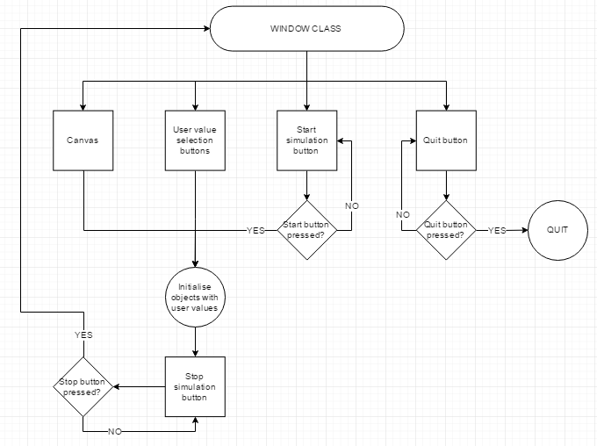Window Class

The window class will host all of the graphical user interface-specific variables that will be used to store and display things such as buttons and messages to the user inside the main window. Most of these will be initialised as soon as the user starts the program – they are initialised inside the __init__ method of the window class. However, things such as the stop simulation button will only be initialised after the user chooses to start the simulation with the current parameters and presses the start simulation button. This is mainly to prevent any conflicts with the functionality associated with pressing the stop simulation button, as before the simulation starts, there is no simulation running and therefore it will have nothing to stop, potentially creating some problems when it is pressed outside of the simulation. The buttons for the user value selection and the start simulation button will all be greyed-out and will be disabled during the simulation to prevent similar problems.

When the window class is initialised, the __init__ method runs a subroutine which initiates all of the graphical user interface elements of the window, including initialising the actual window itself using the Tkinter module. The window, its resolution and the title of the window are all defined in this initial stage. After this, in the same subroutine, the rest of the graphical user interface elements are defined inside this now-created window, including the canvas and all of the buttons/messages. Each button will contain a subroutine command of its own which will run when the button is clicked. For example, the buttons that let the user select their own values will have a subroutine command which will contain code to open a new window with an entry field to allow the user to enter their own value into the entry field. The values will also be updated inside this subroutine.

When the simulation is started by the user, the window class will call upon the object class in order to initialise the objects, and then the object variables will be placed into the window class inside the canvas of the window. The calculation and updating of these values will then all be handled by the window class, calling methods within the object class to perform the calculations and updating the objects in the canvas to the new positions after each frame. This continues in a loop until the user presses the stop simulation button, which runs a command subroutine to stop the simulation and return to the initial graphical user interface that the user is presented with when they first start up the program.

*Pre-set Scenarios*

One of the main integral features of my simulation is the ability for the end user to change core values for the objects and see how this affects the behaviour of them and their other values in the simulation. Therefore, I have decided to set up some pre-set scenarios which can be used to simulate a particular change of events, for example a decrease in the distance of the objects by a certain value every frame. In order to do this, I will have to create a method inside the window class for each type of scenario that I will give to the end user as an option. Inside each method will be the code to change certain values in each frame to meet the requirements of the scenario in question. This method will then be called according to the user’s choice of scenario and will be looped in the Update method of the window class, resulting in a looping change of values every frame.

I plan on going into much more detail on this aspect of the program when I enter the development phase of my program, as then I will have a much better grasp of what is to entail in achieving this aspect.

*Key Algorithms*

The main algorithms I will use are the physics formulae which will be implemented into the object class so that the different values can be calculated for each object. This incorporates object-oriented programming into the simulation which will make it much easier to manage and manipulate variables of the objects in the simulation. Other less crucial algorithms include the initialisation of each object, the initialisation of the window(s) and graphical user interface elements, and the ability for the user to enter values for the mass and distance of each object.

For the initialisation of each object, I will have to check the mass of the object and set an appropriate radius for the circle which is drawn onto the canvas in the window. I will also have to check the value set for the distance between the objects, and place the circle in the appropriate *x* and *y* coordinates on the canvas. After setting these values and drawing the circle, I will then have to use methods within the object class to calculate the gravitational fields-related values according to the starting position of each object.

For the initialisation of the graphical user interface, I will have to use the Tkinter Python module which will allow me to use relatively simplified code to implement a window with a set resolution, which contains buttons, text and a canvas for the simulation to be shown in. This will allow me to show the students a visual simulation which can be accessed easily with menu-like options and easy to understand functions.

For the implementation of the ability for the user to enter values for the mass and distance, I will have to have an entry field in the main window or perhaps in a separate window in which the user can type an integer value for the mass and distance of each object. I will also have to use exception handling in order to prevent errors when the user, for example, accidentally enters an alphanumeric character. This will likely be done by displaying an error message in the form of a Tkinter label widget under the entry field which will indicate to the user that the value that they entered is not valid.

***Worked Solution***

*Solution Overview*

To devise a solution to this problem, I will have to use the Python module Tkinter. This module allows me to create a GUI window with GUI elements such as buttons with relative ease. In order to learn how to use this module, I have used a variety of sites**[A14/16/17/18/19/20]** which have taught me the basics of how to create widgets and elements in a window and how to create the window itself. I then experimented with each aspect of the module that I learned and eventually fine-tuned it to suit my project, with a canvas on the left side of the screen and buttons on the right side which allow the user to perform different functions.

I also expect to import and use the time module in my program – this will let me update the window at regular intervals – possibly at ~15 frames per second or higher - inside a loop which will give the impression of the objects moving to the user. This object “animation” will be covered in greater detail on how this will work with the Tkinter canvas widget and the tools available to me in the “Object Animation” section of the worked solution.

I will also be using the popular Python integrated development environment named Thonny**[A13]**. This integrated development environment includes extra features that the default IDLE does not include. This includes the ability to view a hierarchical diagram-like perspective of my code as I am developing it, displaying the classes, subroutines, methods and subclasses in my program as parents and children of each other. This will help me to keep track of the different functions and object-oriented classes in my program, allowing me to program more efficiently and keep track of what I am doing.

*Initial Graphical User Interface Setup*

For the first stage of development, I will be setting up a basic GUI window using Tkinter. This will be in 720p resolution (1280x720 pixels) and will contain a canvas widget which will hold the visual elements of the simulation. This canvas will be 800x720 pixels in size and therefore will fill just over half of the main window, with the options and buttons to the right-hand side of the canvas. I have decided to include 3 buttons instead of 3 entry fields for the user to enter the values; these buttons will open a new separate window with an entry field in it which will allow the user to enter their values there and press a button to confirm their value and change it on the main window. I will also include other buttons such as a quit button (to quit the program and close the main window and all other windows), a start simulation button which simply starts the simulation and will in the future initialise the objects in the canvas, displaying them correctly. I also plan, in accordance to my problem criteria, to implement buttons that allow the user to select a pre-set set of values, such as two marbles 50cm apart. I will be using a class in order to call this main window and initialise it, which also opens the door to object-oriented programming possibilities with the use of subclasses and methods for things such as the objects.

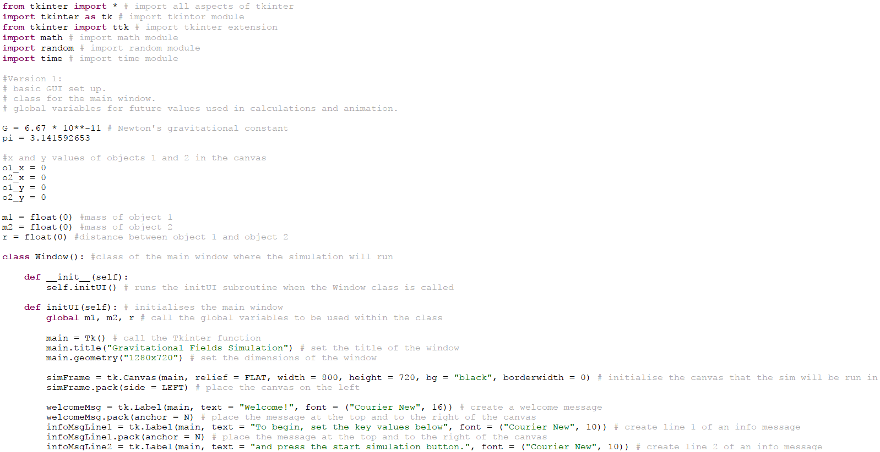My code to initialise this basic graphical user interface is below:

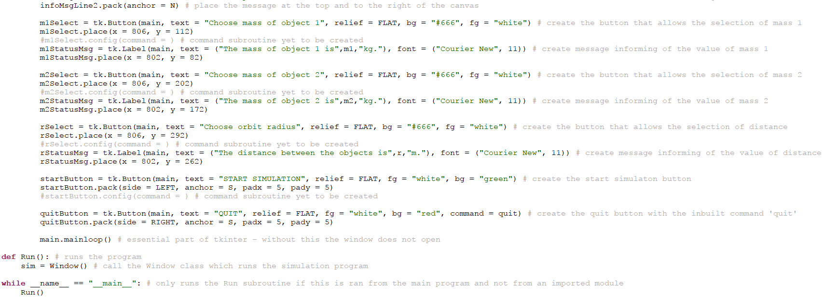

The first thing that needs to happen in this code is the importing of all of the important modules that are used by Python in order to make this program functional. Without these modules, the program would not run properly as there are a lot of functions and commands in this program that require a module to work. For example, the initialisation of all of the graphical user interface elements in the main window, including the initialisation of the main window itself, cannot be done without with Tkinter module which handles the graphical user interface elements of the program. The next thing that is necessary is the initialisation of the constants and global variables. Constants are values that do not change throughout the program and can be called upon at any time. For example, I am using the value for Newton’s gravitational constant (a very specific and very small number) as a constant so that I can refer to it easily in the future in my calculation methods in the object class, using the physics formulae. A global variable is simply a variable that can be accessed and changed throughout the program. Variables such as the user-changeable values and the x and y coordinates of each object in the canvas are important to be kept as global variables so that there are no complications when passing it between subroutines and classes.

Afterwards, I have to initialise the Window class. This class stores the main window, and is immediately called when the program is run (done in the *Run* subroutine towards the bottom of the program). In each method of the Window class, I have had to call all of the useful global variables that I have used and expect to use at the top of the method so that they are recognised as these variables; I had initially run into a problem with this as I did not realise that I had to call the variables inside the class/method, and therefore I was getting an error message when the program was run saying that the variables were not defined. When this class is called, it immediately runs the __*init­­__* method which contains one line of code – this simply runs the next method in the class (*initUI*) which contains the code to initialise the main window and its graphical user interface components. For conventional purposes, I have included the parameter *self* into each method as this simply calls the class itself and does nothing more.

The first thing to do when initialising a Tkinter window is to run the *Tk()* command under a variable. In this case, this variable is simply “main”. This command tells the Tkinter module to create an instance of a window, which will be invisible to the user on its own unless I have defined its dimensions. This is what I have to do next – I have defined the dimensions of the window as 1280 pixels by 720 pixels, which is a 720p resolution. I have also defined the title of the window, which is not necessary but adds to the user-friendliness aspect of the graphical user interface as it informs the user of the name of the program/window that they are looking at.

The next thing that I have done in order to initialise the graphical user interface is to create 3 Tkinter label widgets – these widgets will store the welcome message for the user and instructions on what to do when the window opens. The first is a simple large “Welcome!” message that displays at the top and to the right of canvas, and the other two are two lines of an instruction message which simply informs the user to use the buttons to select their own values and then press the start simulation button to start the simulation and see the resulting movement. These three labels add to the user-friendliness of the graphical interface and allow the user to feel more confident in using the program as everything is relatively simple to do once the program is open. The next thing to do is to initialise the status messages for all three different user-selectable variables, which will also serve as an improvement to the graphical user interface’s user-friendliness as it will show the user what value is currently held by the different variables before the simulation, and shows what values the user has chosen if they decide to choose their own.

After this, I have to initialise the three different value selection buttons, underneath each corresponding status message. Each button will contain the appropriate text in order to direct the user on which value that they are changing when they press this button. These buttons will be active when the program is first started and the window opens, to allow the user to change the values if they want to. However, when the simulation is started by the user, these buttons along with the start simulation button will be disabled, as, if they are not disabled, this could potentially cause conflicts with the calculation methods that are calculating new values for these user-entered values every frame. The next step is to initialise the start simulation button – this is a currently command-less as I have yet to create or define the method that will start the simulation itself inside the window class. Therefore, I have commented this line out as I cannot reference the subroutine yet. When this button is pressed, in the future, it will run a subroutine which will start the simulation itself, initialising the objects and placing them in the canvas, starting the loop of calculations and redraws to the canvas in every frame.

Another button that I have initialised inside the graphical user interface of the main window is the quit button – this button has been given an in-built Tkinter command (*quit*) which, hence the command name, simply quits the program and closes the window when the user decides to press the button. This is placed in the bottom right of the screen and is coloured red. At the end of the initUI method, I have used the *.mainloop()* Tkinter command which is an integral part to the window initialisation process. Without this, the window would not open for the user at all. Therefore, I must include this at the end of the method.

The last part of the program is not completely necessary; however, I have done it primarily out of convention. The *Run()* subroutine is simply what runs when the program is first ran. This subroutine calls the window class, which opens the window and the graphical user interface for the user. After this, at the end of the program, there is an if statement. This if statement checks whether the program is being run from the Python file itself, or from an imported module on another Python file. For example, if my Python file was named “fields_sim.py” and it was in the same directory as the Python file I was currently programming, I could use the line “import fields_sim” to import the variables, classes and subroutines from the fields_sim file. Due to this if statement, if this happens, it ensures that the program does not simply run without my permission when it is imported into the other program. This enables me to use specific classes or subroutines in the fields_sim program to my advantage in the program that I am currently writing.

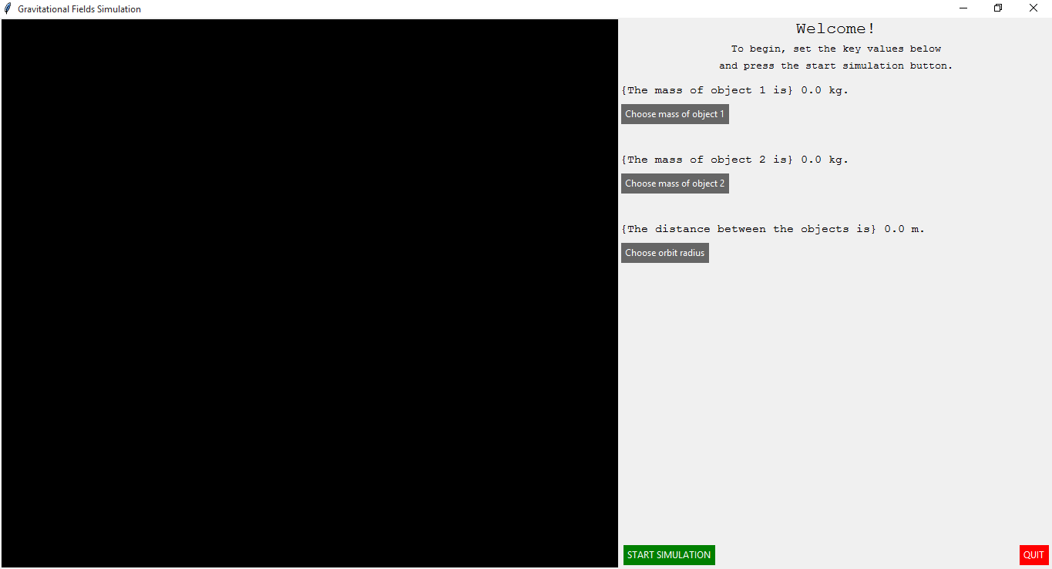The graphical user interface that opens when this program is running is displayed below:

The whitespace in the bottom right above the start simulation and quit buttons could possibly be filled with the table of values that updates with the canvas, in accordance to my problem criteria. This could also be done by opening another window when the simulation is running which will contain the table instead, leaving room for the whitespace to be filled with things such as the pre-set object selection buttons. When the ‘Choose mass of object 1’, ‘Choose mass of object 2’, and ‘Choose orbit radius’ (this means “choose distance”; this was a placeholder name) buttons are pressed, in the future, they will open a new window which will contain an entry field which will allow the user to set their values for each variable.

*User-Determined Values Setup*

When determining how to approach the problem of letting the user press a button and set their own values, I have determined that the best way to do this is to open a new separate Tkinter window which will contain an entry field and a “confirm” button. This is because an entry field readily able to be typed into by the user will not work well once the simulation is started – as far as I am aware, there is no way to disable entry fields so that they cannot be typed in and therefore I cannot disable it while the simulation is running. This could potentially cause problems with data conflicts as the values are constantly updating in the simulation, so if the user were to decide to change a value during the simulation this would cause a lot of problems that cannot be easily overcome. Therefore, I will simply open a new window for the user, allowing only the button to be disabled when the simulation is started. This window will allow the user to enter their own value into the entry field, and then press the confirm button to set the variable in the program to this variable. To do this using Tkinter, I will have to set the command of the button to a subroutine which will perform this process. This subroutine will have to pass parameters such as the variable(s) that the user is going to change and the button itself.

Inside this subroutine, I should have the code that will initialise and display a suitably-sized separate window using the basic Tkinter command which initialise such a window. After this, the subroutine will create and display both an entry field and a confirm button at suitable positions inside the window. When the user enters a value, and presses the confirm button, this confirm button will have a subroutine of its own – this will run when the button is pressed. This subroutine will simply tell the program to close the new window as the value has been selected by the user, and will also tell the program to update the variable being changed to the value that the user has defined. This same method will be used for all of the buttons that let the user select a value, as it is the same process that it being carried out for each, with the exception of a different variable being changed. After this window is closed, I will also have to update the corresponding variable’s status message so that it displays the new correct value for the variable. This will have to be done using the confirm button’s command subroutine as the message will not update automatically when the variable is changed.

The code that I have implemented for this section of the worked solution can be seen in the screenshots below:

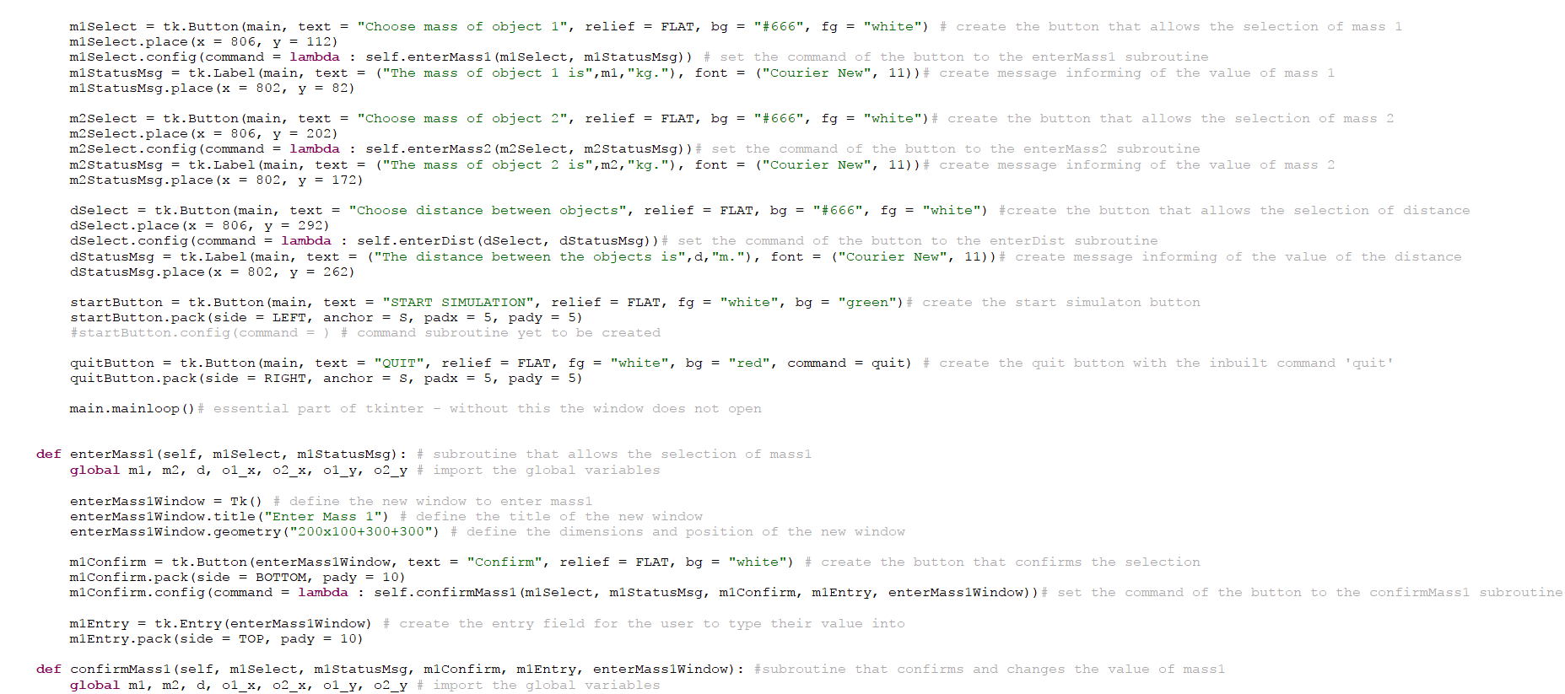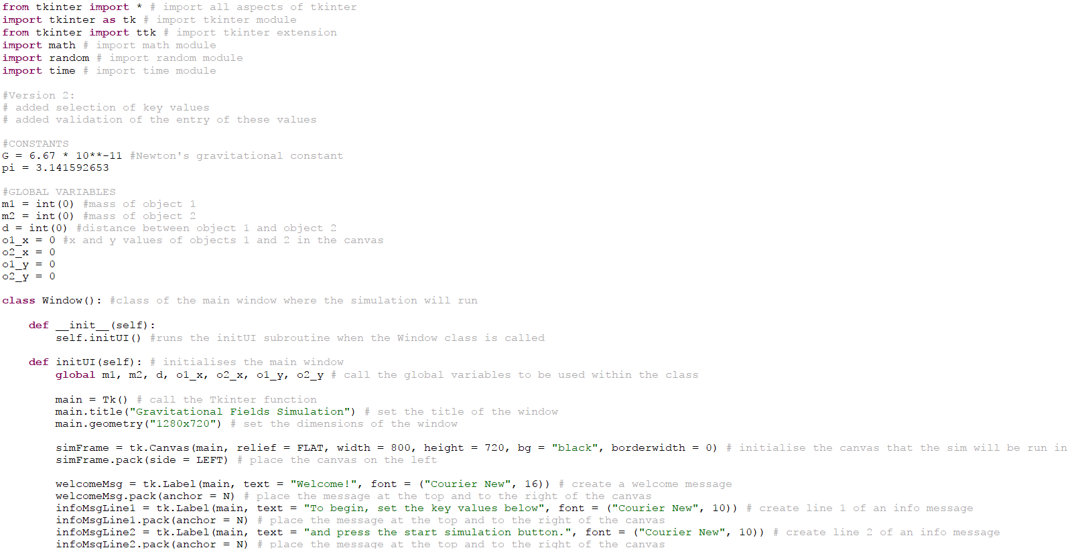

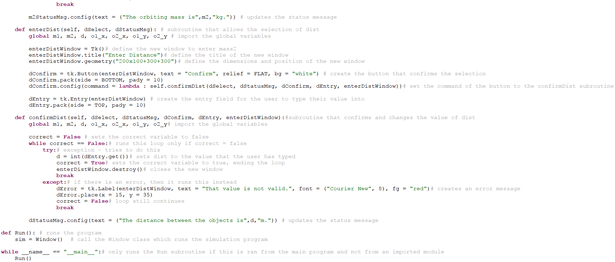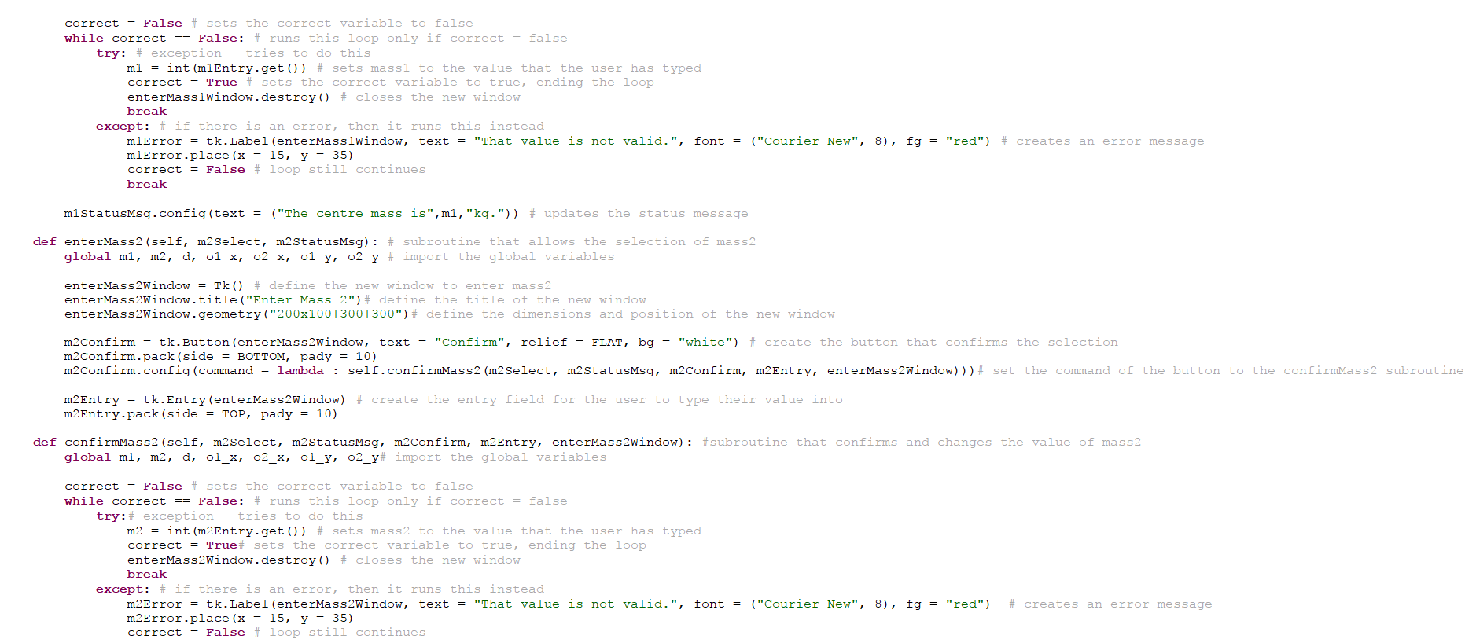I have kept the original code for the initUI subroutine – with the exception of a few minor changes. These minor changes include the lines underneath the initialisation of the value selection buttons – these lines set the commands of the buttons to the suitable methods. At this stage of the development, I have created and completed the subroutines which allow the user to select their own value, and therefore, I have included them as the commands to the buttons I had previously initialised. This means that, when the user presses one of the buttons, the program will run the corresponding method to allow them to select a value. The rest of the initUI method has not been changed; there is still no defined command method for the start simulation button as I have yet to program such a method which starts the simulation.

In order to allow the user to select their own value, I have had to define two methods inside the object class for each value that needs to be changed – for example, with mass1, I have defined the *enterMass1* and *confirmMass1* methods. The first of these methods, *enterMass1*, is the method that is run when the button is pressed. This method initialises a new window using the *Tk()* Tkinter command, which is then defined with a small resolution so that it does not cover the whole of the screen for the user. The internal graphical user interface of this new window is then defined inside this method; the confirm button and entry field are both initialised along with the command method for the confirm button – this command method is the next method that I have defined, *confirmMass1*.

After the user has pressed the confirm button, the *confirmMass1* method runs. This method first sets a variable “correct” to the Boolean value of False so that it can be used to end the while loop contained within the method when this value is changed to true. Inside this while loop, there are *try* and *except* functions – the code under *try* is what is first tried by the program. If the program returns an error which forces the program to stop running during the execution of this code, then the program will simply ignore this error and move onto the code that I have defined underneath the *except* function instead. However, if no errors occur, then only the code under *try* is executed while the code under *except* is ignored. Under the *try* function, I have defined code that sets the value that the user has typed into the entry field as the corresponding variable. If this returns an error because, for example, they entered an alphanumeric string instead, then the code will move onto the *except* function, where I have defined code that will return an error message in the form of a Tkinter label widget inside the new window. The font size of this error message had to be made relatively small after some experimentation due to the limiting window size that I had previously defined to fit with the also-small confirm button and entry field.

The last line of the *confirmMass1* method simply updates the status message in the main window’s graphical user interface to display the new value selected by the user. The methods for all of the other variables that can be changed are mostly identical with the exception of the variable and method names being used. The rest of the program has been kept identical to the previous step of the worked solution and therefore I will not be covering it.

The graphical user interface which opens when this program is run is shown below:

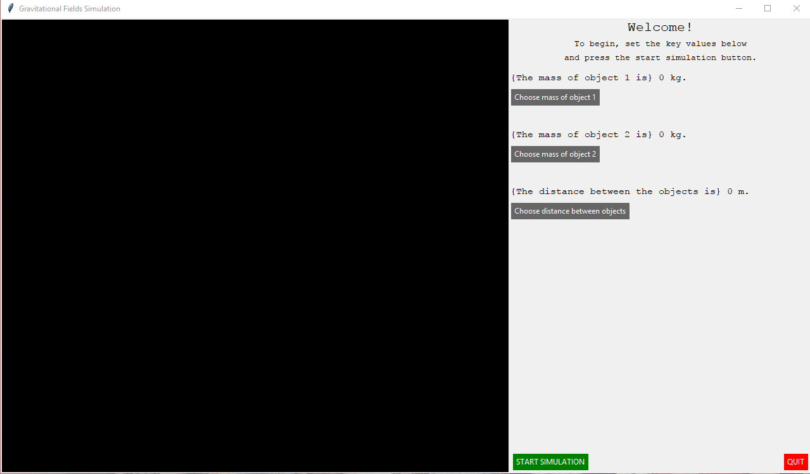

This is virtually identical to the previous step of the worked solution – no code has been added that changes the base appearance of the main window on start-up. When pressing the “Choose mass of object 1” button, this window opens:

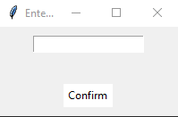

This is the same window that opens for every other value selection button; the only exceptions are the differing titles of the windows and the value that is updated when the user presses the confirm button and the value is accepted. A user can enter a desired value into the entry field at the top of the window and press the confirm button at the bottom of the window to run the other associated subroutine to check and confirm their new value for the variable. An example of a value that would be successfully validated and accepted is shown below:

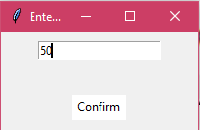

This value, when the confirm button is pressed, would be accepted with no errors and the window would close, updating the value in the status message on the main window. The updating of this status message can be seen below:

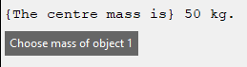

This message is a Tkinter label widget placed at a specific coordinate on the main window so that it lines up just above the corresponding value selection button. When the user enters a valid value and presses enter, this message is updated so that it displays the current value for the corresponding variable.

An example of a value that would not be accepted is a value that is not a number and is instead a string. If the user enters such a value, then the validation technique that I have put in place (using the *try* and *except* functions) will return an error message inside this window, prompting the user that their value is invalid. This is shown in the screenshot below:

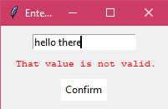

This message will persist on the screen as the user enters more invalid values until the user enters a valid value and the window closes.

*Graphical User Interface Completion*

To complete the graphical user interface, I have had to utilise a currently limited form of object-oriented programming, using the window class. From the window class, when the program is run, an instance of the class is created under the variable “sim”. This uses an element of object oriented programming – the “sim” variable is the ‘object’ as it has its own variables and attributes associated with it. This aspect of Python classes is expected to be used much more extensively in the future of development with the object class. This class will initialise two different instances of objects, each with their own values for various variables. These variables include the mass of each object and the distance between each object.

Otherwise, in order to complete the graphical user interface, I have focused on making the graphical user interface as user-friendly as possible as this will help the user (the teacher) use the program more efficiently which will allow the students to learn the contents of this topic of the A-Level physics syllabus much more effectively and a lot quicker.

*Canvas and Object-Oriented Classes Setup*

In the original code for the initUI method of the window class, I had initialised a blank canvas with a black background. This canvas covers just over half of the window and is going to be utilized in this section of the development in order to create and store instances of the yet-to-be-created object class inside the canvas as visual circles. This will be done using the Tkinter “create_oval” command, which will create an ellipsis shape with the length and height defined in the parameters of the command. This shape will be stored in a defined variable name which can then be called upon to be updated and moved throughout the canvas as the simulation runs.

The object class is expected to be a subclass of the window class as the objects will have to be initialised inside the window and inside the canvas of the window. Making the object class a subclass of the window class will greatly simplify the usage of such variables inside the window class as there is no need to transfer them between unrelated classes. This will enable me to simply import the window class variables into the object class’ methods by defining the parameters of these methods. The objects will change in size according to their mass – the scale I expect to use is 1 kilogram = 5 pixels in diameter. This will allow me to give a visual representation of what the mass of the object is, and allow the students to better understand the influence of the mass of an object on its gravitational field. The distance between the visual representation of the objects on the canvas will also be proportional to the value for distance that has been chosen.

Screenshots of the updated code used to set these elements up can be seen below:

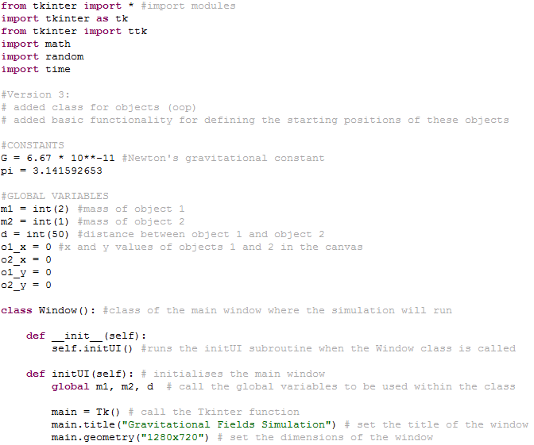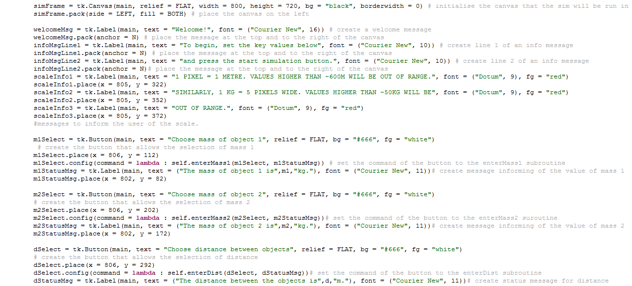

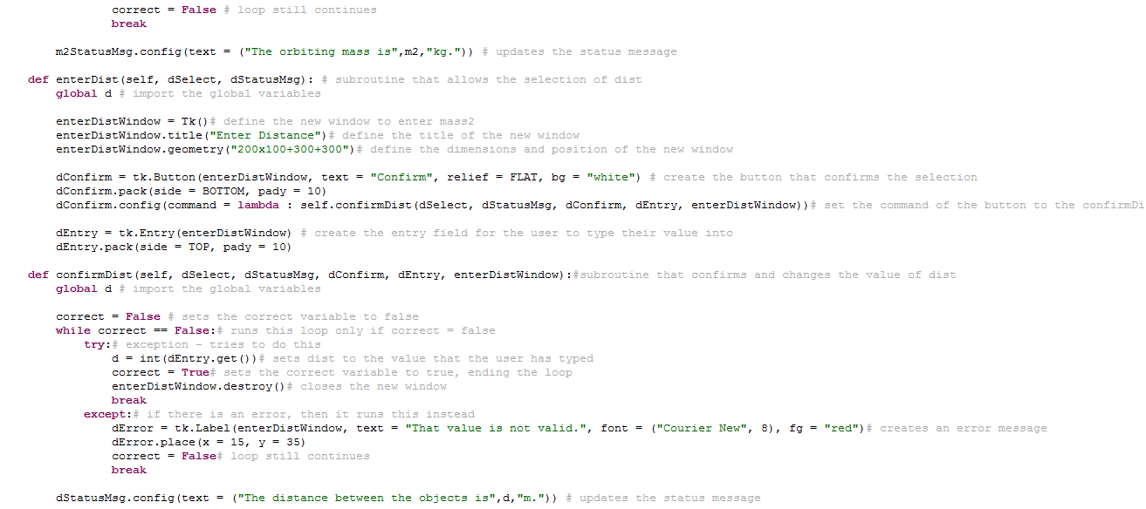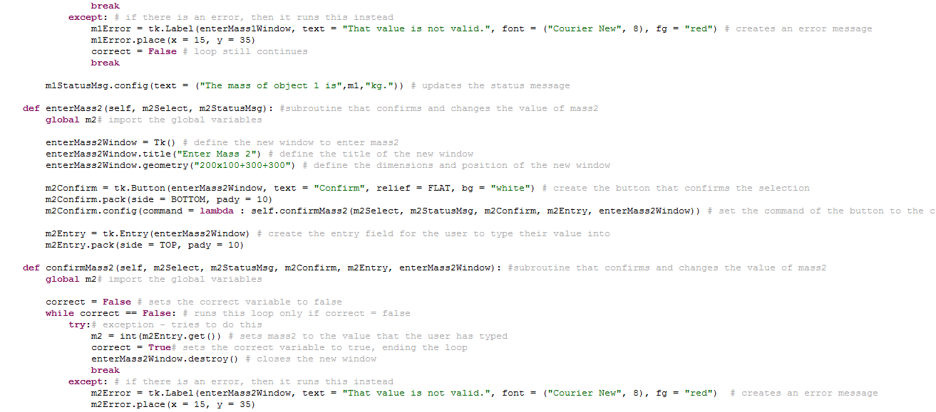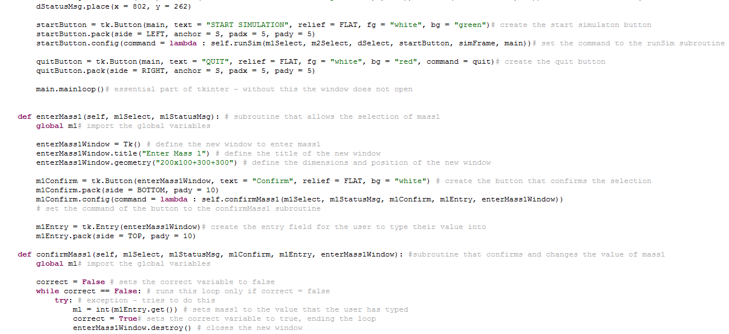

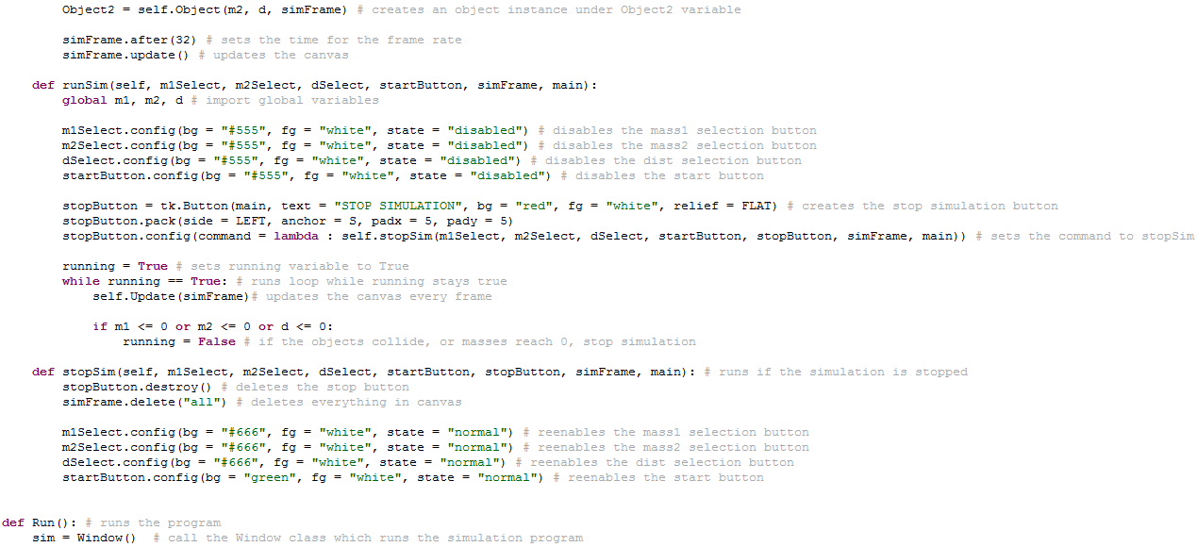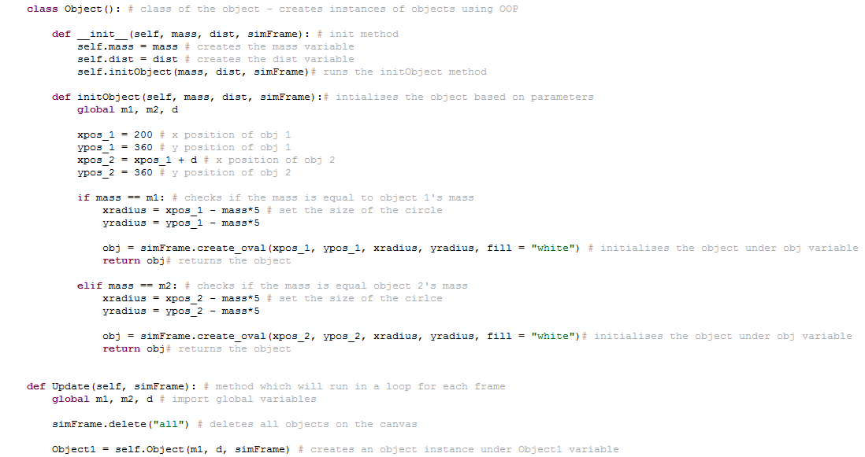The initUI method has once again been changed in this stage of the implementation. I have added a command for the start simulation button which points towards the runSim method of the window class. This method is what runs when the start button is pressed and will, in the future, contain all of the code needed to run the simulation, including the calling of different methods in both the object and window class. In the initUI method, I have also added 2 information messages underneath the value selection buttons and status messages. These messages are simply to inform the user of the scale of the values that they are entering. I have used the scale of 1 pixel = 1 metre for the distance, and 1 kilogram = 5 pixels in diameter for the scaling of the objects due to their mass.

The main things that I have added are the Update, runSim and stopSim methods inside the window class, and the object class itself.

The object class is the class that is called when I want to initialise an instance of an object, with its own variables for mass/distance and other variables. This means that the object and its variables can be manipulated independently of the rest of the program, and independent from the global variables that it was assigned in the beginning. For example, the variable for mass for object 1 is held by the global variable *m1*. However, when the object class is called to initialise an instance of object 1 inside the simulation canvas, the global variable *m1* is assigned to the internal variable of the object class, *Mass*. This allows the mass of object 1 to be changed inside the class and therefore it is independent of the global variable. This means that the global variable can be kept the same for when the user decides to press the stop simulation button and stop the simulation; the original values that they had chosen would be displayed in the right-hand side of the main window again, allowing them to run the simulation again with the same values that they had previously chosen if needed.

The runSim method is the method that is run when the start simulation button is pressed by the user. This method will, in the future, contain the main bit of code which is looped around each frame when the simulation is running. The loop will contain the Update method of the window class, which contains code to update the canvas inside the main window each frame. The rest of the runSim method will contain code outside the loop. This code will disable all of the buttons that were used for things such as selecting values and starting the simulation. This means that the buttons cannot be clicked when the user tries to. This avoids any conflict of data when the simulation is being run. The stop simulation button is also created in the runSim subroutine, with the command method stopSim.

The stopSim method is what is run when the stop simulation button is pressed. This method contains code to stop the simulation. In order to stop the simulation, the program needs to first of all delete all of the objects that have been initialised inside the canvas of the main window using instances of the object class. This is done by simply using the *canvas.delete(“all”)* Tkinter command which deletes all of the children of the parent canvas variable. The second thing that needs to happen when the simulation is being stopped is the re-enabling of all of the relevant buttons that had been previously disabled to prevent conflicts. This allows the user to once again enter values and start the simulation again when they have stopped it. After this, the program then needs to close any windows that may have been opened during the program, such as a table of values. This will allow the program to open it again after the program is run a second time without opening a duplicate of the window.

The Update method is run in a loop in the runSim method which updates the canvas in the main window each frame. This will, in the future, contain code that will delete and re-initialise each object at each frame. This will prevent duplicates of the same object appearing over and over again when the simulation is running. Although this could assist in the creation of a ‘path’ that the object is following (a trail behind the object), this would potentially cause some performance problems. All of the calculation methods which use the physics formulae will also be called inside this Update method – these will be used to calculate the various values needed for the next frame. The method will then need to use the *canvas.after(ms)* command to set the number of milliseconds to wait in between the updating of the canvas each frame. This value is technically the framerate; if you divide 1000 (the number of milliseconds in a second) by a desired framerate you can get the value that needs to be put into the *.after()* command in milliseconds. This is what I plan on doing when I implement a system to let the user select a custom value for the frames per second (and therefore allow them to slow down or speed up the simulation) further into the worked solution.

The graphical user interface which opens up when this program is run is shown below:

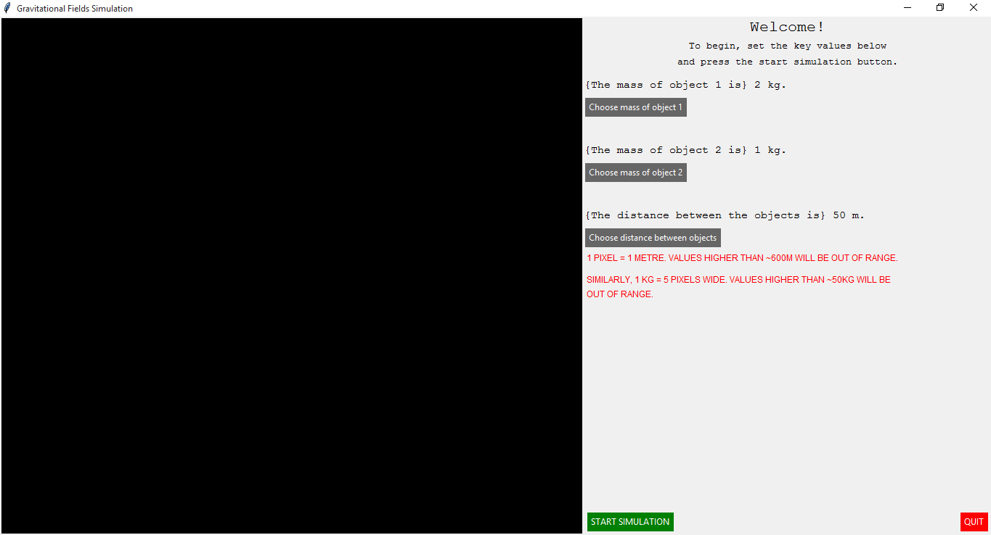

This is virtually identical to the previous section of the implementation, aside from the scale information messages below the value selection buttons. These information messages simply inform the user of the scale of the values that they have been permitted to enter, and therefore they can make a sensible judgement on what can be seen inside the canvas. If they were to enter a value that was out of range, they would most likely not be able to see the full object inside or the canvas or possible not see the object at all. This can cause problems as it loses the visual element of the simulation – the core design element of the program that I am going for to help students understand this topic. Therefore, I have added these scale indication messages in the colour red so that it stands out to the user and they read it before they confirm their values.

I am going to set some random suitable values for the masses and distance and press the start simulation button to generate the objects according to the values I have set. As mentioned previously, the simulation, when started, should generate two objects that have a diameter which is equal to 5 times their mass in kilograms, and a distance in pixels which is equal to their distance in metres. The result of this can be seen below:

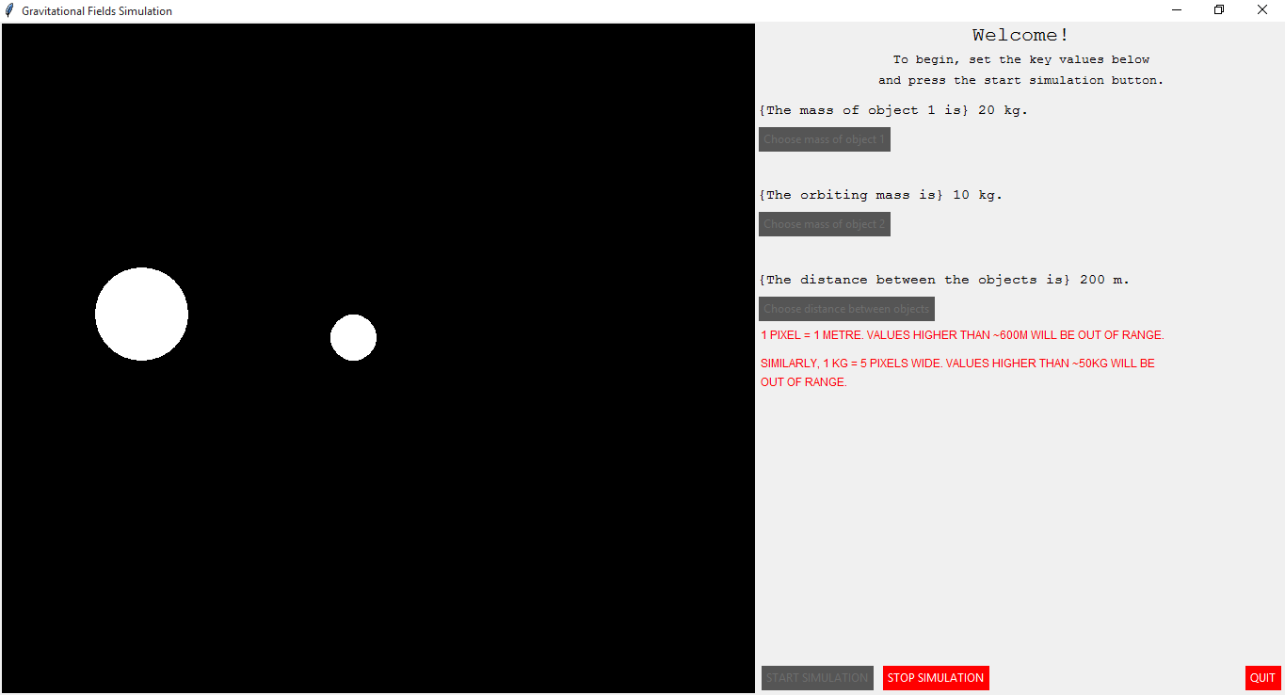

As can be seen, the objects have been generated on the canvas when I have pressed the start simulation button. I have set the mass of object 1 to 20 kilograms, and the mass of object 2 to 10 kilograms. This, as expected, generated two objects that are double and half the size of the other object respectively. Scaling the masses up, the actual diameter in pixels of each object is 5 times the mass of each object. So, the diameter of object 1 is 100 pixels, and the diameter of object 2 is 50 pixels.

The distances have also been scaled so that each pixel is 1 metre wide. This means that, at the value of distance that I have set at 200 metres, the objects are 200 pixels apart. This allows me to easily scale things such as the diameter and radius of each object. In this case, the radius of object 1 (half of the diameter) is 50 pixels, and the radius of object 2 is 25 pixels. These values for diameter and radius will then be used to calculate things such as the volume of each object. The values for volume can then be used in the equation for density to calculate the density of each object and

*Calculation Methods for Physics Formulae*

Inside the object class, I will have to define a variety of methods which will calculate and return different values for the variables of each object. One such value would be the gravitational force – for this, I would have to create a method which would use the masses of the objects and the distance between them. These variables would be used in a physics equation to calculate the gravitational force acting on each object. Separate methods will be used for each calculation as this will allow me to return only one value per method, simplifying the process of calling the method and running it as I will only have to pass 1 variable into the method which will become the variable of the value that is calculated at each frame.

I will have to define one method inside the object class for each value that I calculate. This means that I will have to have a method for calculating the gravitational force, a method for calculating the kinetic energy, and a method for all other values. I will also have to return the value that I have calculated using these formulae from each method so that they can be used elsewhere in the window class when I call the methods in the Update method. In some methods, such as the method in which I will calculate the gravitational field strength of each object – I will need to take into account the gravitational field strength of both objects as they will not be equal, and therefore I will have to return two values from the method. The majority of calculation methods will be like this – the only values that are equal for both objects is the gravitational force and the gravitational potential.

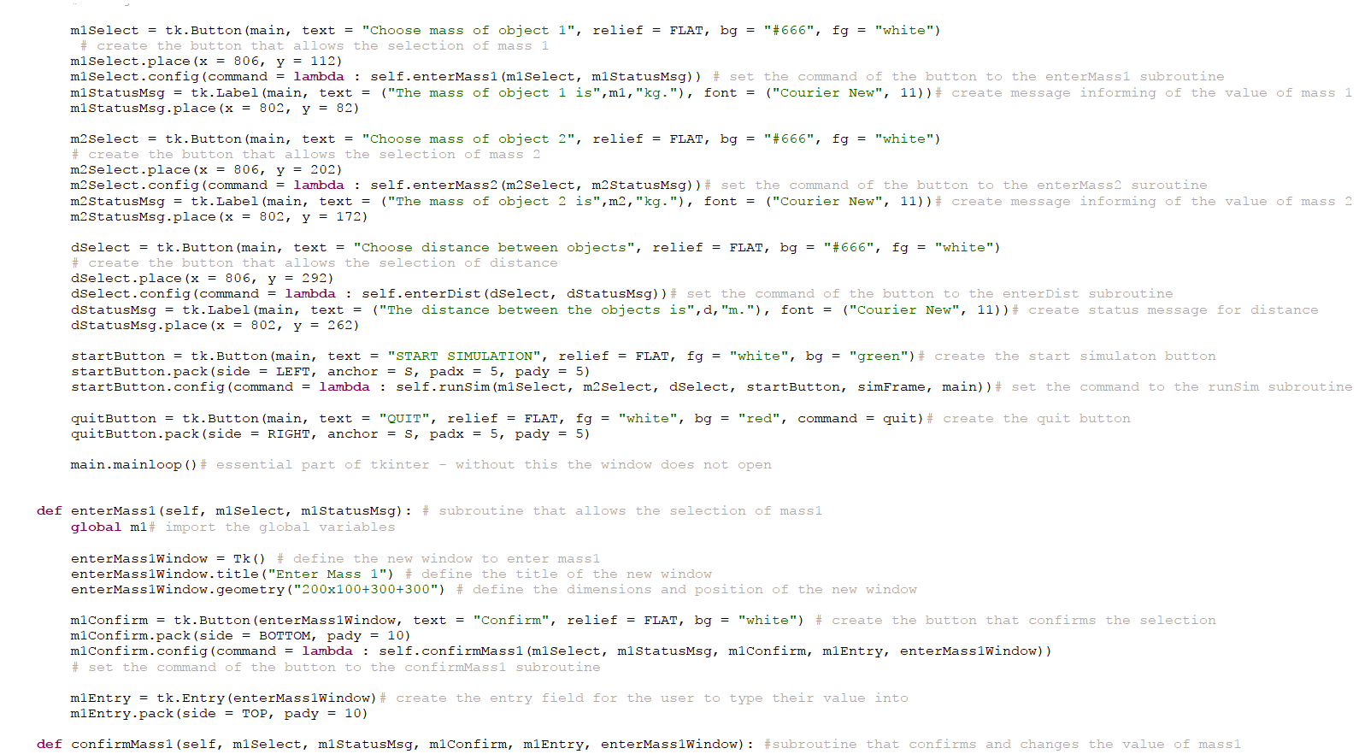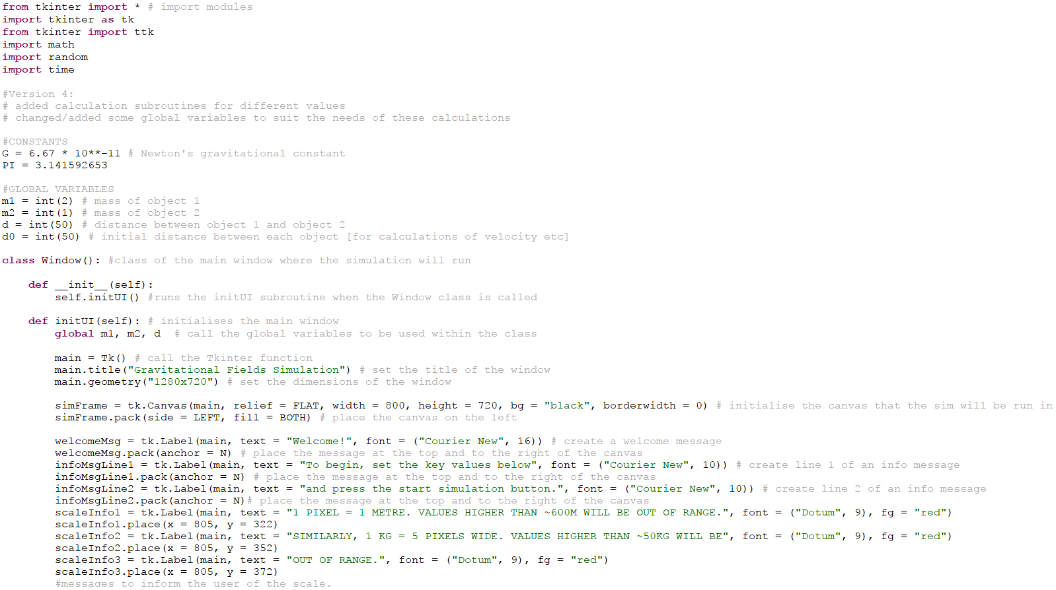The code that I have implemented in order to calculate values using the physics formulae can be seen below:

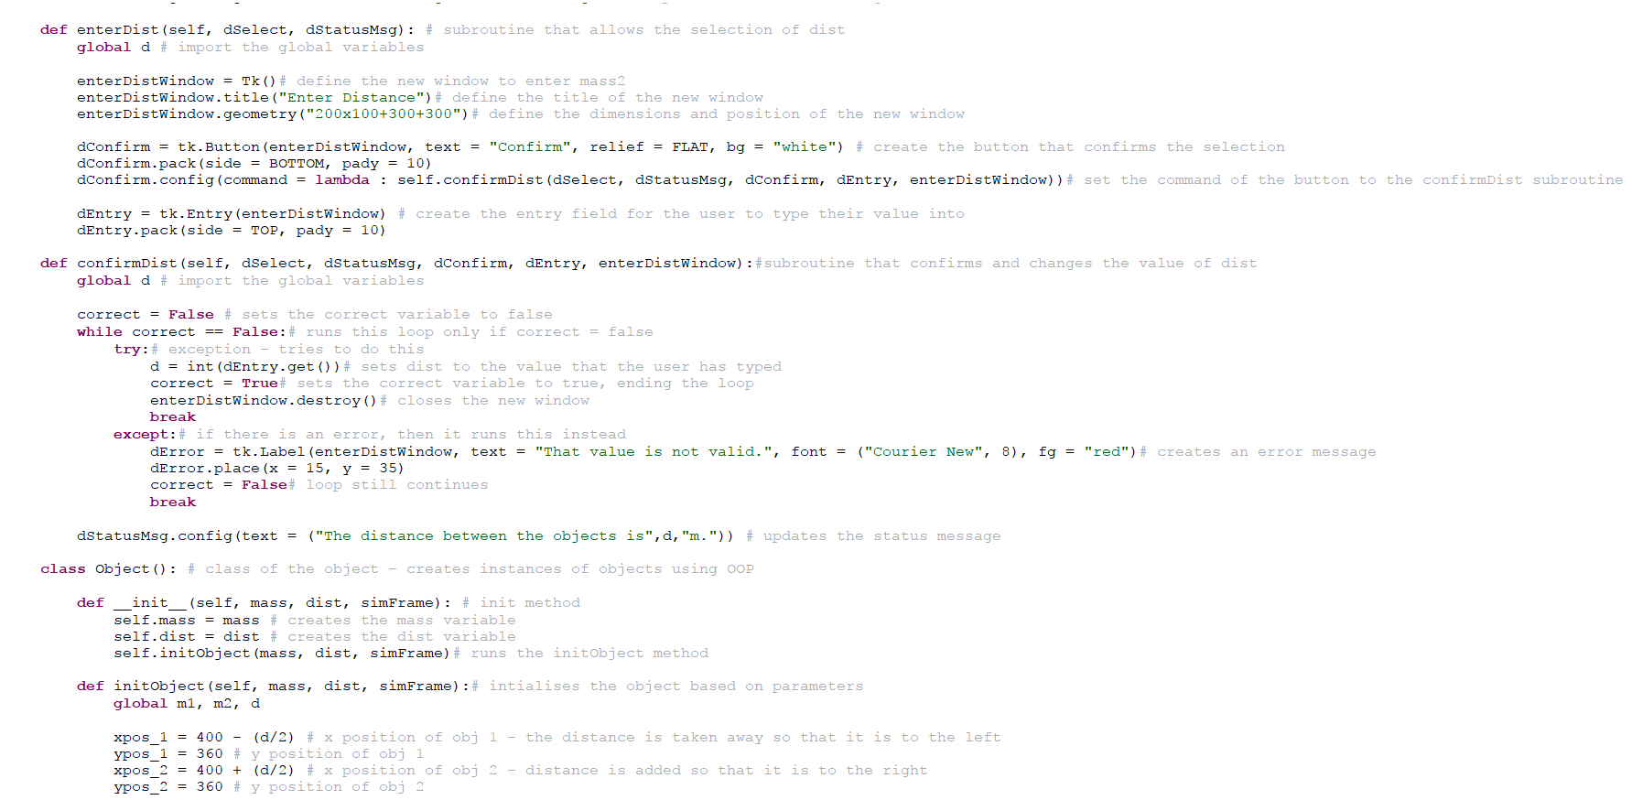

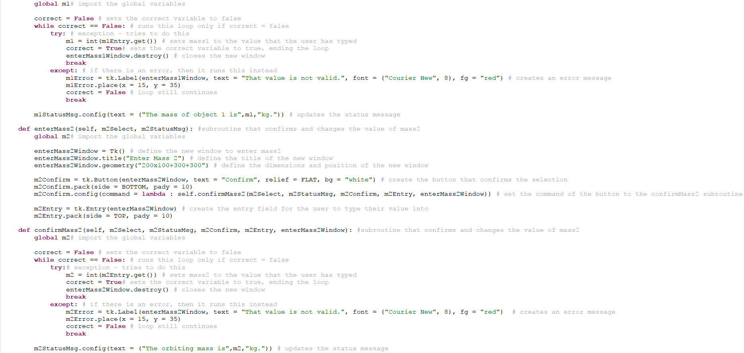

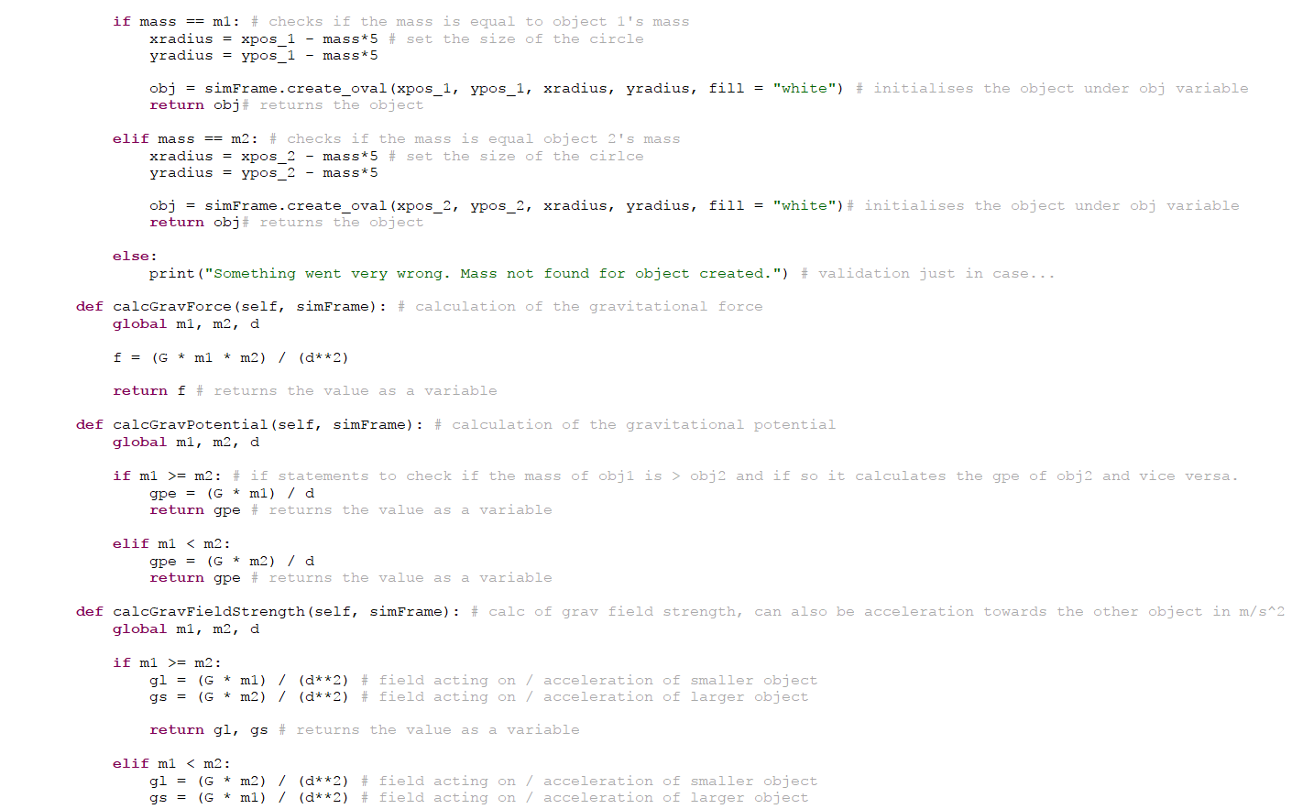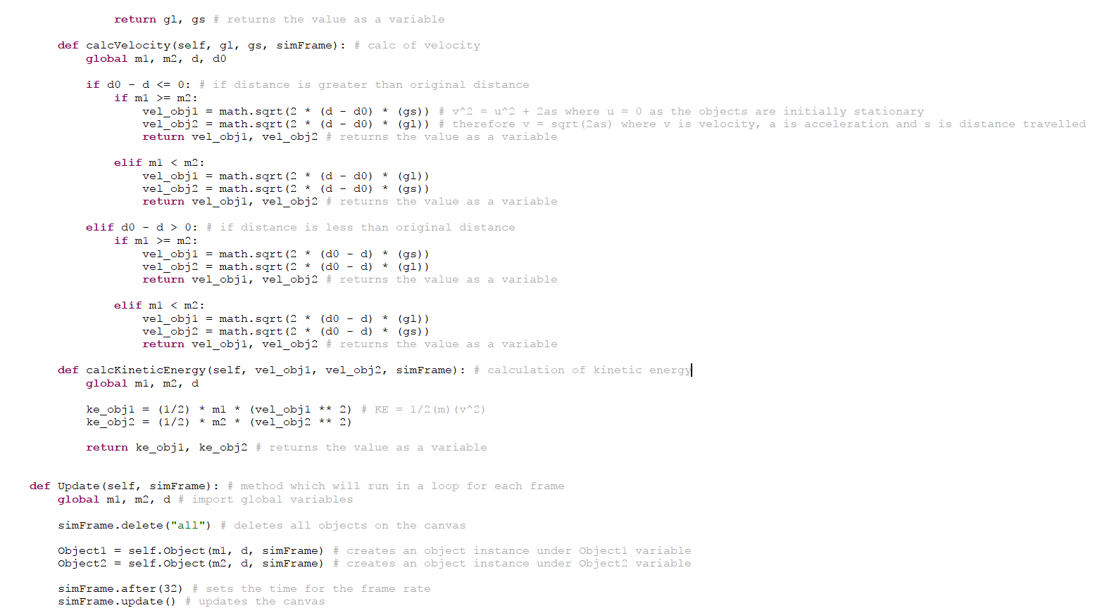

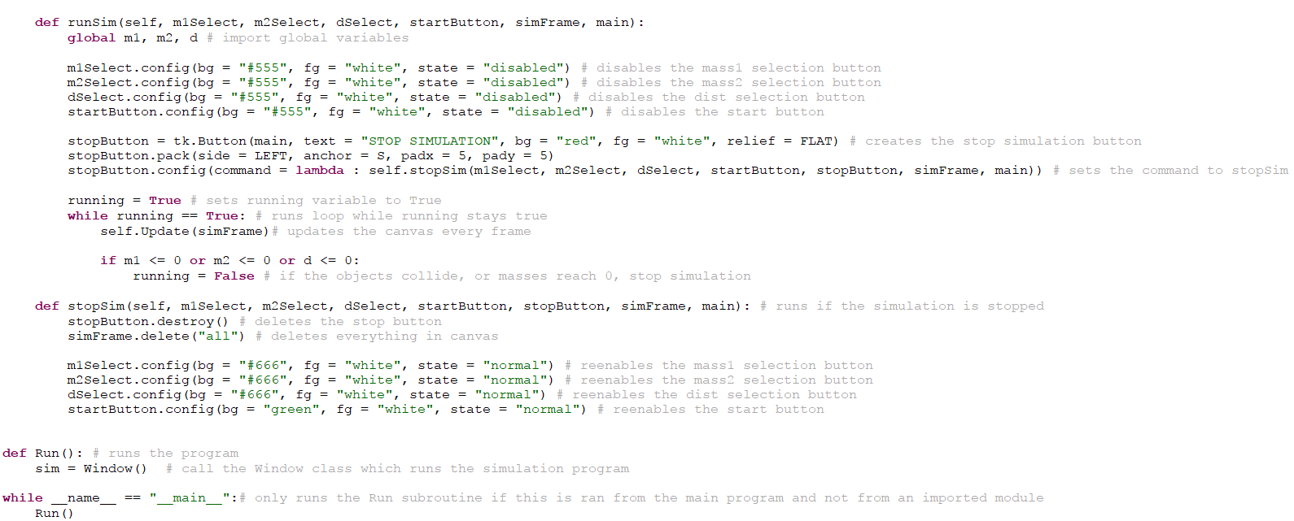In this code that I have implemented, I have defined five different calculation methods inside of the object class that all return at least one value to the window class which can then be used in the Update method of the window class. Inside the update method, I have implemented some code that will allow the objects to be deleted and then redrawn onto the canvas every frame. In order to delete the objects from the canvas, I have to use the following command:

This command tells the canvas to delete all objects and other elements that have been initialised previously as children of the parent canvas. This, in this case, includes the objects that I have initialised in the object class. Due to the fact that the commands inside the Update method are all running in a loop, the program will delete all objects from the canvas every time it updates.

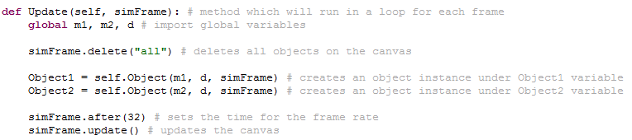The next command that needs to be executed inside the Update method is the command which initialises the objects from the object canvas – this is the most crucial part of the Update method as it is the main element of the canvas that is initialised and is what the user will see as a visual representation in the canvas. In order to execute his command, the following code is needed:

These two lines of code are the commands which initialise both objects as an instance of the object class. Each object has a variable assigned to them, with the names “Object1” and “Object2” respectively. I will then be able to call these variables when I need to edit the variables within the objects themselves or when I need to use one of the methods inside the object class to, for example, calculate a value during a frame.

The next part of the Update method is what updates the canvas inside the main window when the objects are re-initialised. This is done using a time command (*canvas.after(ms*)) and an update command (*canvas.update()*):

The *.after()* command with the number inside the parameters of the command tells the program how long to wait before updating the canvas. This is essentially the frames per second that it is running at, converted into the time in milliseconds between each frame. I have set this to thirty-two milliseconds so that the simulation runs at 30 frames per second. However, I plan on allowing the user to select this value in the future. The *.update()* command, when executed, simply tells the canvas to update itself on the screen to the user. Without this command, the user would not see any change in the object’s positions or sizes, even though their values for the x and y coordinates are changing inside the simulation.

The five calculation methods inside the object class are:

1. calcGravForce
2. calcGravPotential
3. calcGravFieldStrength
4. calcVelocity
5. calcKineticEnergy

These five methods can be called inside the Update method so that the corresponding values can be calculated inside the Update method and updated at every frame. This will allow me, in the future, to display a table of values that will update with every frame during the simulation, giving the end user a good idea of how the values are changing over time as a result of changing different variables. These calculation methods all use the corresponding appropriate formulae, which use other variables in order to calculate the desired value and return it from the method in order to be called in the Update method. For example, the calcGravForce method uses the values for the object’s mass and the object’s distance in order to calculate the gravitational force that is being exerted on the object.

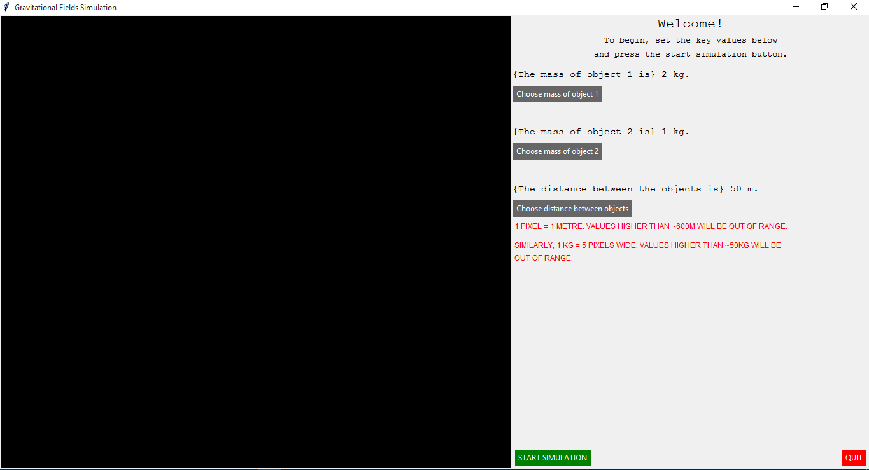The window that opens when this program is run is displayed in the screenshot below:

This window is identical to the previous step of the worked solution as I did not have to modify anything in order to achieve this step of the solution.

When I start the simulation with some sensible values, I can see that the calculations for each value are running using the shell (output) section of the Thonny integrated development environment. To make sure the values are calculated, I have modified the Update method in the window class so that the values are first calculated and then printed to the Thonny shell as an output during each frame. I have also increased the time between each frame so that the shell does not end up crashing because it prints values 15 times per second. This issue will be resolved with a table of values that will not print over and over again but will instead just update the contents of a Tkinter label widget.

The modified code that enables this to happen can be seen below:

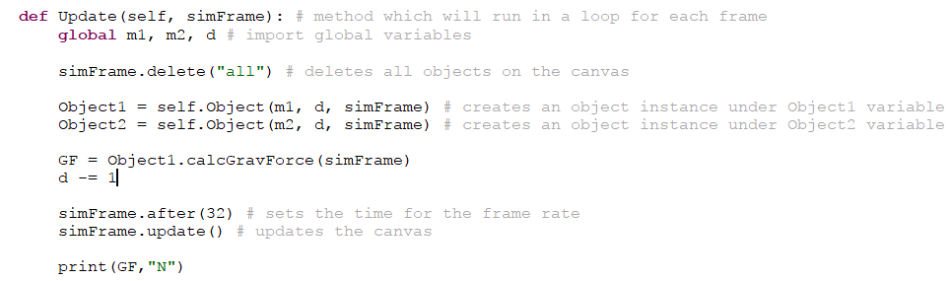

In this code, I have amended the Update method so that the calcGravForce method is called. I have then added a command at the bottom of the Update subroutine which prints the current value for this variable when the canvas updates. When running the simulation, I have also added a command in the Update subroutine that decreases the distance between the objects by 1 each. This allows me to see if the values change when the distance is reduced – the force should increase.

The values that I have selected in order to see if the values are calculated correctly are shown in the initial graphical user interface below:

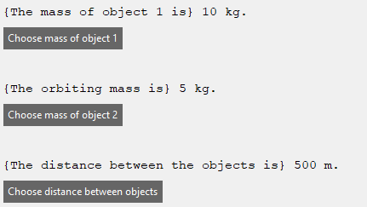

The values that are calculated when this simulation with the values I have selected is run can be seen below:

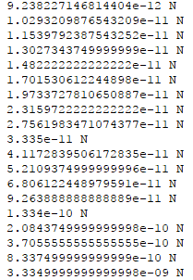

As can be seen, in the last few frames of the simulation, the values for the gravitational force when the distance gets closer to 0 are increasing rapidly – from the order of magnitude of 10-12 to 10-9. This shows that the calculations that I am using are calculating the values accurately and can give me consistent results when certain variables are changed. I plan on testing all of the rest of the calculations in the testing section of this project.

*Object Initialisation*

I have already partly completed this step in the previous “Canvas and Object-Oriented Classes Setup” stage of the implementation process, however I will be going into a lot more detail on how the objects are initialised and placed on the canvas in the main window, and the rules that they follow according to both the values entered by the user and some pre-determined values. In order to initialise objects, the program will need both of the user-defined variables, mass and distance. The mass of each object will tell the program how big the circle created on the canvas will have to be; the scale for this is the diameter is 5 times the mass of the object. The distance between each object will tell the program the x and y coordinates of each object when they are initialised as they will be a certain distance apart from each other in pixels and therefore I will have to account for that accurately in the canvas. The scale for this is 1 pixel is equal to 1 metre – this makes it relatively simple and also allows for quite high values for distance as the canvas is 800 pixels in width, therefore allowing for a distance of 800 metres maximum.

The code which was previously implemented to allow for the object initialisation can be seen below:





In order to initialise each object inside the object class, I have to first create a method inside the object class that will do this. I will also have to call this method inside the __init__ method of the object class which will run as soon as the object class is called. I will then use the parameters of the __init__ method when calling the object class inside the window class in order to use the global variables for each object when initialising them. Inside the method that initialises the objects, I will first have to import the global variables from the rest of the program at the top of the method so that I can use them in the method. The next thing that I have to do when initialising an object inside the initialise method is to set the starting *x* and *y* positions of each object. In order to achieve this, I will have to define the coordinates as a specific integer value after some experimentation – in this case, the starting *x* value of object 1 is 200 and the starting *y* position of object 1 is 360. The starting position of object 2 is the same for the *y* value; however, the *x* value is different as it needs to account for the distance between the objects. Therefore, the *x* value for object 2 is simply the *x* value for object 1 added to the user-defined value for the distance between the objects.

This method of defining the *x* coordinate of object 2, after developing the rest of the program in future versions, has proved to not be very effective as I would not be able to get object 1 to move left at all as it will always initially spawn on the very left-hand side of the canvas. Therefore, I made a global variable for the *origin point* (approximately the centre of the canvas) and initialised the objects either side of this centre point. The objects are initialised at a distance equal to a half of the value set by the user, so as to preserve the total distance between the object.

After I have initialised the initial positions of each object, I have to then set the radius of each object. As explained previously, the radius of each object is proportional to their mass set by the user. Therefore, I will have to set the radius to the scale that I have set – 5 times the mass of the object. To do this, I have to set new variables for the radius and then set them to the value of 5 times the global variable that has been set by the user for maths. After I have defined these values for each object, I will then use them as parameters in the *create_oval()­* Tkinter canvas command which creates an oval with the defined parameters for length, width and position on the canvas.

The *if* and *elif* statements that check before running the previously explained code are there to check whether the mass that has been used for the object is equal to the global variable for mass 1 or the global variable for mass 2. This means that it is checking which object it is initialising and therefore where it needs to place the object it is initialising on the canvas – object 1 needs to be placed to the left-hand side of the origin point and object 2 needs to be placed to the right-hand side of the origin point.

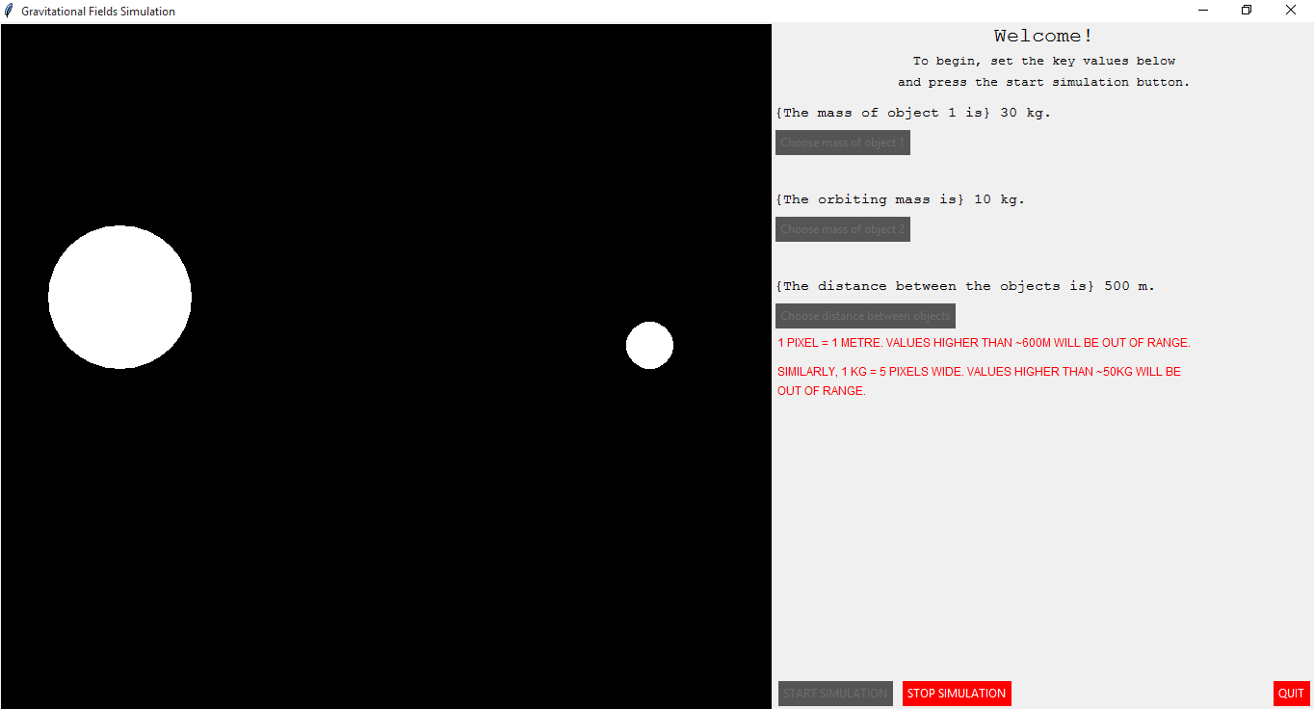When this code is run, and I enter specific values for the mass and distance for each object, this is what is initialised in the canvas:

As can be seen, the objects have initialised correctly and object 1 is roughly 3 times bigger than object 2. This reflects their values for mass that I have selected, at 30kg and 10kg respectively. The value for distance has also been accurately reflected, at roughly 500 pixels apart in accordance to the value for distance at 500m.

*Object Animation*

When the objects are updated at each frame, the objects are simply deleted completely from the canvas in the main window and then immediately re-initialised in a new position and/or with new values for its variables. The rate that this happens can be adjusted with the previously-discussed “.after()” Tkinter command, used for the Tkinter widget canvas, as the integer in the parameter brackets of this command signifies the number of milliseconds between each update of the canvas.

I also intend on, in the future, adding a system which allows the user to select their own value for the frames per second that the simulation is run at – this will effectively allow the user to set the speed at which the simulation is running at when they press the run simulation button. For example, if the user sets the value for the frames per second to 10 frames per second, then the canvas inside the main window will update the objects’ positions 10 times every second. This will also slow the program down compared to if it was running at 30 frames per second instead – this also means that there is a greater time in between each calculation and therefore the objects will move slower if they are moving at a rate of 1 pixel every frame.

The code that I have written to implement the animation of the objects can be seen below:

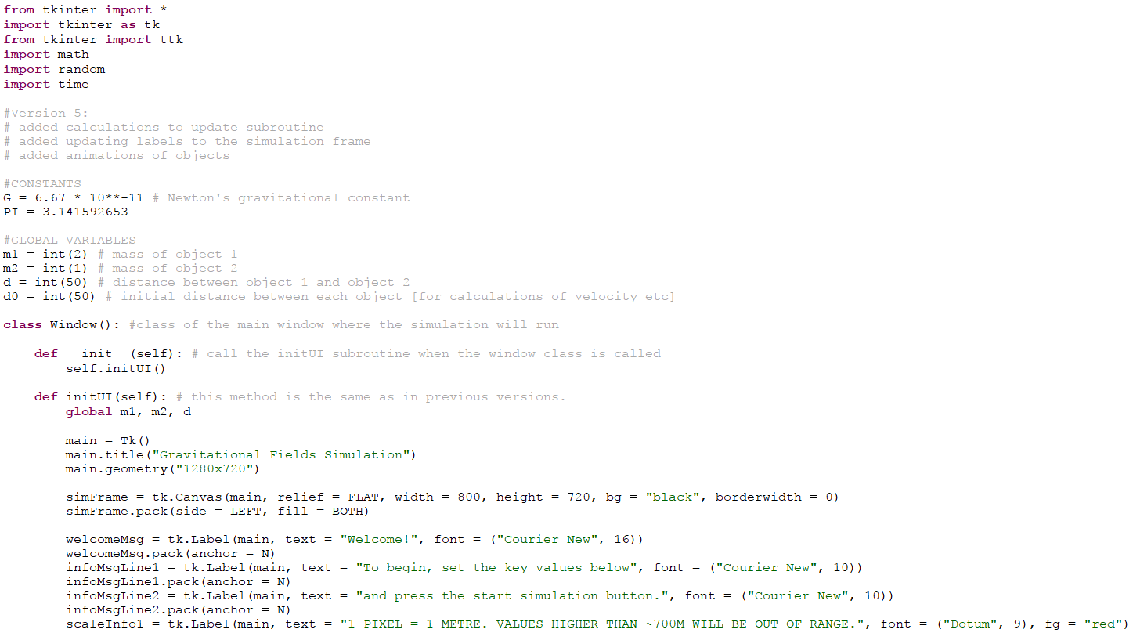

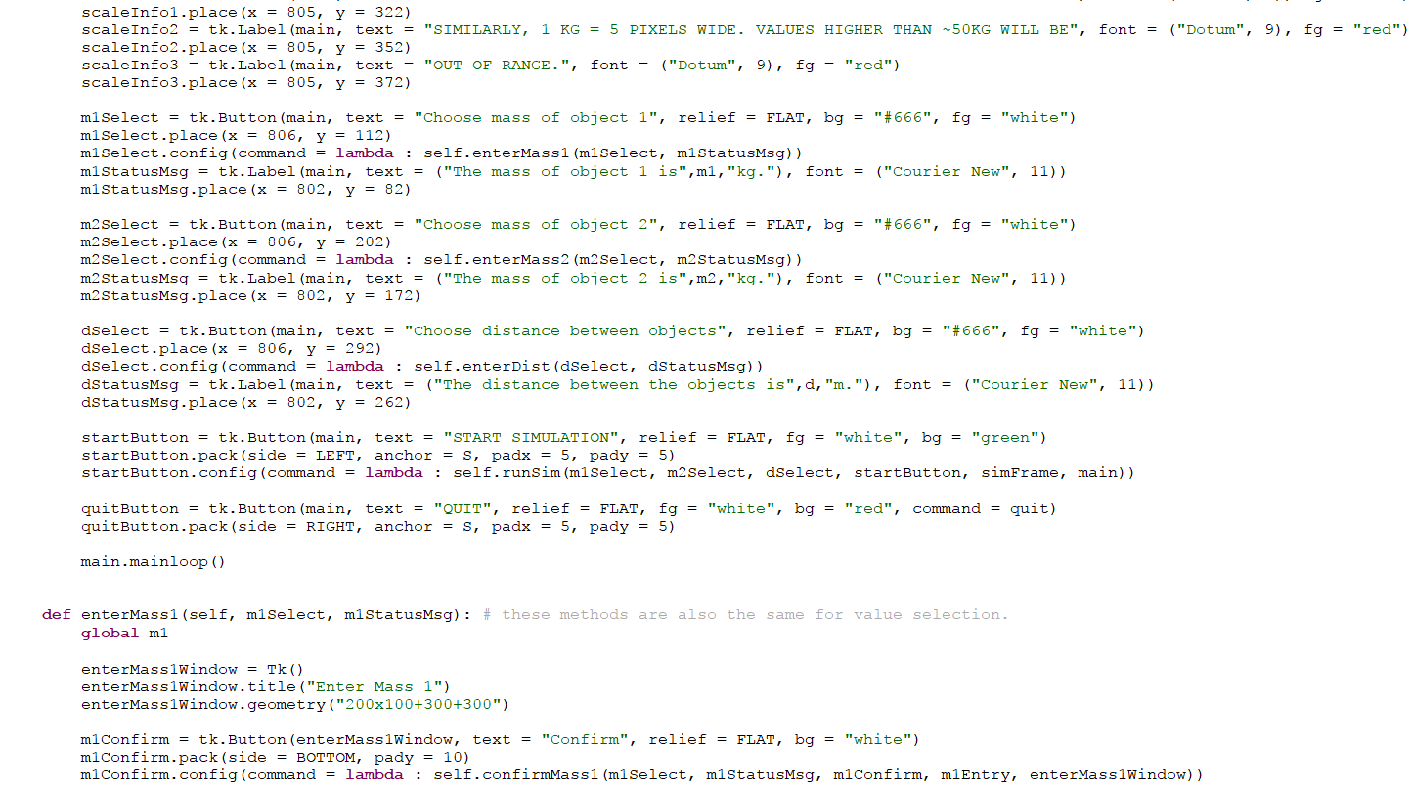

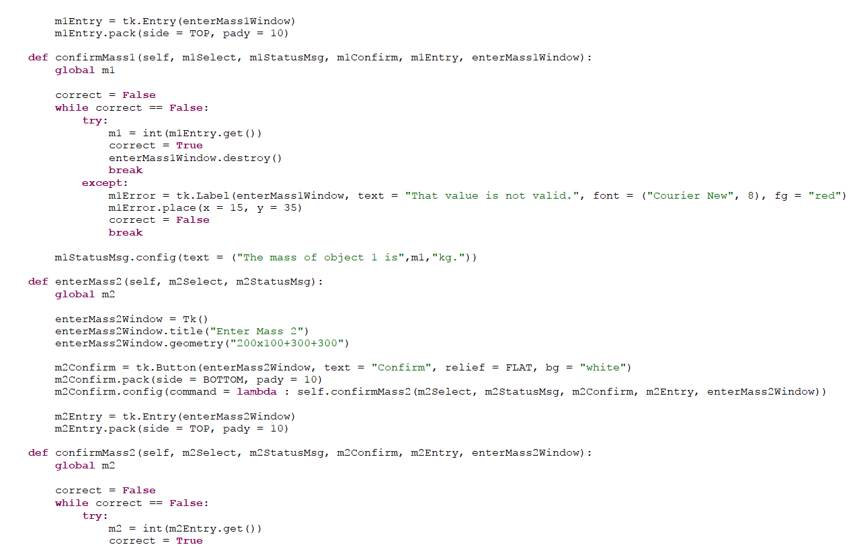

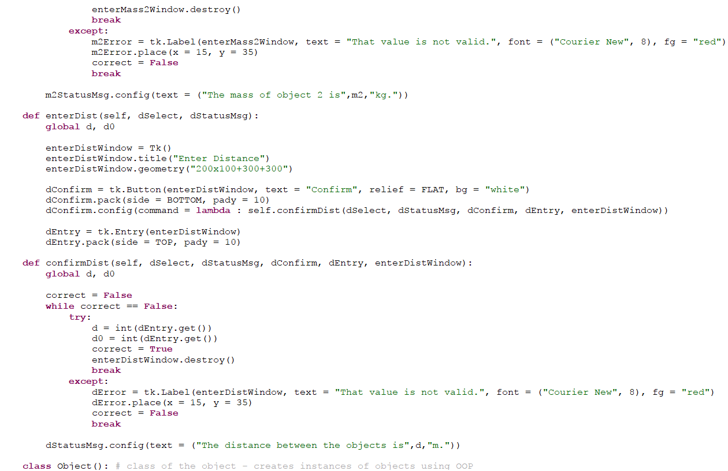

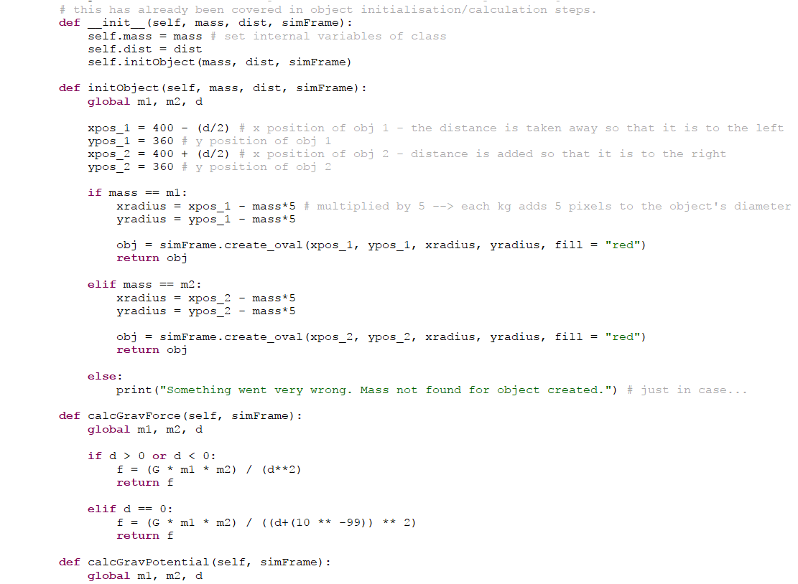

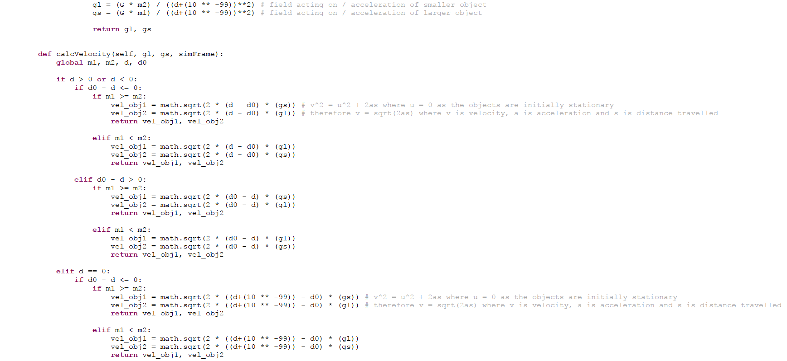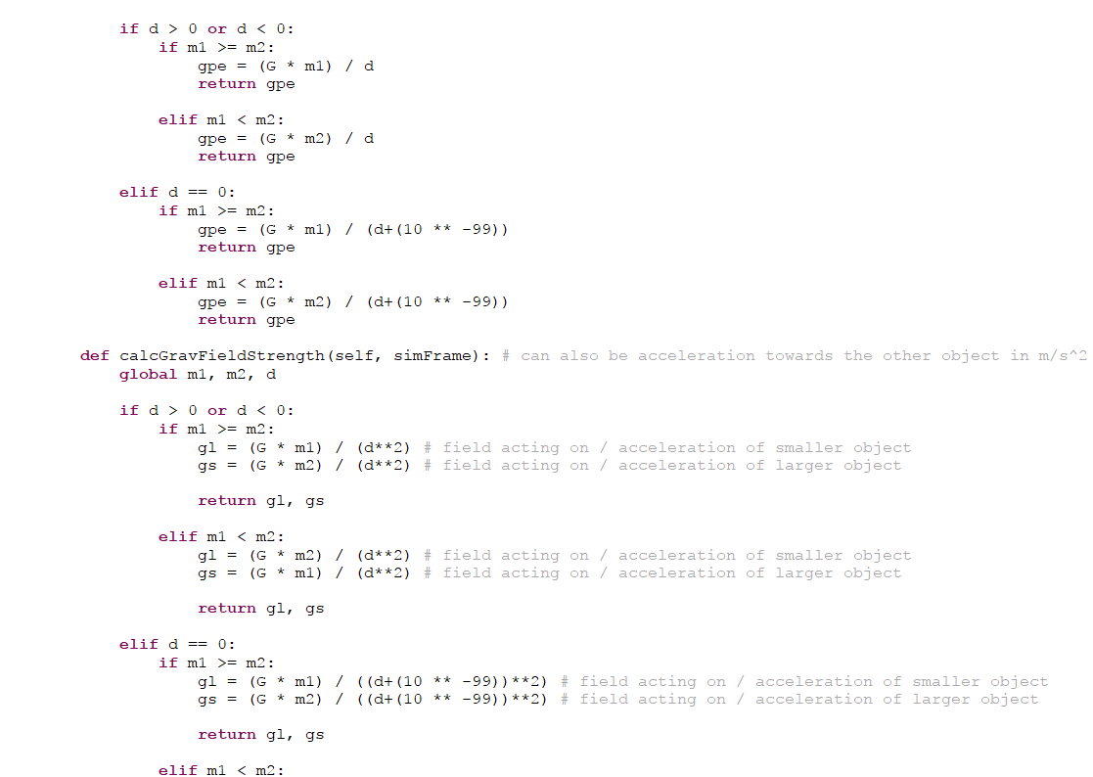

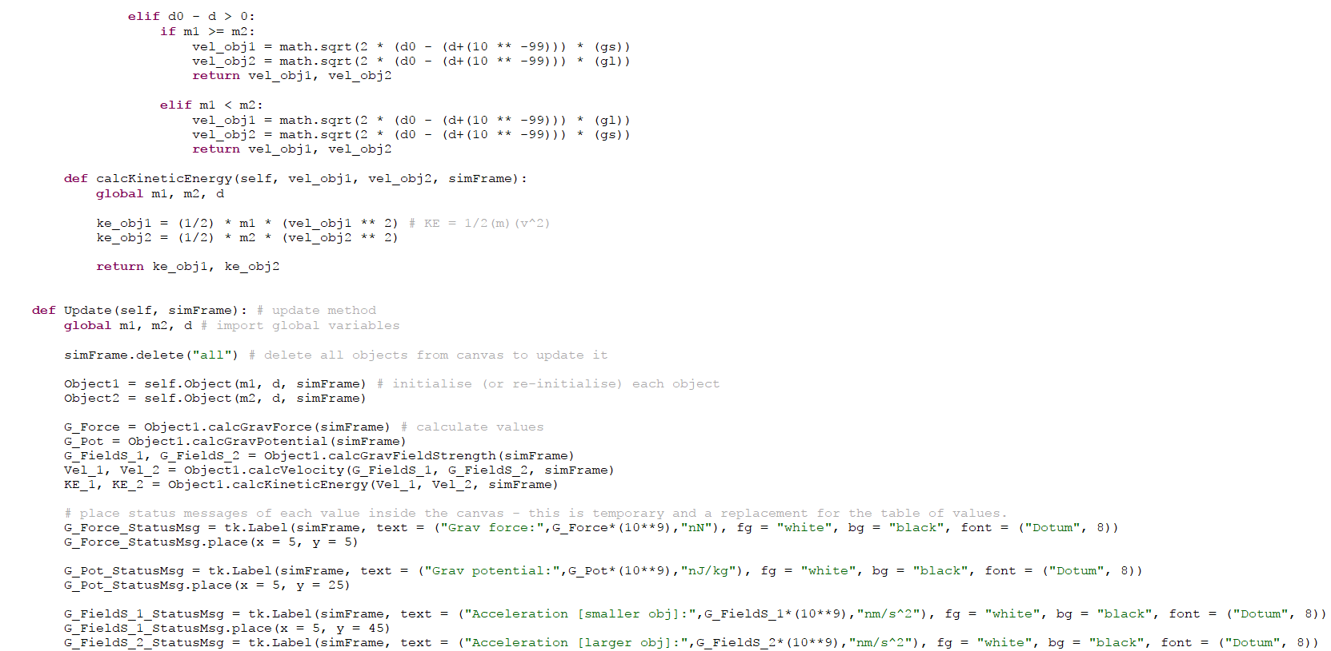

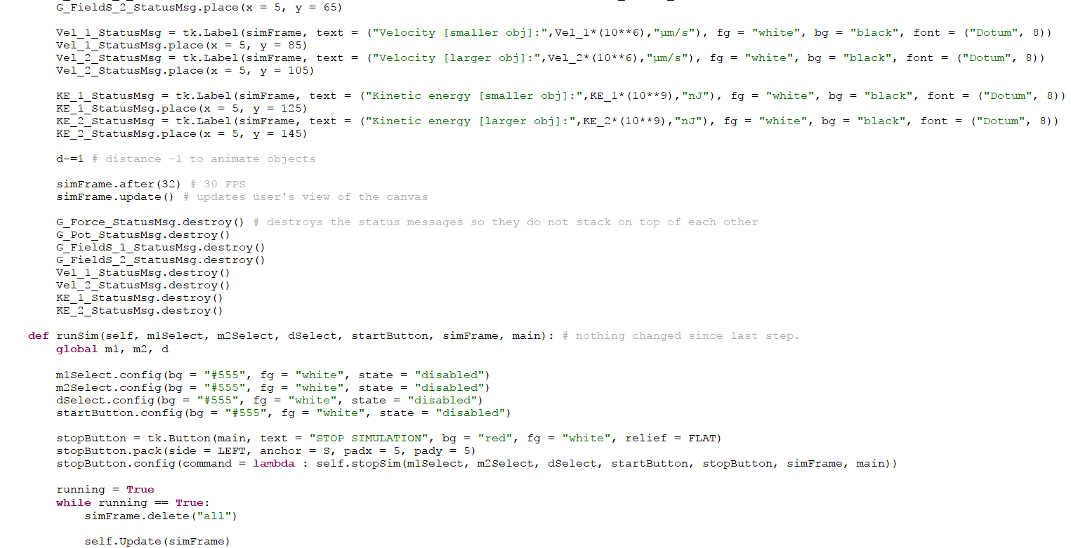

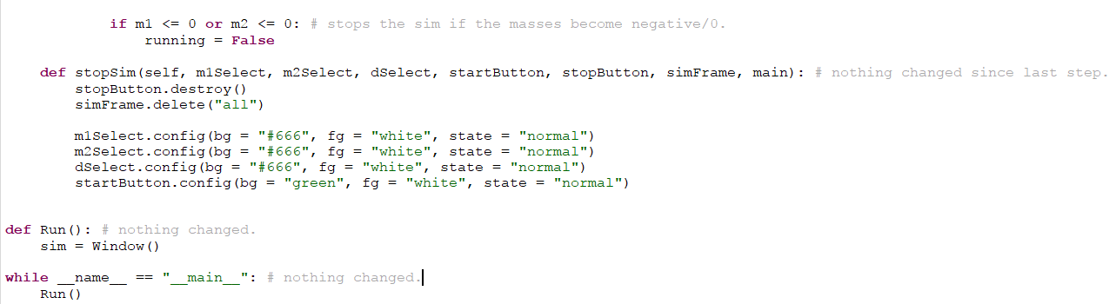

The main focus of this step in the code was the Update subroutine – this subroutine is the method inside the window class that will allow me to animate the objects by moving them every frame. In order to do this, I have set up some Tkinter-specific commands that work with the canvas inside the main window to update it every frame. The first of these commands is the *canvas.after()* command. This command tells the simulation how long to wait between the updating of the canvas at each frame. The parameter in brackets is required to be an integer value which signifies the number of milliseconds that the program waits. For example, I can set the value inside the parameter brackets of the command to 32 milliseconds – this signifies that the simulation will run at approximately 30 frames per second.

The second command that is used in the Update method of the window class is the *canvas.update()* command. This command simply tells the program to update the canvas and display on the screen to the user the current state of the canvas. If this command is not used, then the canvas on the screen will not update and the user will not see any change in the object’s positions on the screen even though technically their positions are updating on the canvas, they are just not being sent to the graphical user interface.

In order to animate the objects, I have simply amended the Update method inside the window class so that the distance decreases by 1 each frame. This will allow me to see if the objects are effectively animated or not. I do, however, plan on adding the ability for the user to select how these values will change and how the objects will move in the form of a scenario selection system in the future. I have also added a system which creates status messages inside the Update method which are displayed in white text on the black background of the canvas. This is just a temporary placeholder for the table of values and allows me to see the values updating more easily without looking at the shell.

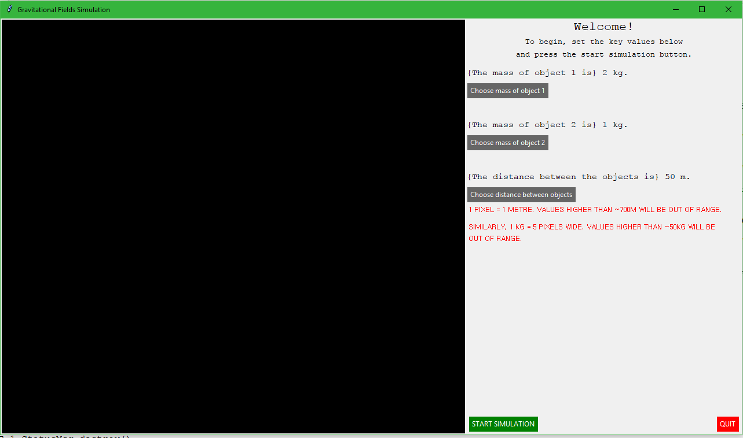The initial graphical user interface before the simulation is run is shown in the screenshot below:

This is the same as the last step of the worked solution and therefore I will not be covering it.

The initial view of the simulation when it is started can be seen below:

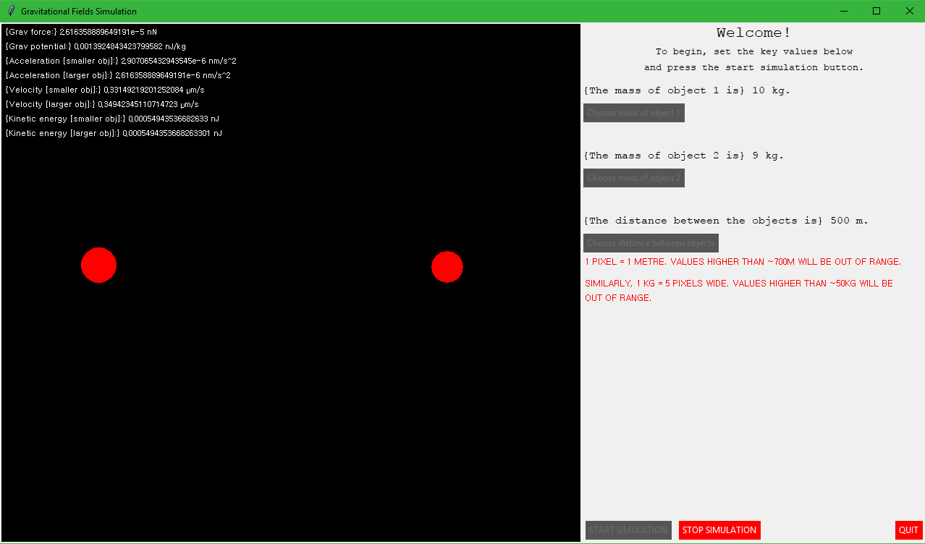

The view after a couple hundred frames can be seen below:

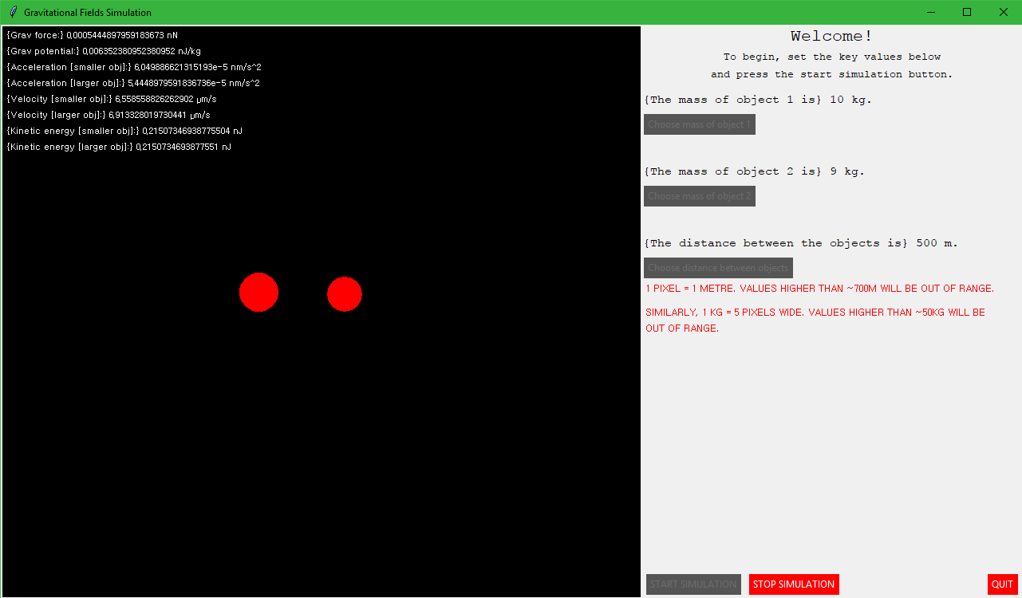

As can be seen, the objects are moving towards each other and are updating by moving 1 pixel inwards each frame. I plan to have video evidence of this in the testing section of my project. As is evident, my code that I have implemented has successfully allowed the objects to be animated by changing certain values.

*Pre-set Scenarios*

The final integral part of my simulation is the implementation of the ability for the user to change the way the simulation will progress once they press the start simulation button and the simulation starts.

When the user presses the start simulation button, I plan to change the command method of the button to a method which opens another new window before starting the simulation. This simulation will contain a menu of selection option and a confirm button. The user can then select a scenario that they would like to see when the simulation is running and then press the confirm button. Instead of the start simulation button, the confirm button will have its command method set to the runSim method. This means that the simulation will only start once the user presses the confirm button.

The scenarios that I plan on implementing as an option for the user to select at the start of the simulation are as follows:

* Take away 1 from distance each frame
* Add 1 to distance each frame
* Add 1 to mass1 each frame
* Add 1 to mass2 each frame
* Add 1 to mass1 and take away 1 from mass2 each frame
* Add 1 to both masses each frame
* Add 1 to masses and take away 1 from distance each frame
* Subtract 1 from masses and add 1 to distance each frame
* Add 2 to masses each frame
* Take away 2 from masses each frame
* Add 2 to distance each frame
* Take away 2 from distance each frame

These scenarios give me the most variety in the possible change of value that can happen throughout the course of the simulation. This allows the end user to show the most variation possible on what can happen when certain things are changed, leading to a greater overall understanding of the theory of the physics topic of gravitational fields by the physics students.

The code that I have implemented in order to achieve this aspect of the development can be seen below:

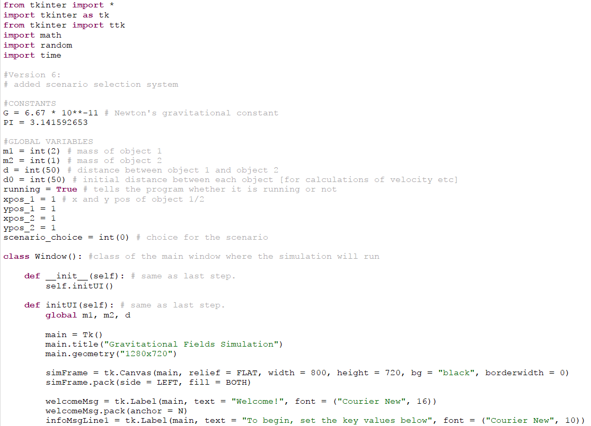

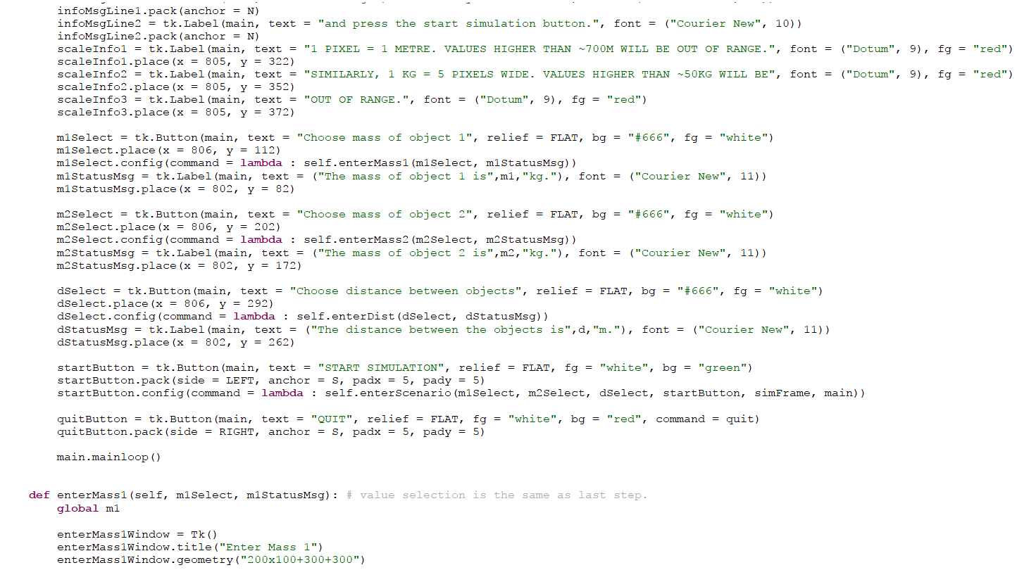

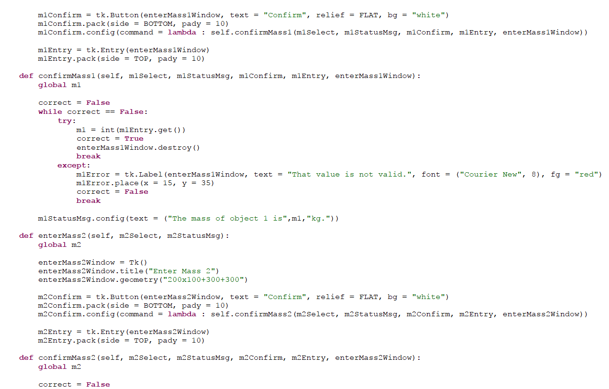

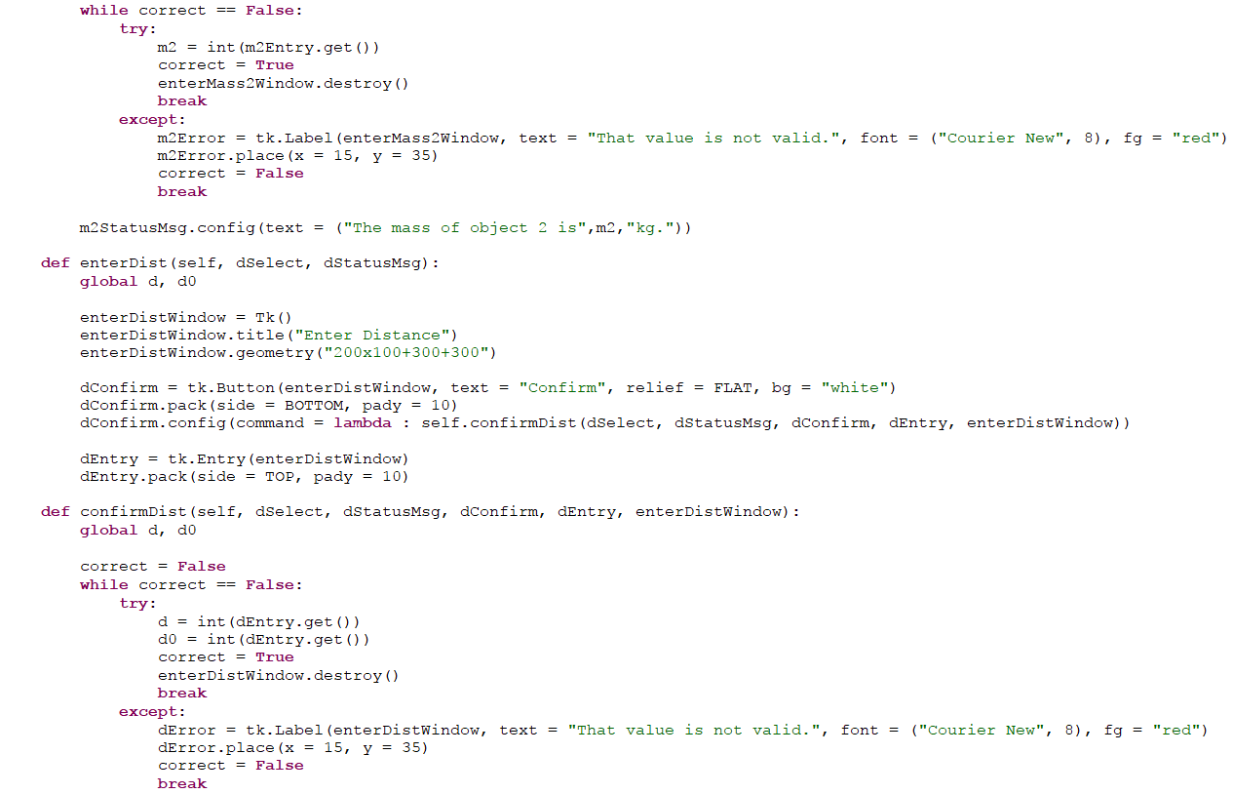

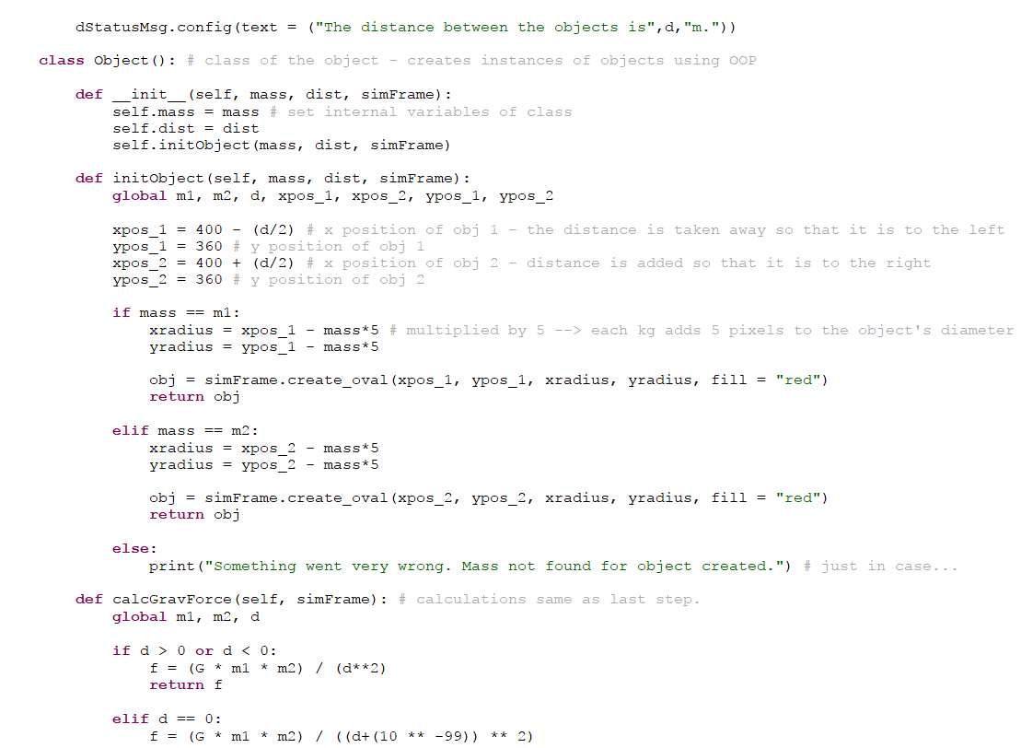

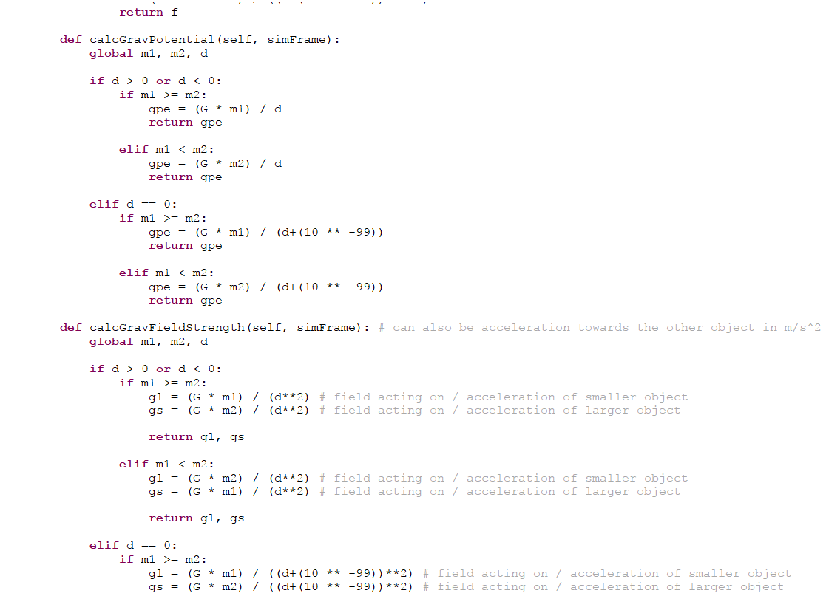

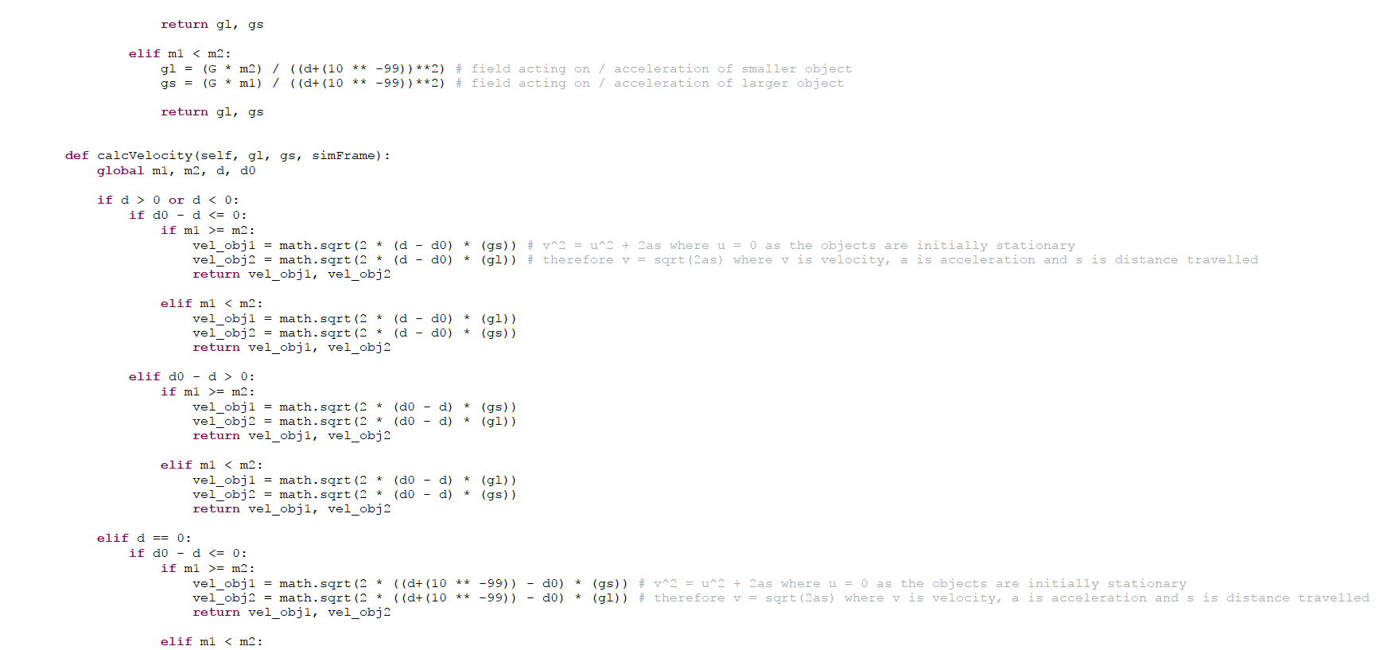

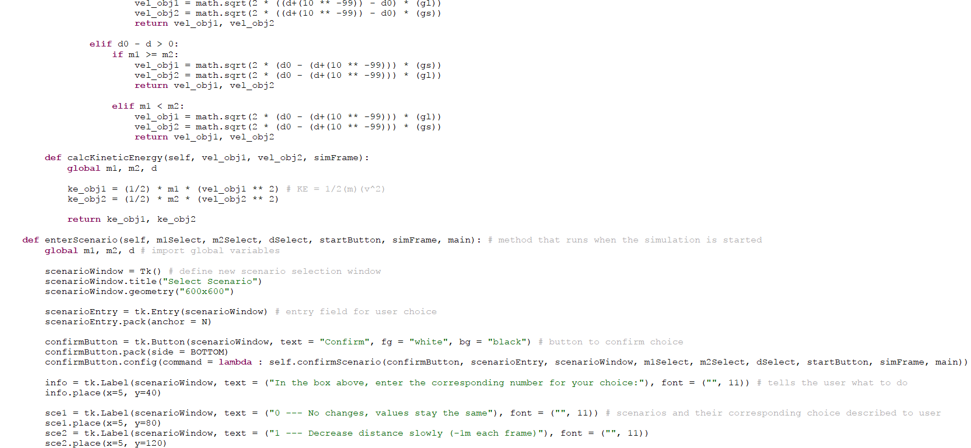

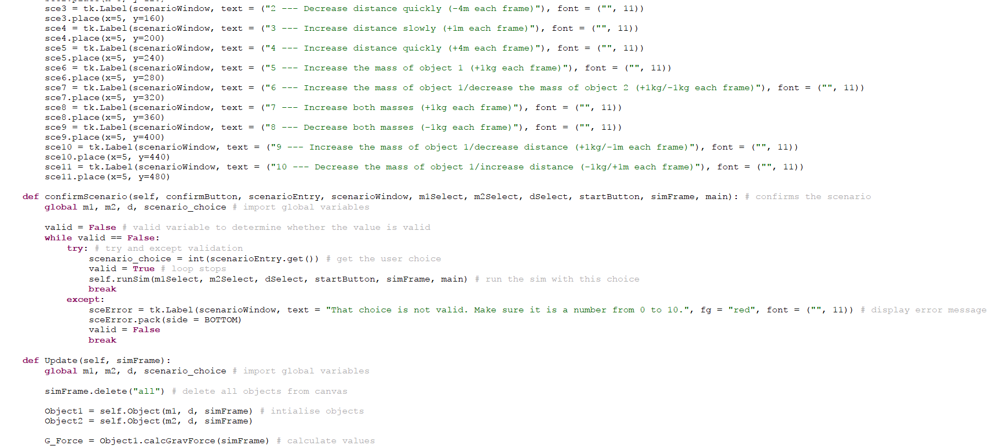

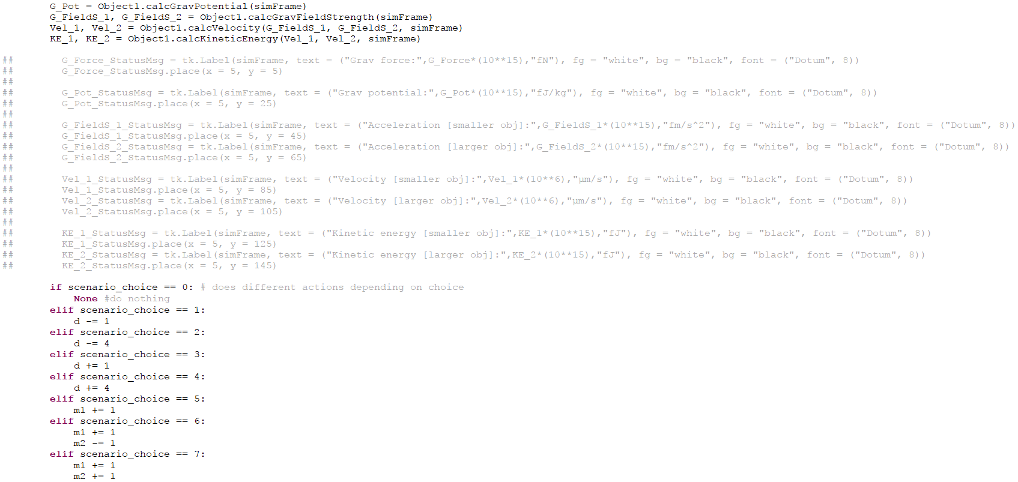

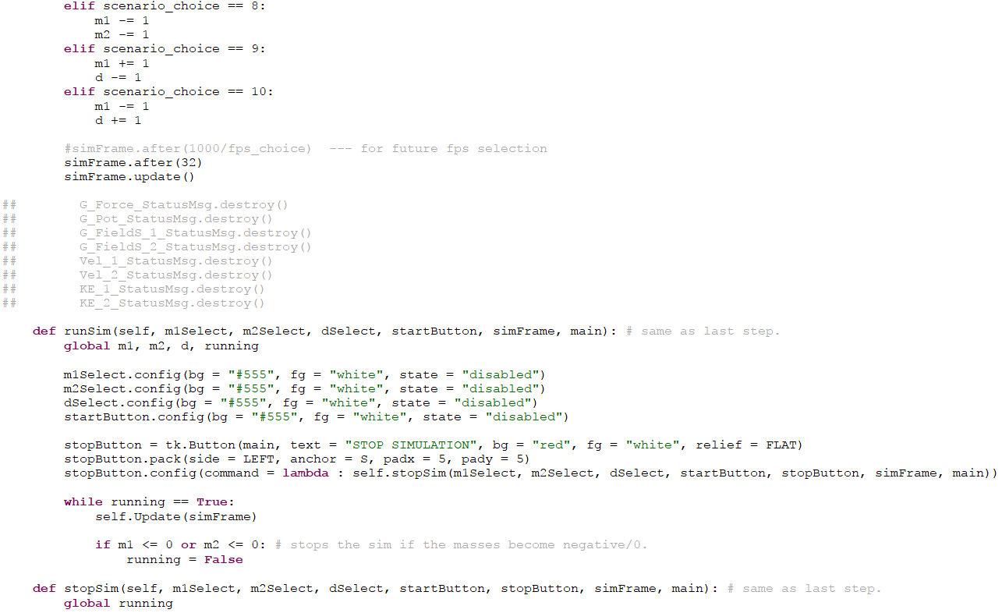

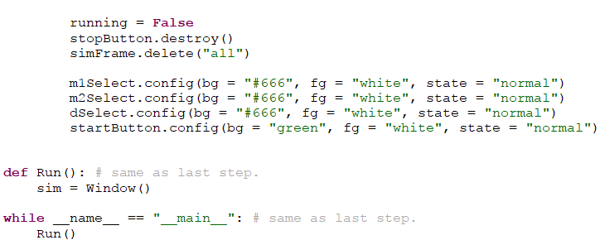

The window that opens when the start simulation button is pressed is shown in the screenshot below:

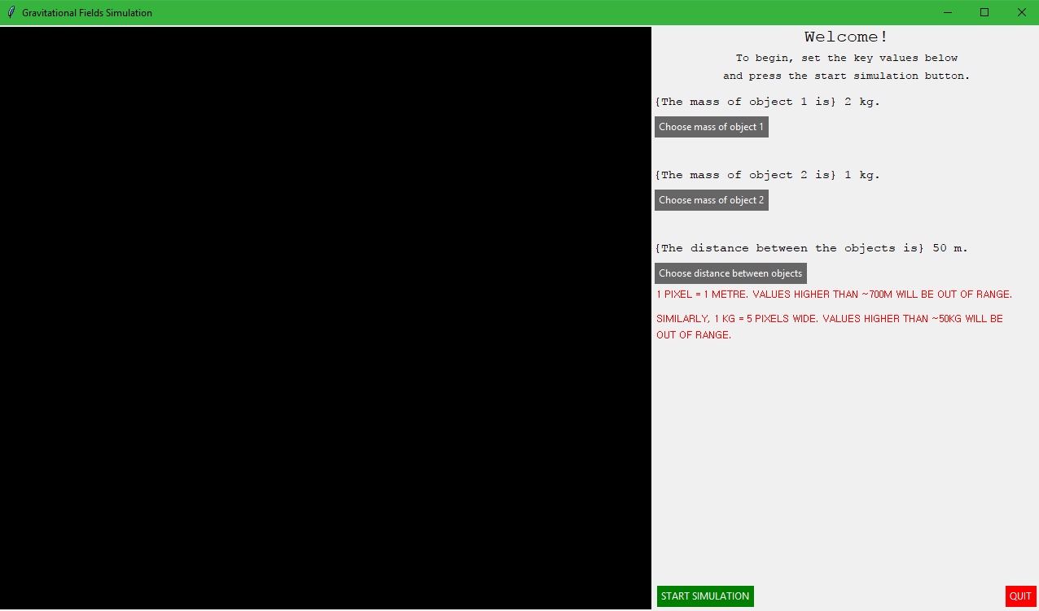

This is the same as the last step and therefore I will not be covering any extra features as there are none.

When the start simulation button is pressed, the scenario selection window opens which gives the user the option of choosing from 10 different scenarios:

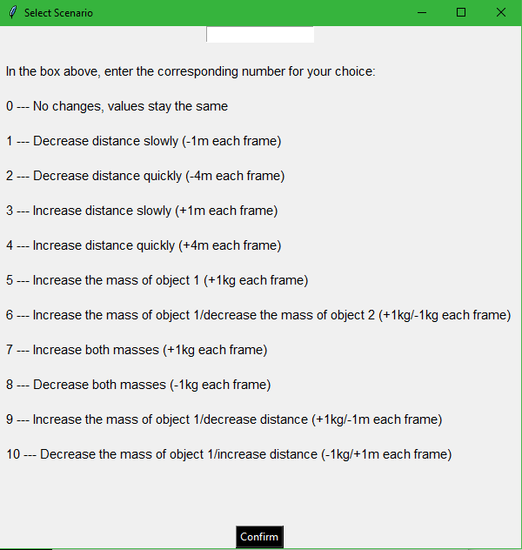

These scenarios provide the greatest variety of the change in values when the simulation is running and therefore will provide greater understanding and assistance to the end user. When the user enters the corresponding number for their desired scenario, the program will perform the corresponding action each frame in order to animate the objects and also change the values when the objects are moving. This will be proven in the testing stage of my project.

*Addition of Final/Extra Features*

Allowing the user to choose the FPS

This feature will allow the user to choose the value for the frames per second that the simulation will run at. For example, if the user enters 15 as their value, then the simulation will run at 15 frames per second, updating and redrawing the objects 15 times every second.

The code that I have implemented in order to allow the end user to select a value for the frames per second of the simulation can be seen below:

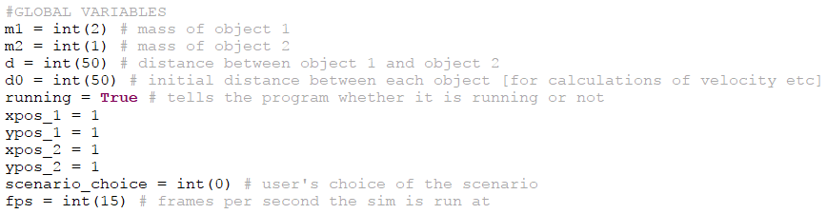Global variable for the user choice:

Amended Update method:

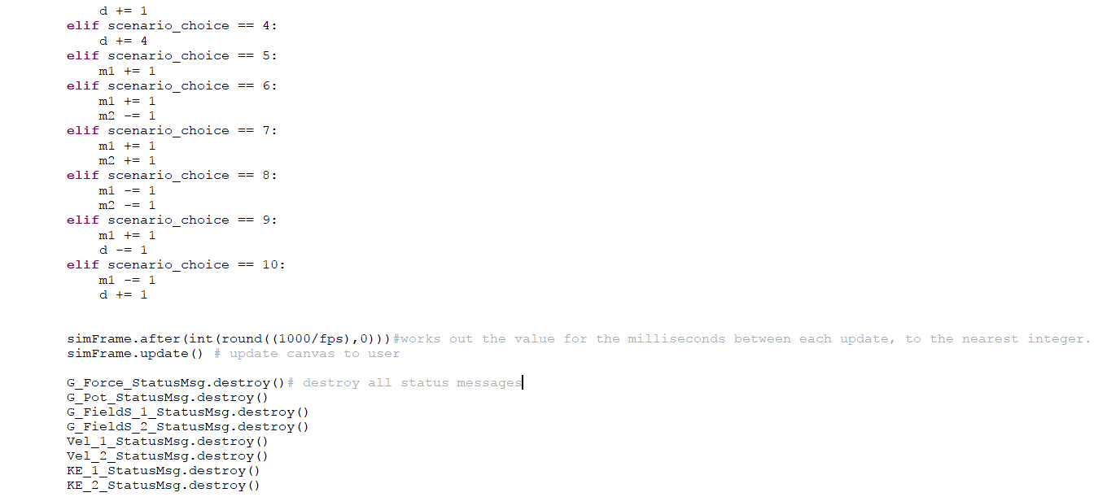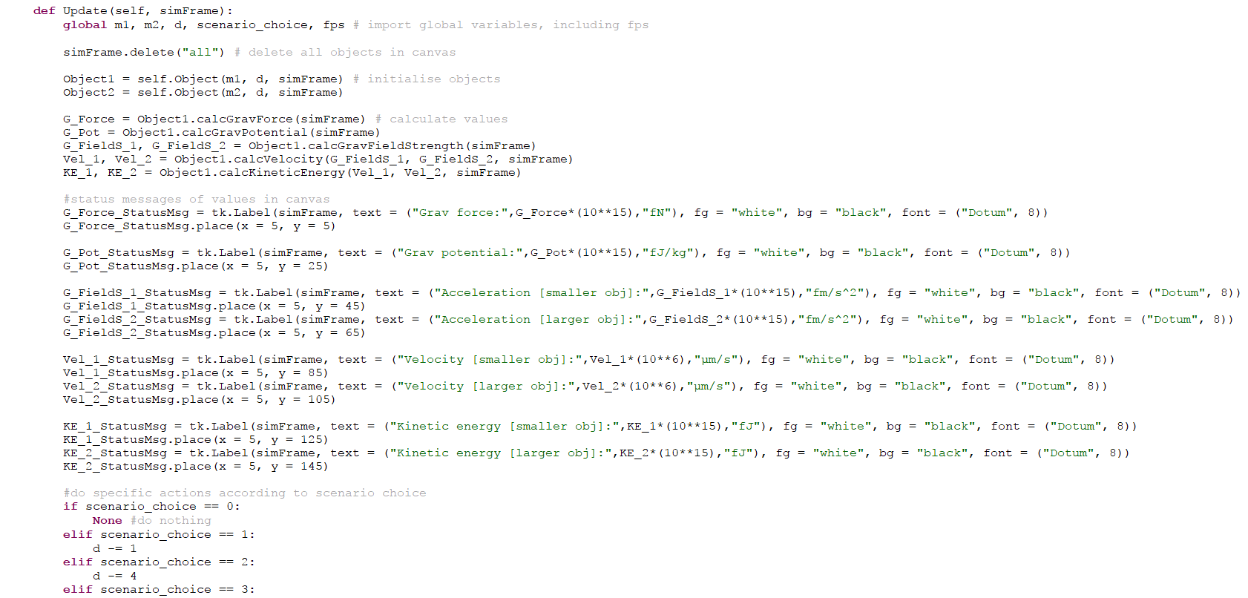

In this code, I have added a global variable (*fps*) which is what the user’s choice is stored under when they choose a value for the frames per second. I have also amended the Update method inside the window class so that the value for the frames per second in milliseconds between each update is calculated from the user’s choice and used as the parameter for the *.after()* command. In order to calculate the value for the frames per second in milliseconds between each update, I have to use the *round()* command that is built into Python. This command tells the program to round the value that is calculated to a given number of decimal places. This number of decimal places is defined within the parameter brackets of the command and is separated by a comma from the value that is being calculated.

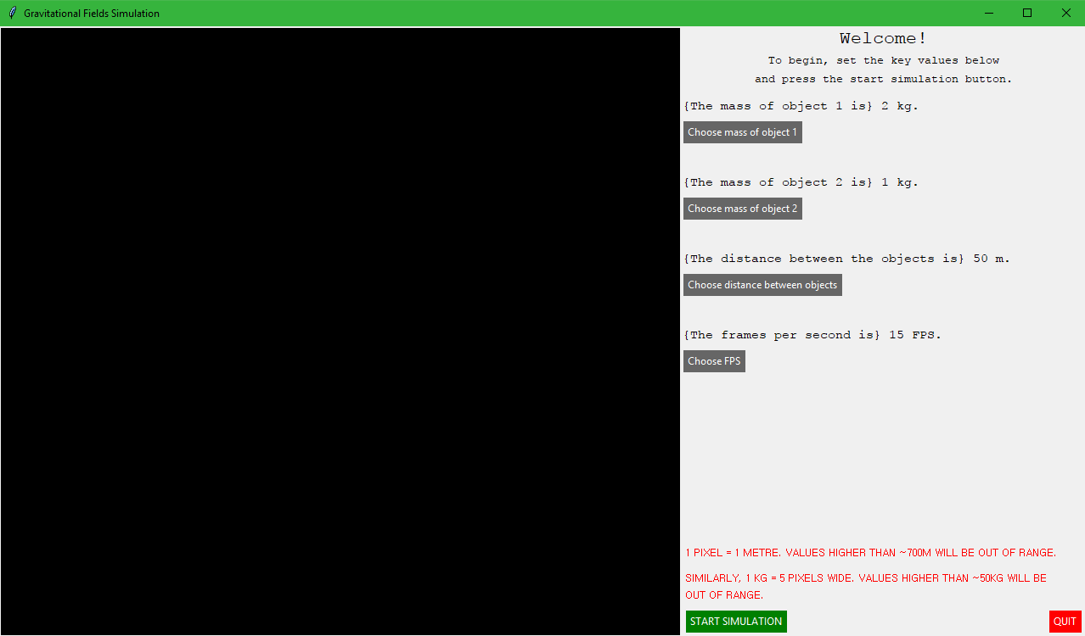The graphical user interface which opens when the program is run can be seen below:

As can be seen, the select FPS button has been added underneath the other value selection buttons, along with the corresponding status message for the user-selected value of the frames per second above the button. When the user presses this button, the following window opens:

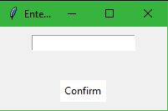

This window is identical to the previous value selection windows and has the same function with the same error message when an invalid value is entered. The value that is entered into this value selection field is assigned to the global variable for the user FPS choice, and is then used in the Update command to calculate the number of milliseconds between each update.

Pre-set simulation values

In order to accomplish the implementation of this feature, I will first have to define some pre-set values for the user selectable variables in the form of global constants at the top of the program. These global constants are defined in Python by convention using an all-capital letters word. Such an example of this would be “TENNISBALL_MASS”. A constant indicates a variable that will not change no matter how the rest of the program changes, and therefore can be kept as constant. The values (and therefore pre-set options) that I am going to enable the user to use are as follows:

* Two bowling balls
* One boulder and one bowling ball
* Two boulders

I believe that these pre-sets will provide the largest range of values produced and this will therefore give the students of the end user a better understanding of how the difference in values affects other values in the physics topic of gravitational fields.

The code which I have implemented in order to allow for pre-set simulation values to be selected by the user can be seen below:

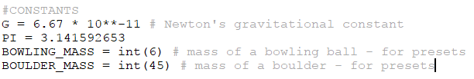Global constants:

Amended initUI method:

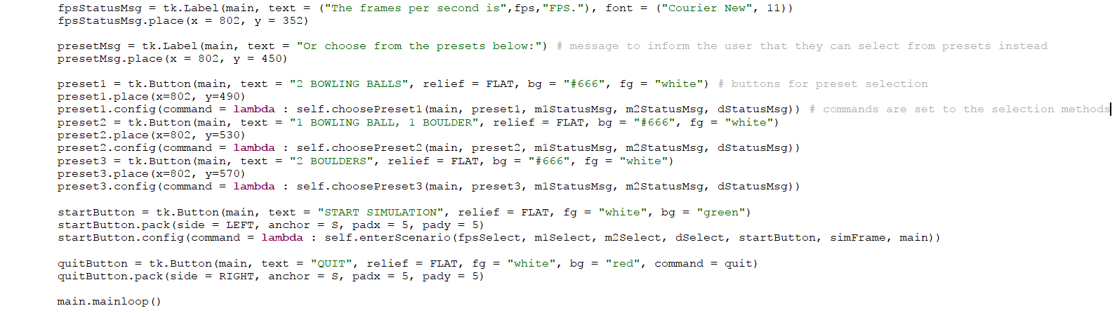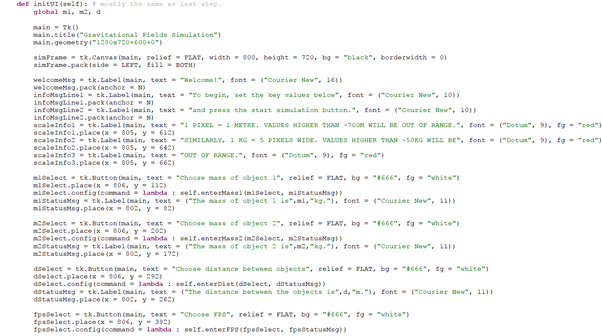

Selection methods:

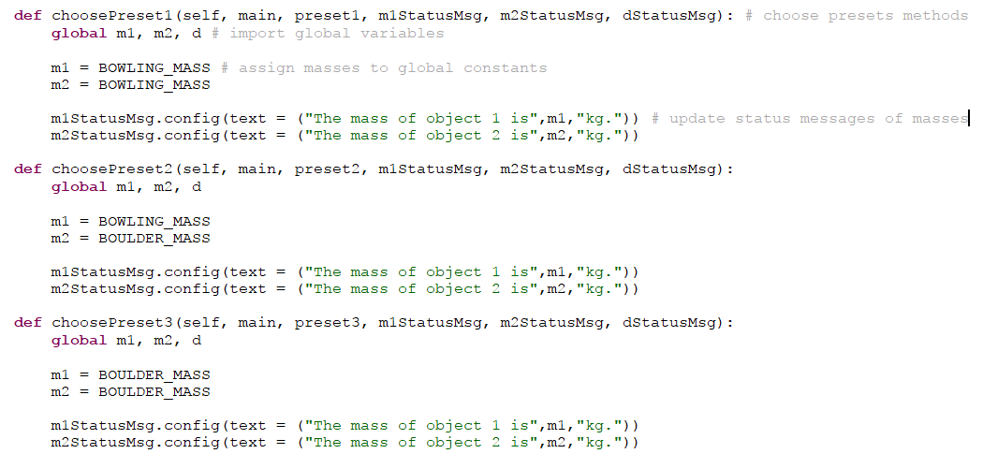

The first thing that I have done in this code is assigned some new global constants. These two constants are values for the mass of a bowling ball and the mass of a boulder respectively. These will be used when the user selects a specific pre-set – the values will update for the global variables for mass and the status messages will be updated. This is what the choosePreset methods do inside the window class when the user presses one of the pre-set selection buttons.

Inside the initUI method, I have defined the three pre-set selection buttons and an information message which informs the user that they can also choose a pre-set instead of setting their own values. These buttons, when pressed, update the values for the global variables for the masses of the two objects. They also update the status messages of each object in the main window.

The graphical user interface which opens when this program is run can be seen below:

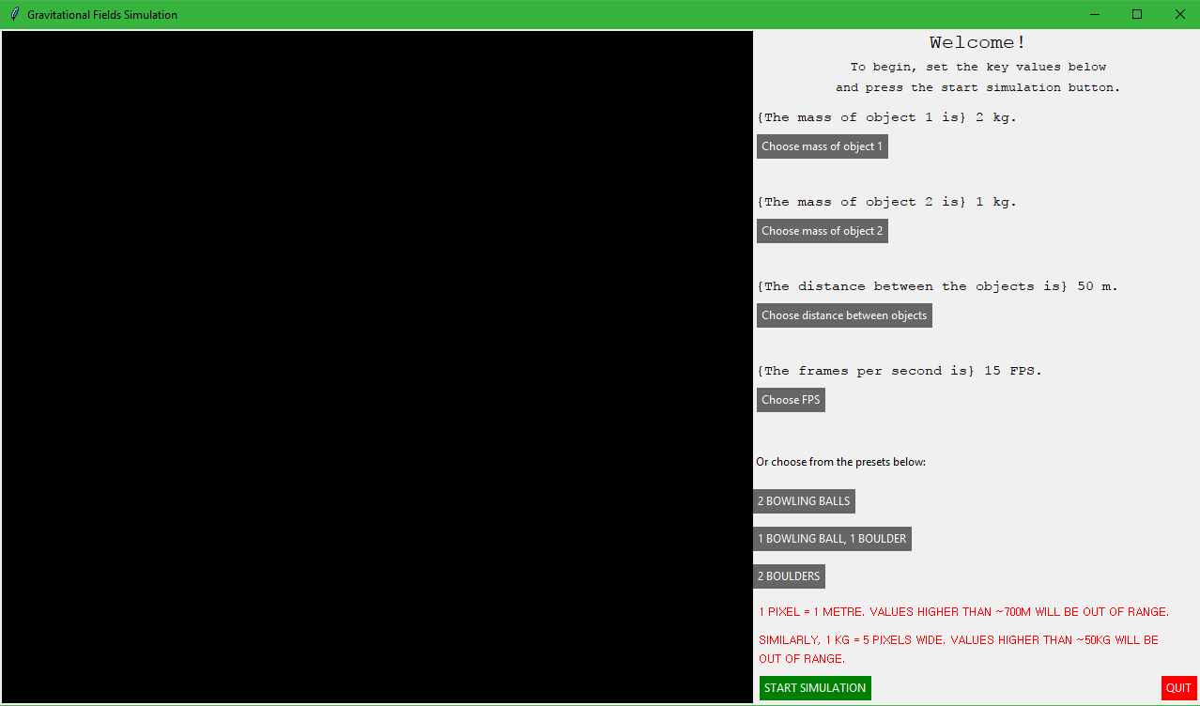As can be seen, the three pre-set simulation selection buttons have been initialised successfully below the other value selection buttons and the information message for the user has also been initialised successfully.

The values changed when the first pre-set button is pressed can be seen below:

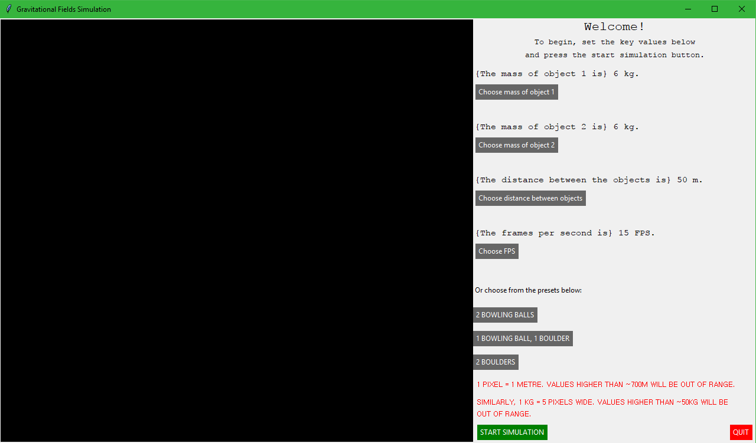

The values changed when the second pre-set button is pressed can be seen below:

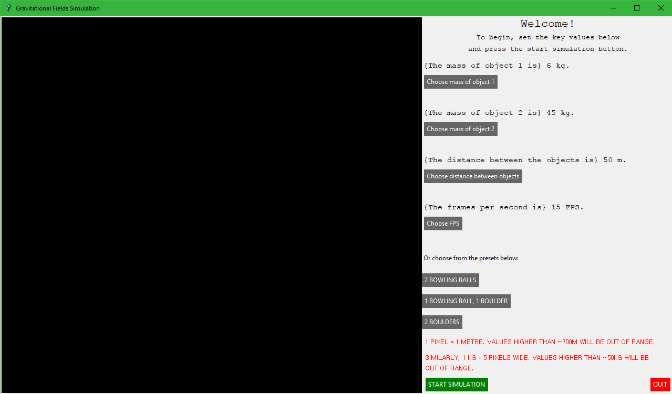

The values changed when the third pre-set button is pressed can be seen below:

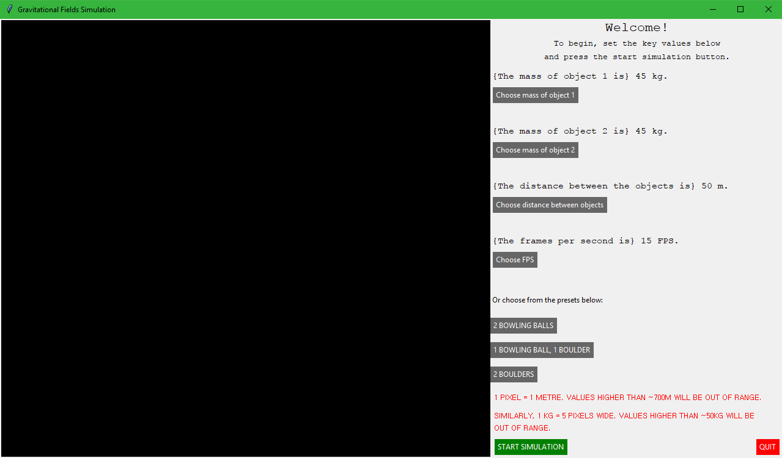

As is seen, all three buttons work correctly when pressed and update the values for the masses to the global constants accordingly.

Table of values

This feature requires the use of a new method inside the window class which will contain separate code that will initialise a new window and place the table of values inside this window. In order to initialise this table of values, I will have to use the Tkinter label widgets that will allow me to place alphanumeric text onto the window. These labels will allow me to show the user which values they are looking at as they change over time.

The implemented code that I have created in order to accomplish the implementation of this feature can be seen below:

Global variables:

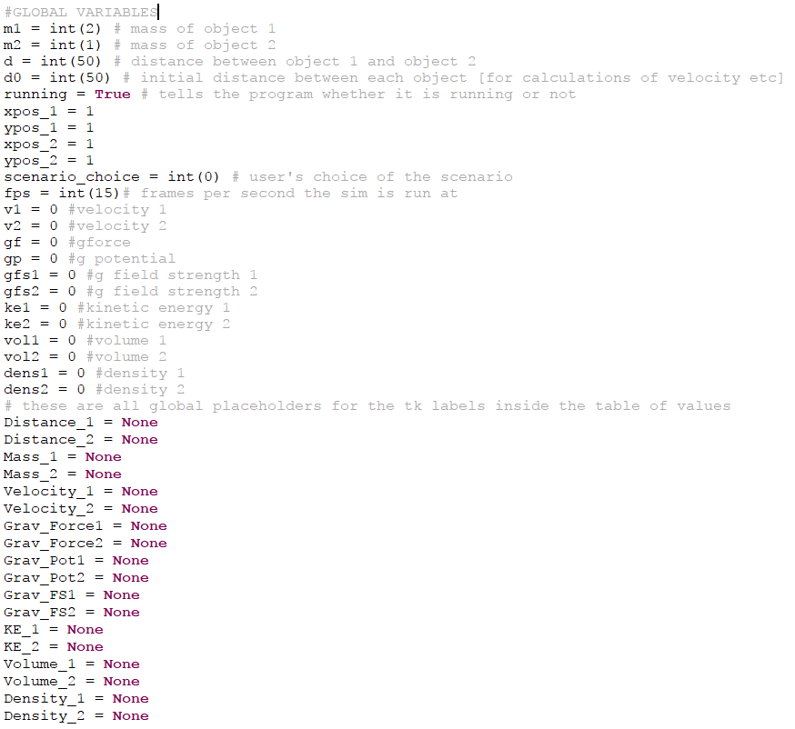

Create table of values method:

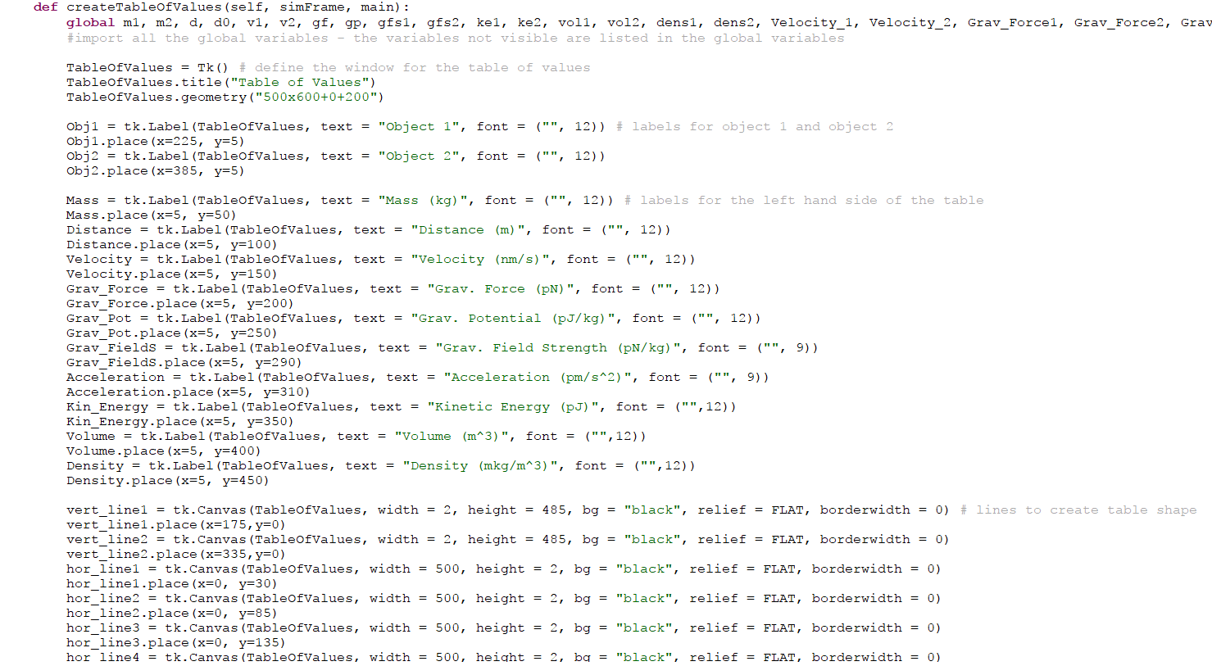

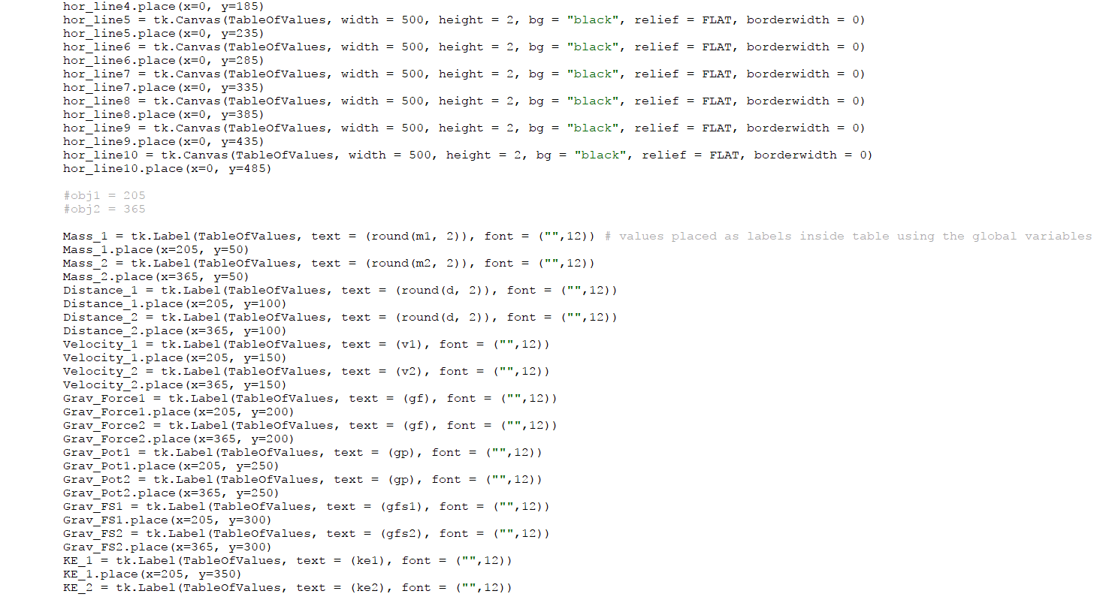

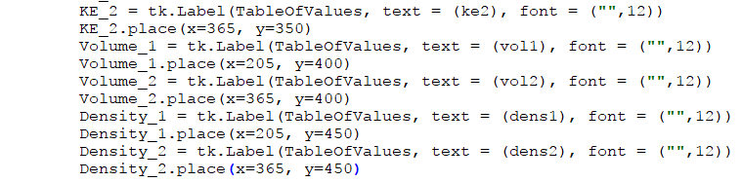

Update method:

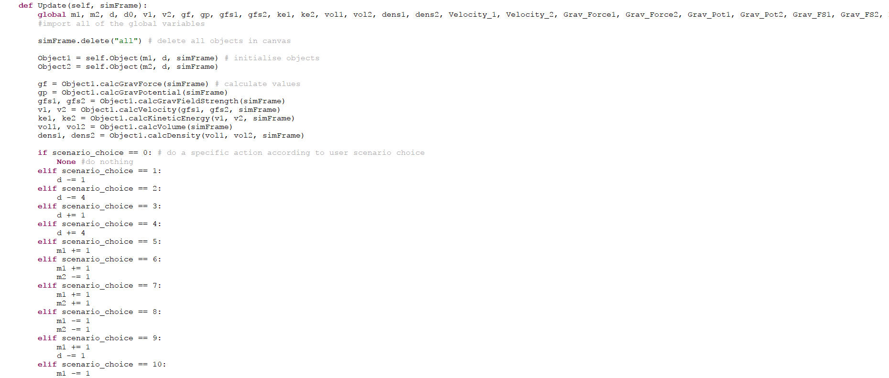

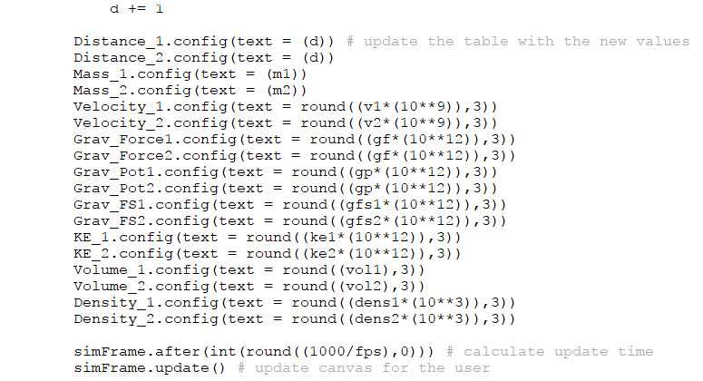

In this code, I have created a new method inside the window class which creates a new window when it is called. This new window contains the table of values in an organised fashion, using canvases as the lines separating the values. This method of creating lines is highly unconventional; however, I found it to be the easiest method to use as I simply had to define the length and width of each canvas as the length and width of each line. Therefore, I could make the canvases and therefore the lines two pixels wide. The table of values contains all values that are calculated with each update inside the Update method. The window which hosts the table of values contains many label widgets as this is the widget that will be updated for each value when the values are updated each frame.

In order to get the values to update in the table of values, after much trial and error, I have decided to define each Tkinter label widget for the values as a global variable which is initialised at the start of the program. These global variables will be given the value of *None* (the default “ground state” of a variable, effectively null) until it is needed in the method that creates the table of values window. This was done due to previous problems that I had with the variables not being recognised between methods within the window class, and this fixed those problems. I do, of course, have to call these variables as global variables in the Update and table of values methods now.

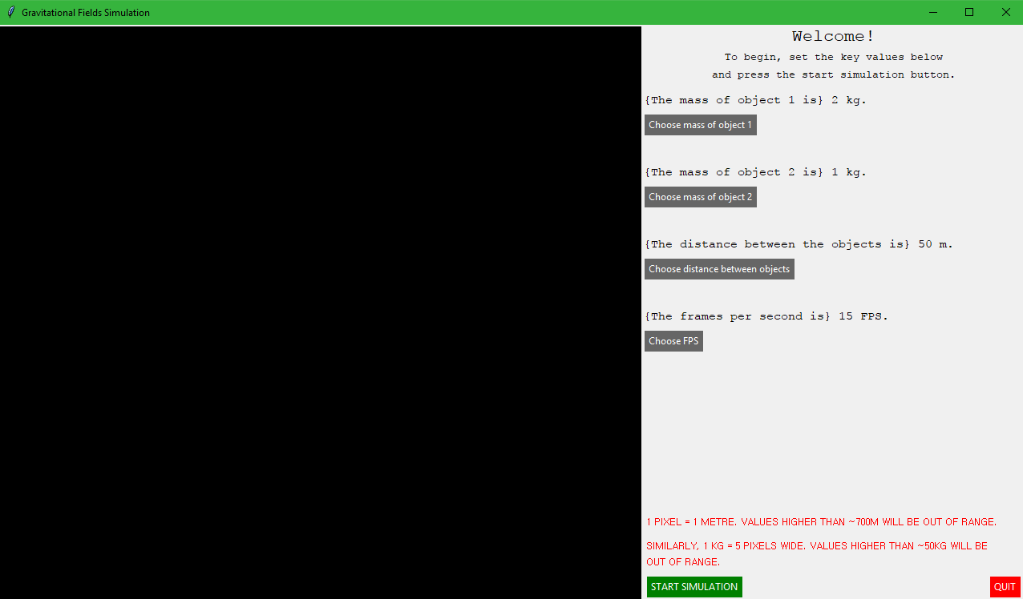The graphical user interface that is initialised when the program is run can be seen below:

This is the same as the last step of the worked solution and therefore I will not be covering it (this was done before the implementation of pre-set simulations).

The table of values window which opens when the program is run can be seen in the screenshot below:

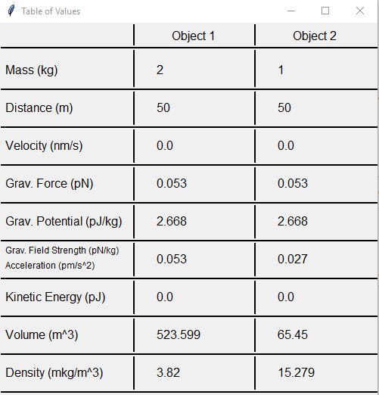As can be seen, the table of values has been initialised successfully and the values are all displayed correctly. I plan on showing these values changing in the video evidence of the testing section of the project.

Calculation of density

The accepted equation that is used in most of physics to calculate the density of an object is as follows:

$$p=\frac{m}{v}$$

Where *p* is the density of the object; *m* is the mass of the object and *v* is the three-dimensional volume of the object. The fact that the volume is required to be three-dimensional and the objects that I have defined in my program are two-dimensional seemed like a major problem at first, but after looking at the equation for the volume of a sphere, it has become evident that I can easily calculate a rough estimation of the volume of a sphere of a certain mass (and therefore certain radius, as the radius the objects in my simulation are proportional to their mass). This equation for the volume of a sphere is shown below:

$$v= \frac{4}{3}πr^{3}$$

Where *v* is the volume of the sphere; $π$ (pi) is the mathematical constant that is commonly used in the calculation of many values related to circles and spheres, approximately equal to 3.14; and *r* is the radius of the sphere. As can be seen, the only value that is needed aside from pi is the radius of the sphere which can easily be found using the two-dimensional equivalent of the sphere – a circle on the canvas of my main simulation window. Therefore, I can easily calculate the volume of my objects and then the density of my objects using two different methods in the object class that will calculate and return both values. These values will then be displayed in the table of values as they update; however, these values will not need to be updated as it will not change for either object throughout the simulation.

The code that I have implemented into the program in order to achieve the addition of this feature can be seen below:

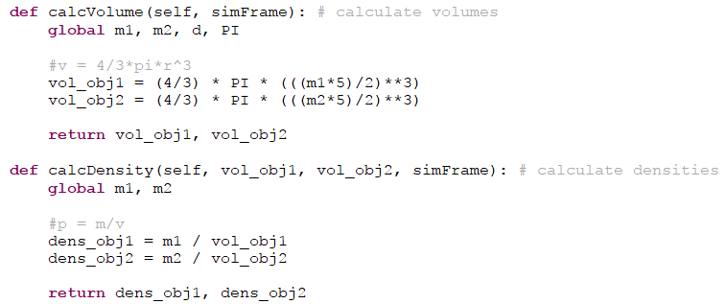Calculation methods:

Update method:

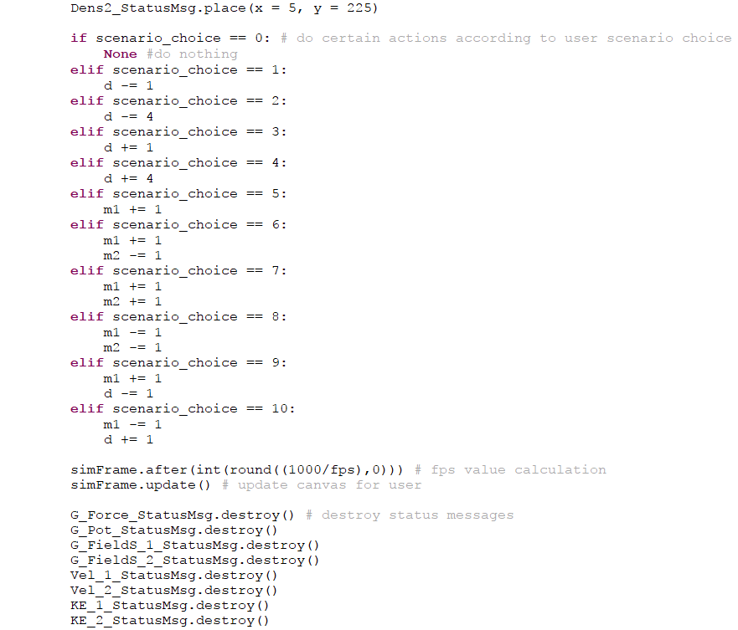 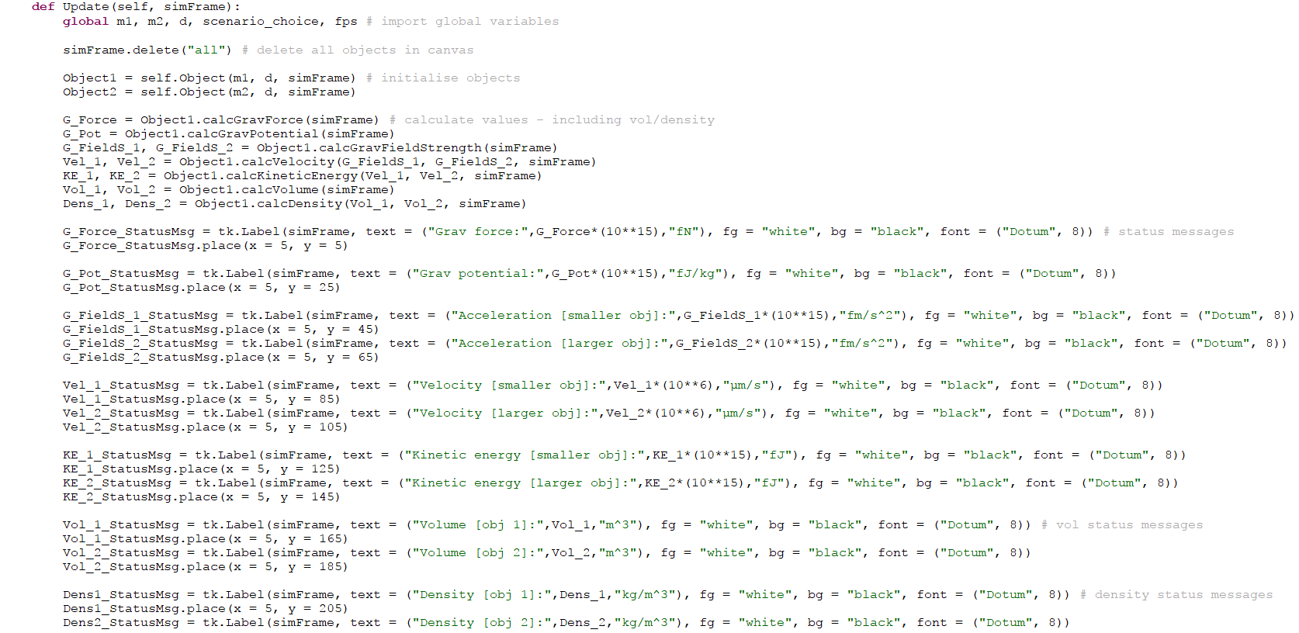

In the object class, I have added two new methods which calculate the volume and density of each object respectively. These methods use the formulae mentioned previously in order to calculate these values, using the mass and volume of each object as well as the global constant that is set for the value of pi. I have also amended the Update method inside the window class so that the methods for calculating the volume and density of each object are called and the values are calculated in each frame; I have also added another four status messages inside the canvas to display the current values as a placeholder for the table of values (this was done before the table of values was implemented).

The graphical user interface which is displayed when this program is run is displayed below:

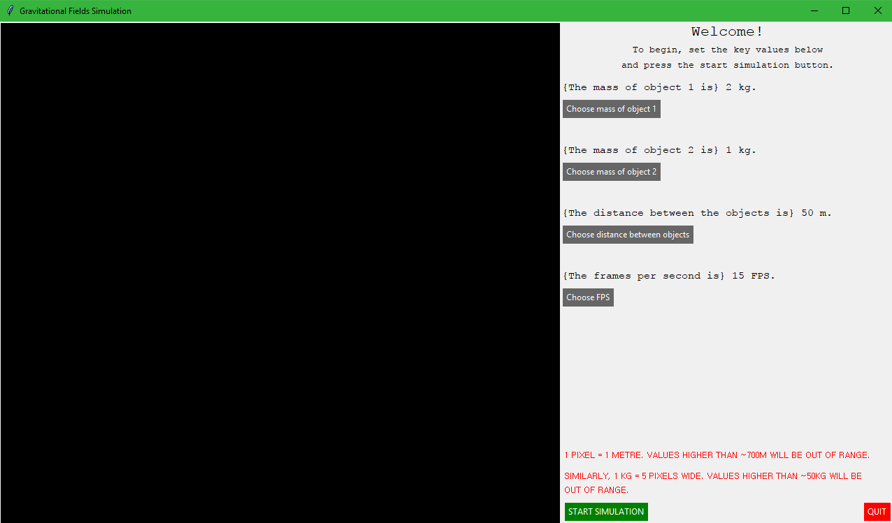This is the same as the last step and therefore I will not be covering it (this was also done before the pre-set simulation selection system was implemented).

The calculation of the value of density when the simulation is running can be seen below for each object:

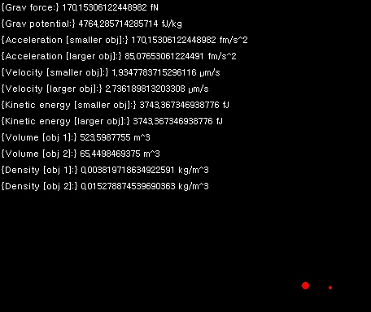As can be seen, the values for volume and density for each object have been calculated and displayed next to the other values successfully.

*Final Code*

The final working code for my project can be seen in the screenshots below.

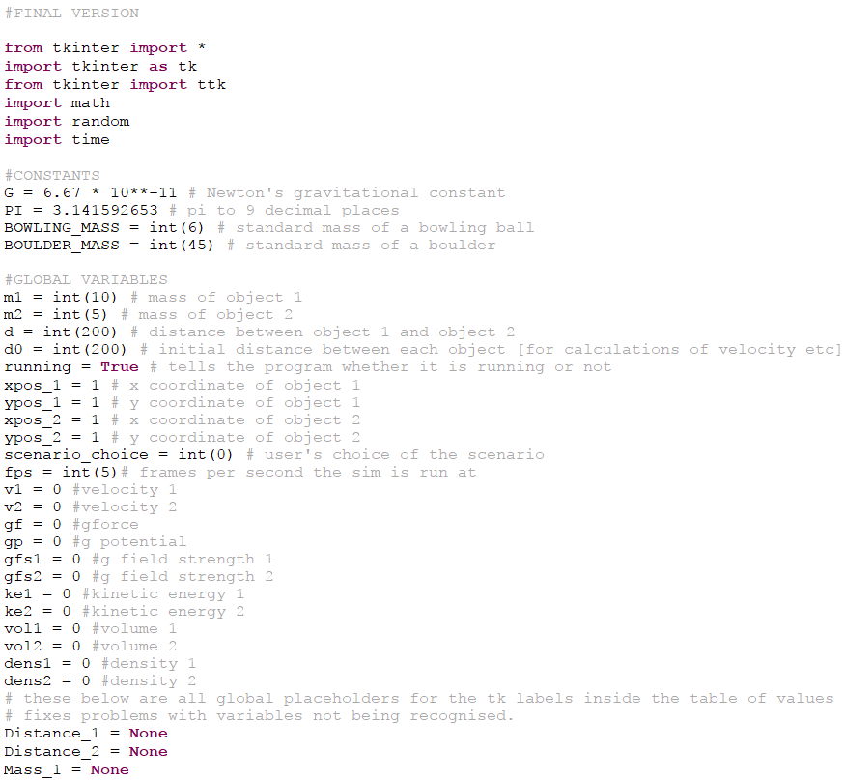

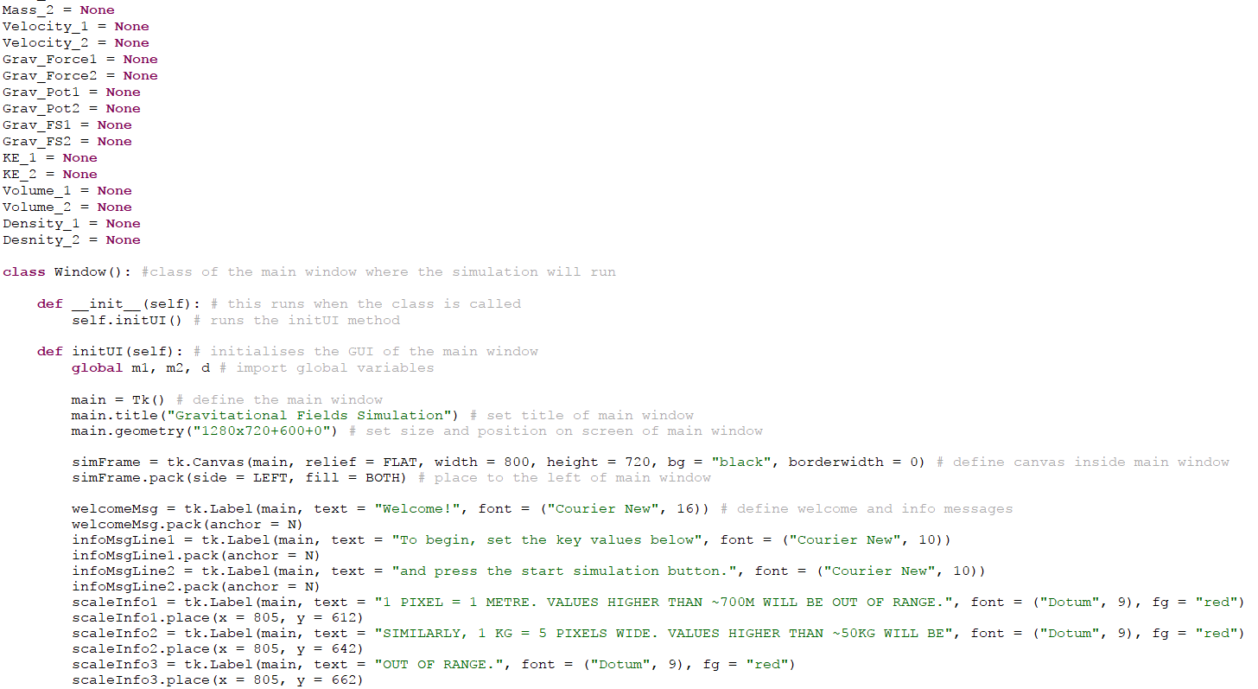

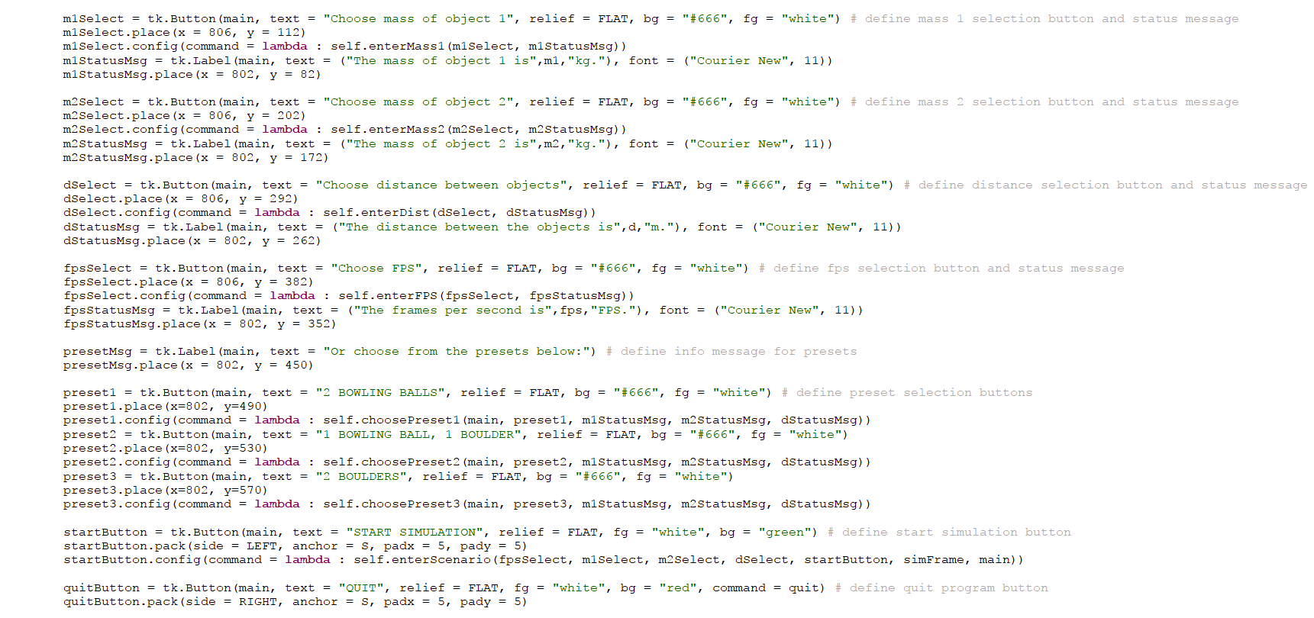

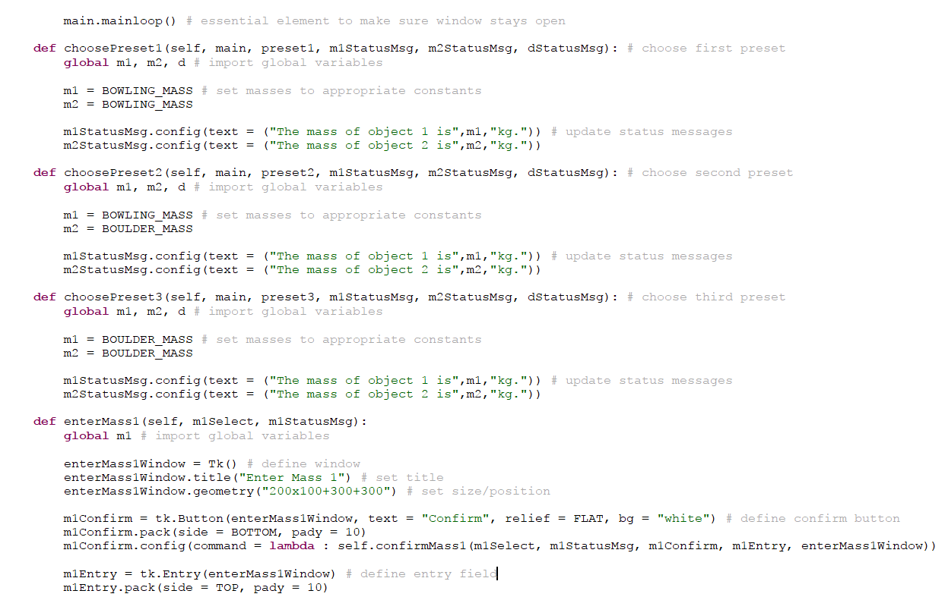

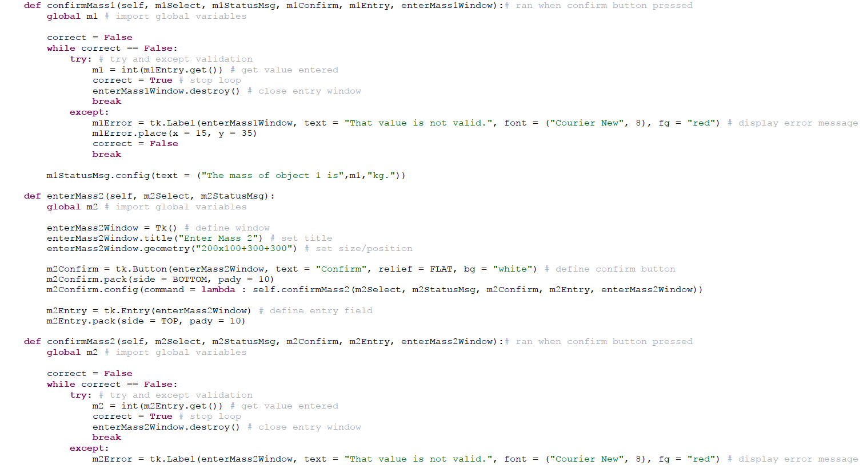

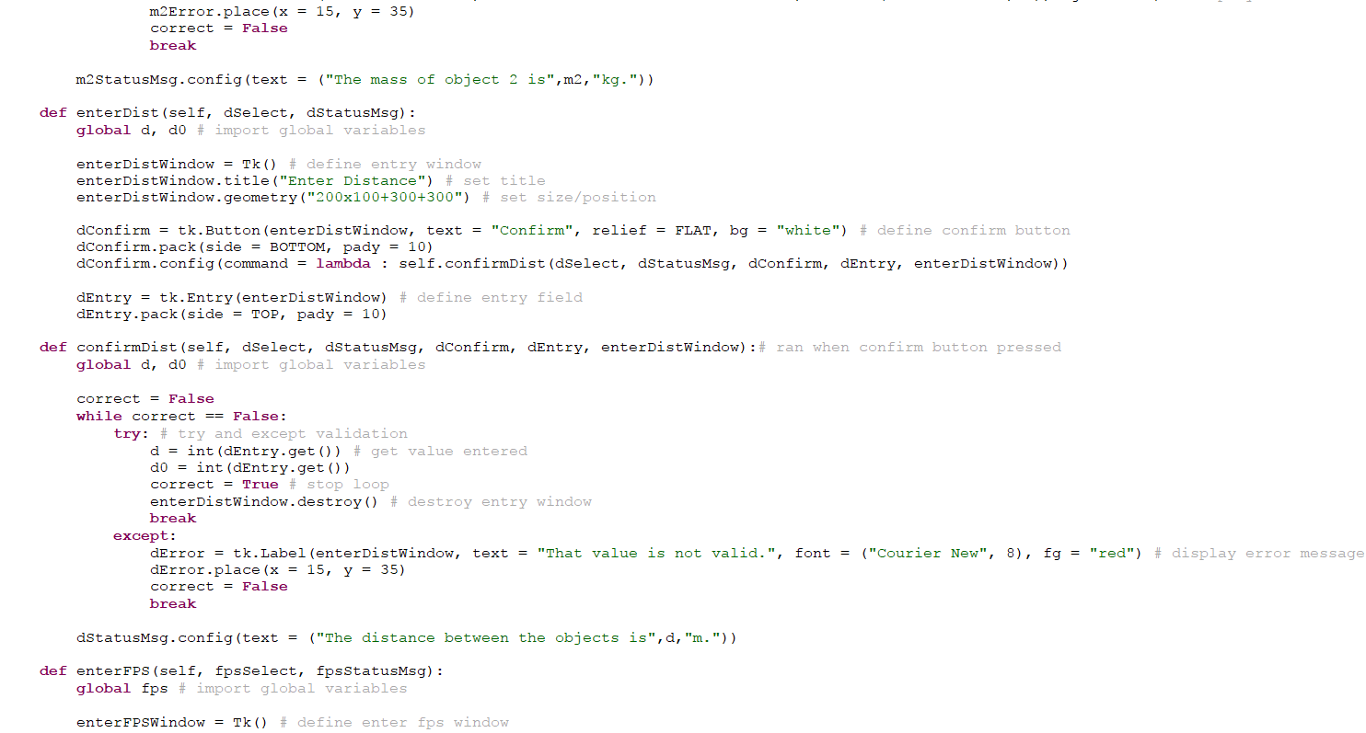

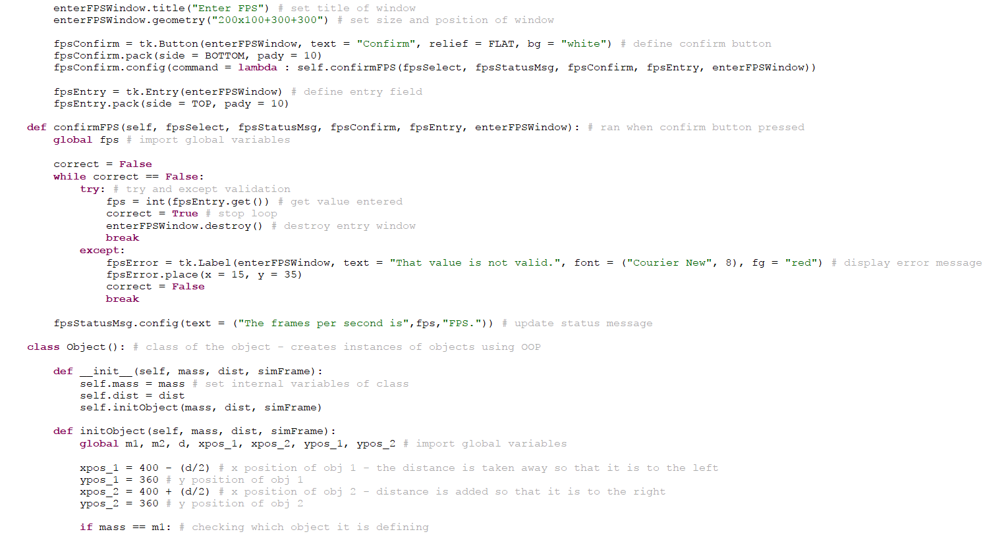

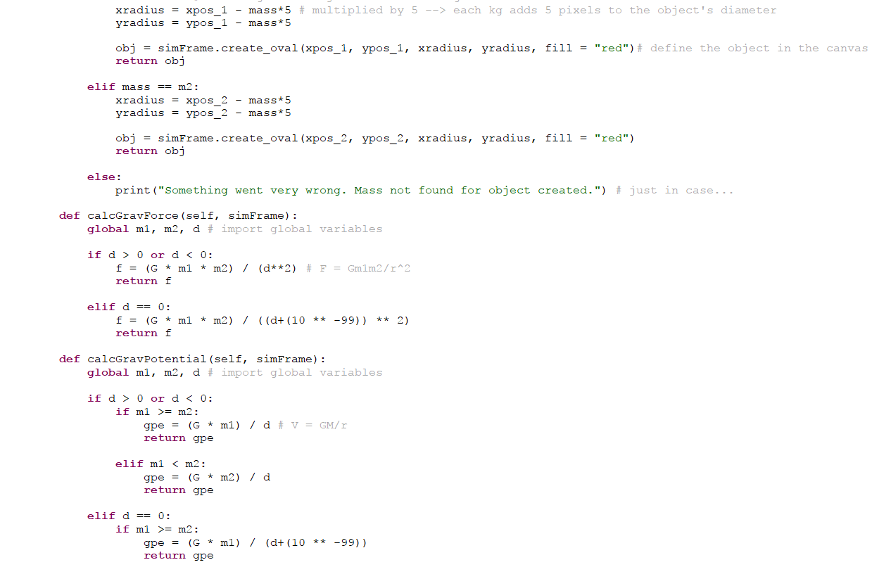

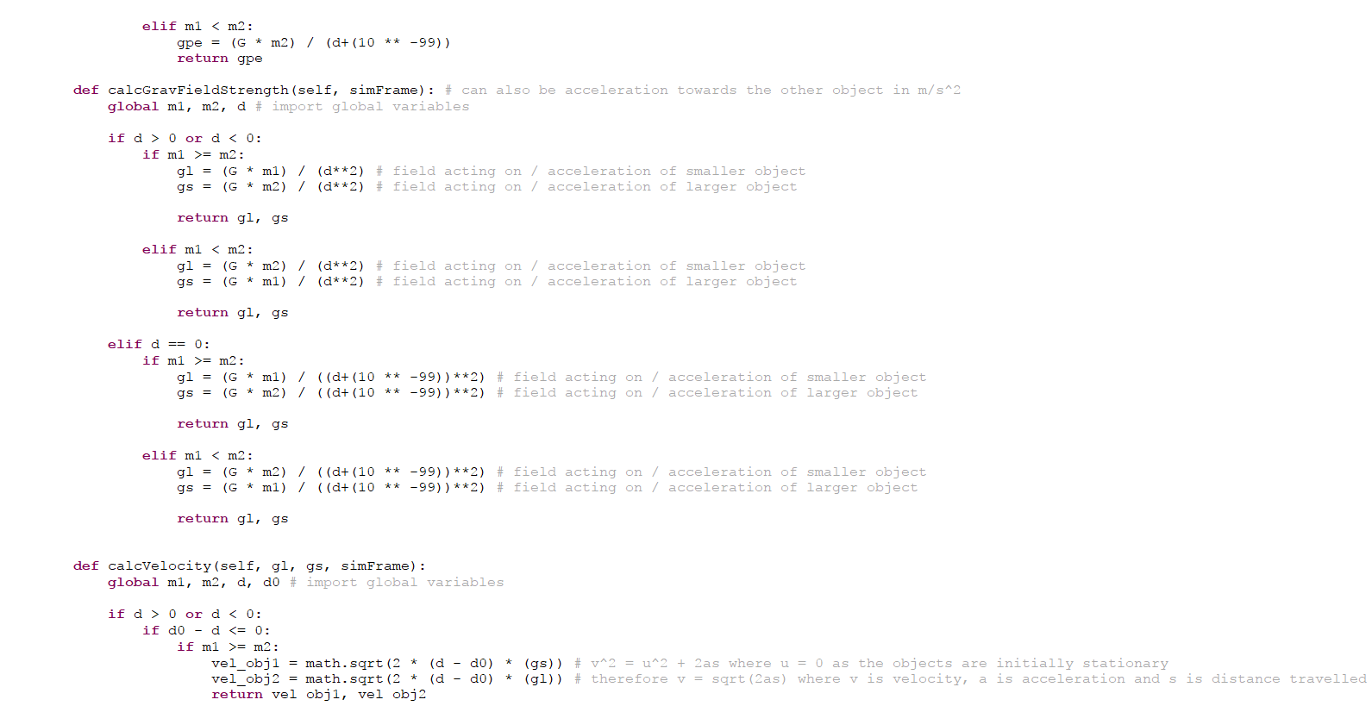

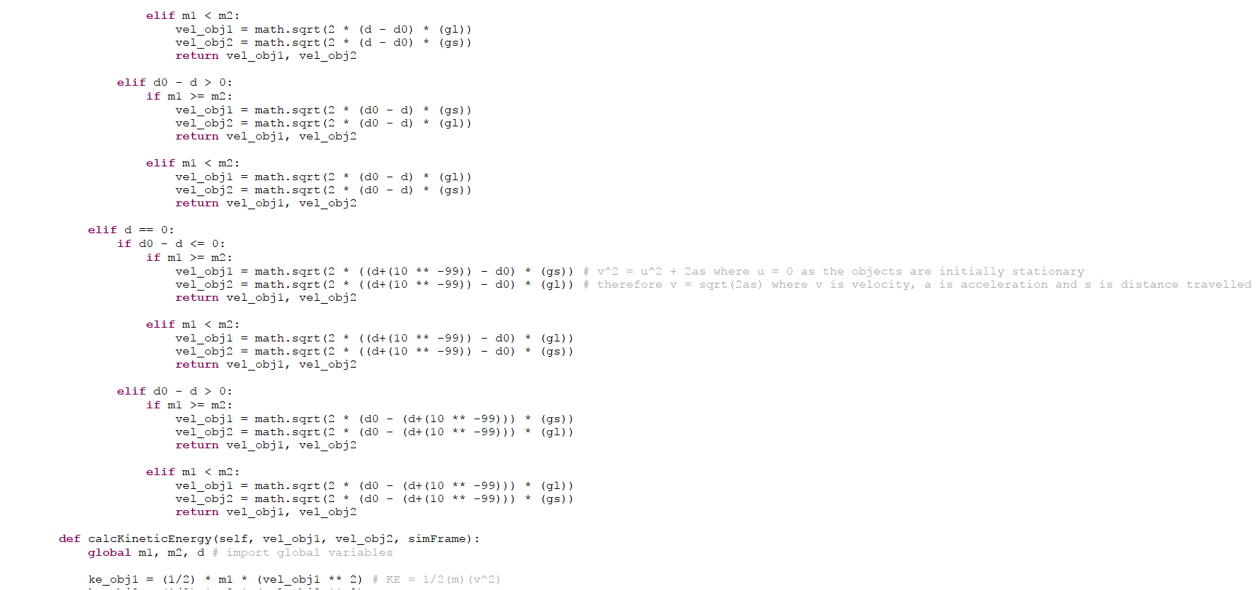

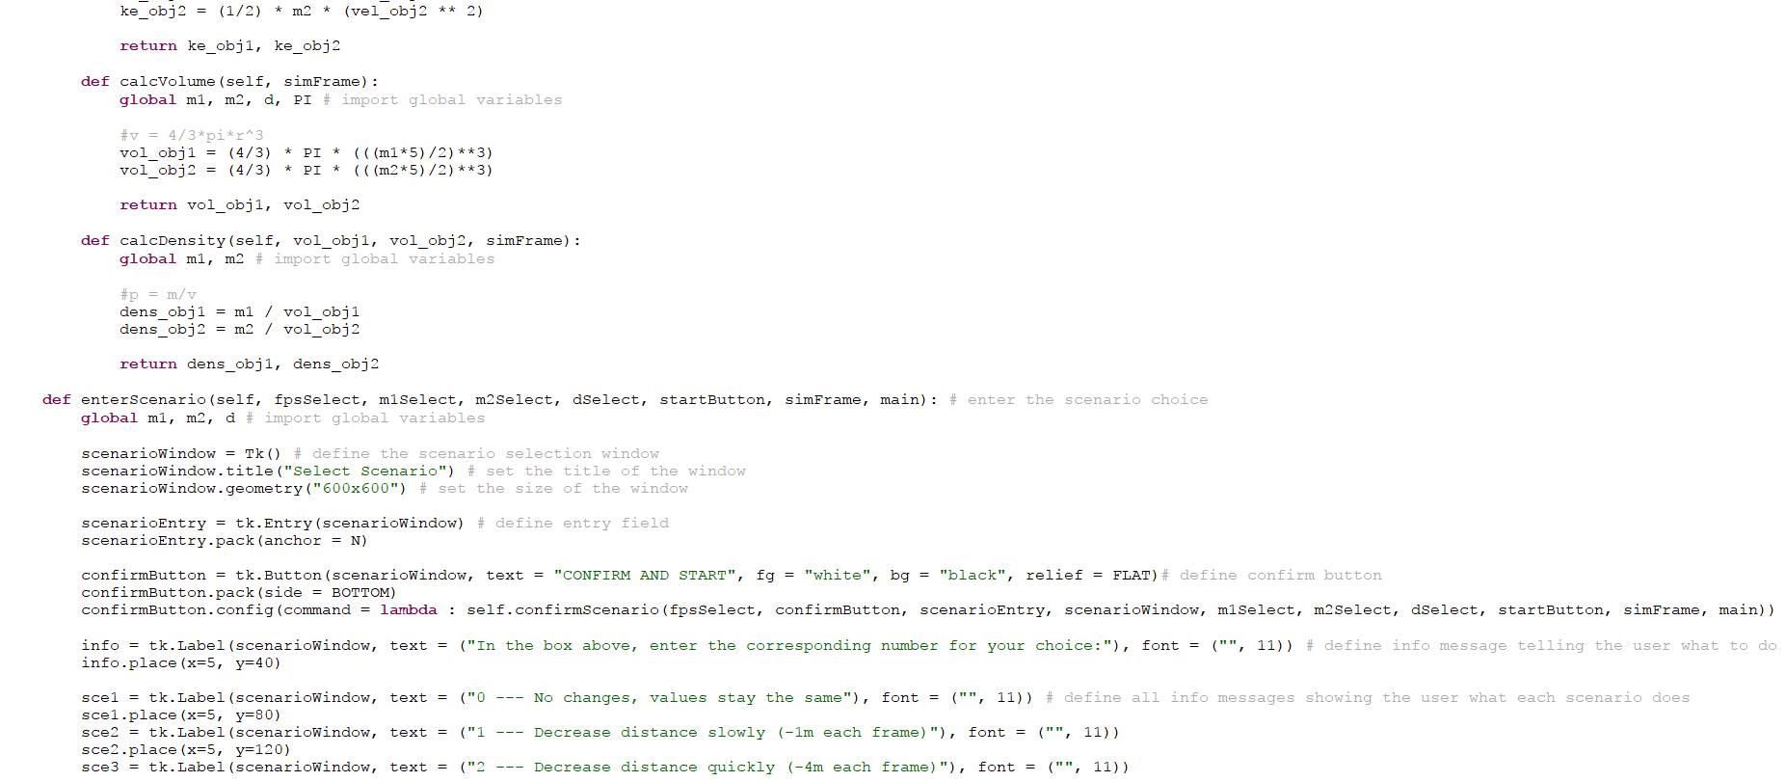

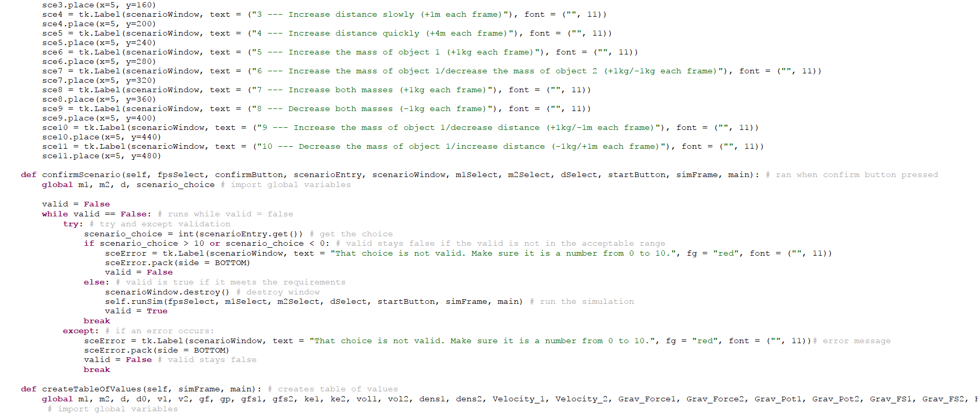

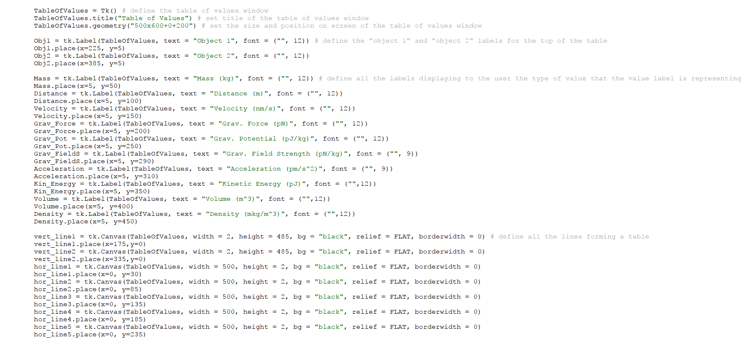

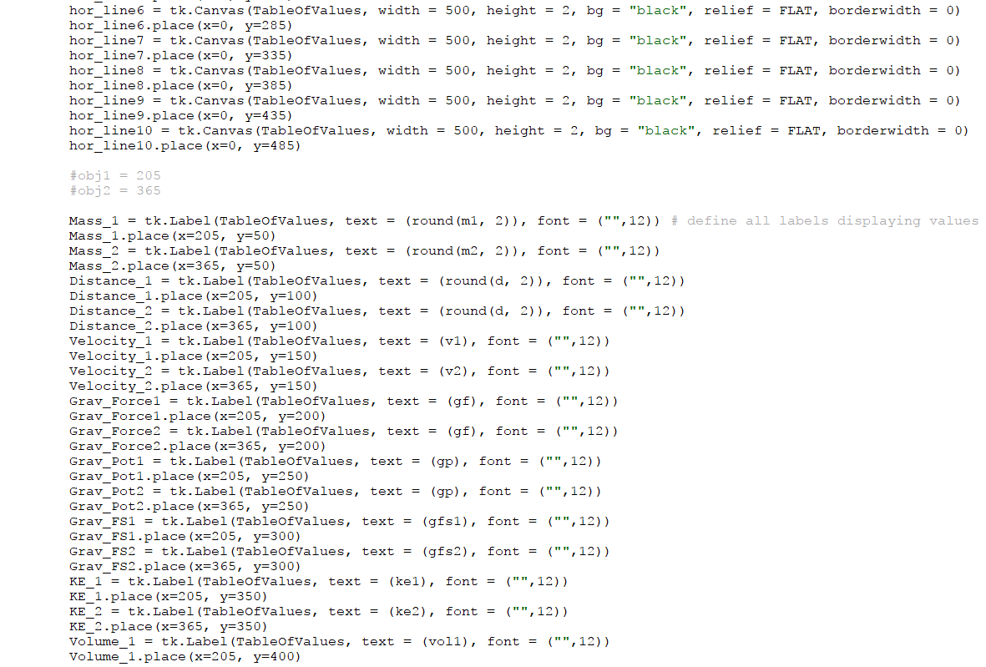

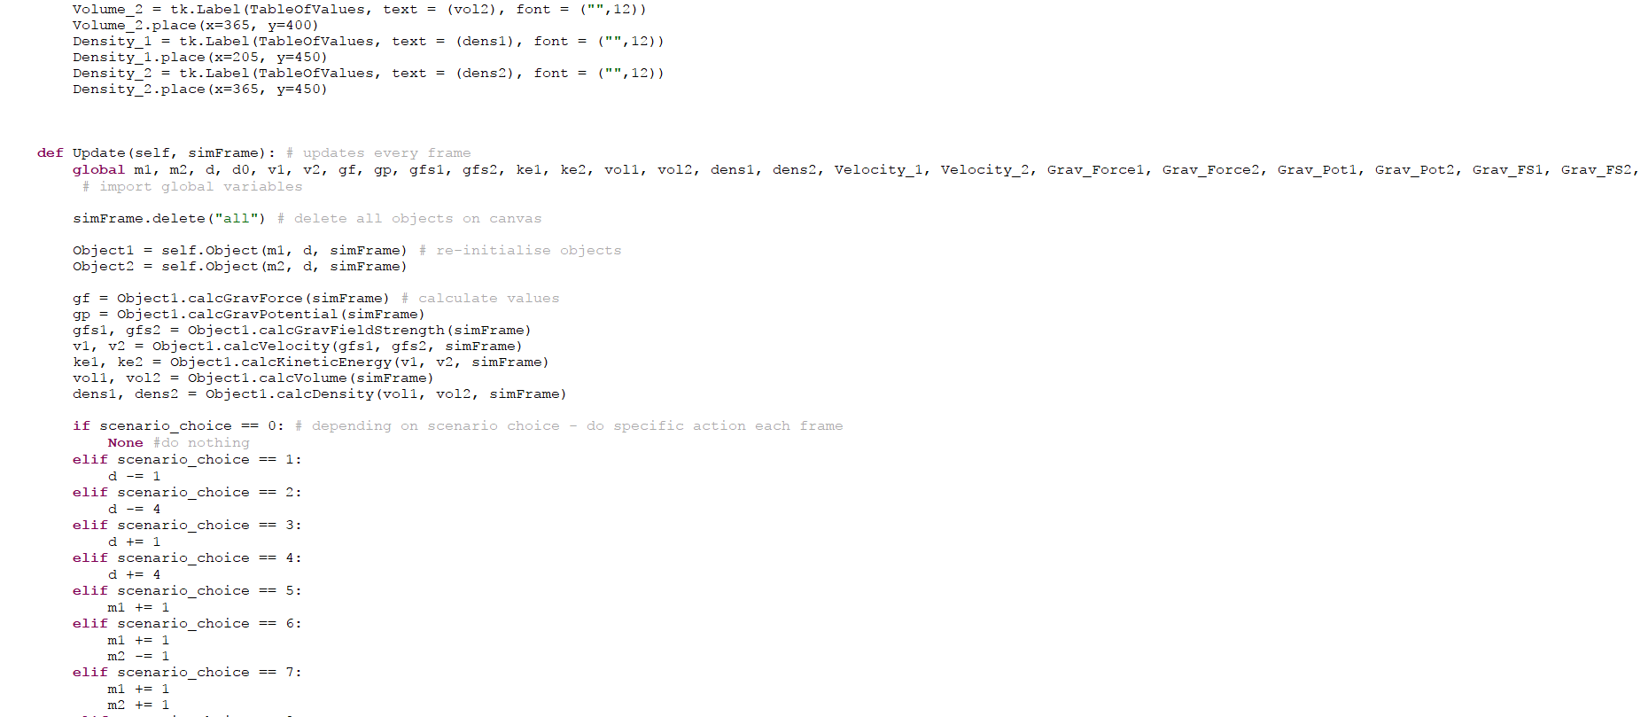

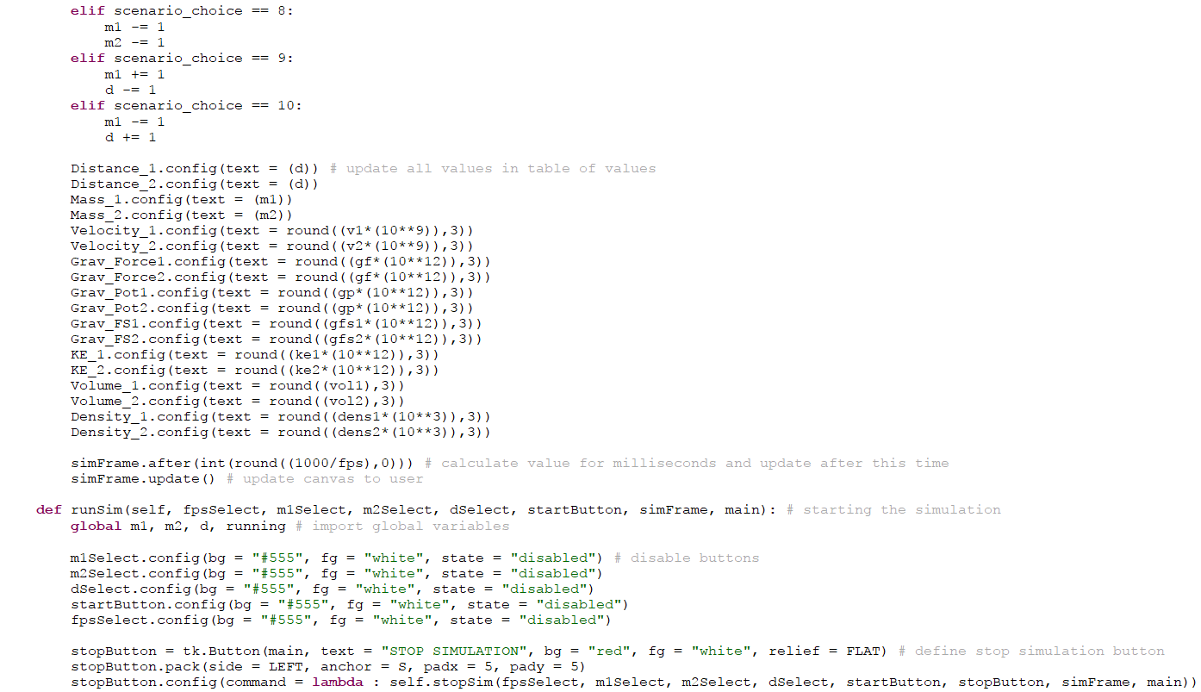

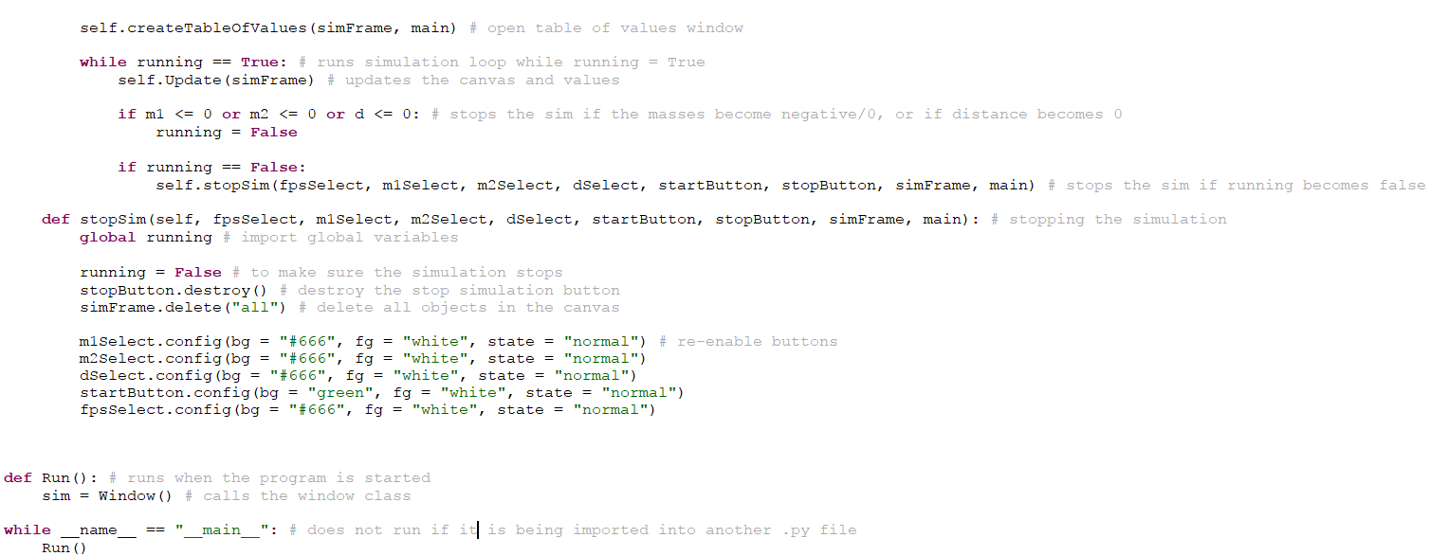

*Final Table of Variables*

|  |  |  |
| --- | --- | --- |
| Variable name | Data type | Description |
| *m1* | Integer | Stores the mass of object 1 |
| *m2* | Integer | Stores the mass of object 2 |
| *d* | Integer | Stores the distance between the two objects |
| *v1* | Floating point | Stores the velocity of object 1 |
| *v2* | Floating point | Stores the velocity of object 2 |
| *gf* | Floating point | Stores the gravitational force experienced by both objects |
| *gfs1* | Floating point | Stores the gravitational field strength exerted by object 1 |
| *gfs2* | Floating point | Stores the gravitational field strength exerted by object 2 |
| *ke1* | Floating point | Stores the kinetic energy of object 1 |
| *ke2* | Floating point | Stores the kinetic energy of object 2 |
| *vol1* | Floating point | Stores the volume of object 1 |
| *vol2* | Floating point | Stores the volume of object 2 |
| *gp* | Floating point | Stores the gravitational potential experienced by the smaller object from the larger object. |
| *dens1* | Floating point | Stores the density of object 1 |
| *dens2* | Floating point | Stores the density of object 2 |
| *d0* | Integer | Stores the initial distance between the two objects, for use in calculations of velocity and other calculations where the initial distance is needed |
| *fps* | Integer | Stores the user’s choice for the frames per second the simulation is run at |
| *scenario_choice* | Integer | Stores the user’s number choice for the scenario of the simulation |
| *xpos_1* | Integer | X-coordinate of object 1 |
| *ypos_1* | Integer | Y-coordinate of object 1 |
| *xpos_2* | Integer | X-coordinate of object 2 |
| *ypos_2* | Integer | Y-coordinate of object 2 |
| *running* | Boolean | Runs the simulation while it is True, stops it when it is False |
| *valid* | Boolean | Used in validation of user selected values and is set to False if the value entered is not valid |
| *main* | Tkinter window | The variable that stores the instance of the main window |
| *simFrame* | Tkinter canvas | Stores the canvas inside the main window |
| *TableOfValues* | Tkinter window | The variable that stores the instance of the table of values window |
| *Object1* | Object class instance | Instance of the object class which stores the variables for object 1 |
| *Object2* | Object class instance | Instance of the object class which stores the variables for object 2 |
| *startButton* | Tkinter Button Widget | Button which starts the simulation when pressed |
| *quitButton* | Tkinter Button Widget | Button which quits the program when pressed |
| *m1Select* | Tkinter Button Widget | Button which allows the user to select the mass of object 1 when pressed |
| *m2Select* | Tkinter Button Widget | Button which allows the user to select the mass of object 2 when pressed |
| *dSelect* | Tkinter Button Widget | Button which allows the user to select the distance between the two objects when pressed |
| *fpsSelect* | Tkinter Button Widget | Button which allows the user to select the frames per second when pressed |
| *preset1* | Tkinter Button Widget | Button which sets the values for mass to the first pre-set when pressed |
| *preset2* | Tkinter Button Widget | Button which sets the values for mass to the second pre-set when pressed |
| *preset3* | Tkinter Button Widget | Button which sets the values for mass to the third pre-set when pressed |
| *G* | Global constant – floating point | Newton’s gravitational constant – used in calculations |
| *PI* | Global constant – floating point | The value of pi to 9 decimal places of accuracy |
| *BOULDER_MASS* | Global constant - integer | The value for the mass of a boulder – used in pre-sets |
| *BOWLING_MASS* | Global constant - integer | The value for the mass of a bowling ball – used in pre-sets |

*Summary*

Overall, I think that the implementation of this program has taught me many things to do with Python; especially to do with its Tkinter module. Things such as how to initialise a window and place buttons inside it was completely unknown to me before I started the work on this project – this has definitely enabled me to do a lot more in the future and potentially improve on this project with the improvements that I will mention in the evaluation section.

There are many things that I could have done better – such as making the process of selecting values and the process of checking what the user’s choice for scenarios is much more efficient.

***Testing***

The testing will be carried out in the form of a video uploaded to YouTube which is edited to show each test in order. I will also be adding the times in the video that each test is carried out in the evidence section of the table of testing.

*Table of Testing*

|  |  |  |  |  |
| --- | --- | --- | --- | --- |
| Test Description | Input | Expected Output | Actual Output | Evidence  [timestamps] |
| Does the window open successfully with its GUI when the program runs? | Run the program | The window and its GUI opens for the user | [as expected] | Test 01  0:00 |
| Does the program close without any error messages when the quit button is pressed? | Press the quit button | The window closes and no trace of the program is left, i.e. error messages | [as expected] | Test 02  0:08 |
| Does a new window open with a text box & confirm button when the select mass 1 button is pressed? | Press the select mass 1 button | A new small window opens with an entry field and confirm button | [as expected] | Test 03  0:15 |
| Does a new window open with a text box & confirm button when the select mass 2 button is pressed? | Press the select mass 2 button | A new small window opens with an entry field and confirm button | [as expected] | Test 04  0:24 |
| Does a new window open with a text box & confirm button when the select distance button is pressed? | Press the select distance button | A new small window opens with an entry field and confirm button | [as expected] | Test 05  0:31 |
| Does a new window open with a text box & confirm button when the select FPS button is pressed? | Press the select FPS button | A new small window opens with an entry field and confirm button | [as expected] | Test 06  0:40 |
| When I enter a valid numerical value into the entry field, is it accepted? | Enter “50” and press confirm button | Window closes and value is updated | [as expected] | Test 07  0:47 |
| When I enter an invalid alphanumerical value into the entry field, is it rejected and does an error message display? | Enter “hello” and press confirm button | Window stays open and an error message is displayed on the window to the user | [as expected] | Test 08  1:00 |
| When an invalid non-integer value is entered into the entry field in the value selection window, is it rejected and does an error message display? | Enter “2.5” and press confirm button | Window stays open and an error message is displayed on the window to the user | [as expected] | Test 09  1:12 |
| When the first pre-set button is pressed, do the values for mass 1 and mass 2 update in the window? | Press the first pre-set button | The status messages for mass 1 and mass 2 will update to 6kg and 6kg respectively | [as expected] | Test 10  1:23 |
| When the second pre-set button is pressed, do the values for mass 1 and mass 2 update in the window? | Press the second pre-set button | The status messages for mass 1 and mass 2 will update to 6kg and 45kg respectively | [as expected] | Test 11  1:31 |
| When the third pre-set button is pressed, do the values for mass 1 and mass 2 update in the window? | Press the third pre-set button | The status messages for mass 1 and mass 2 will update to 45kg and 45kg respectively | [as expected] | Test 12  1:38 |
| When the start simulation button is pressed, does the scenario selection window open? | Press the start simulation button | The scenario selection window opens with the correct elements inside it | [as expected] | Test 13  1:45 |
| When a scenario option that is greater than 10 is entered, is an error message displayed? | Enter “11” into the entry field in the scenario selection window | Error message informs the user that their value is not valid | [as expected] | Test 14  1:55 |
| When a scenario option that is less than 0 is entered, is an error message displayed? | Enter “-1” into the entry field in the scenario selection window | Error message informs the user that their value is not valid | [as expected] | Test 15  2:04 |
| When a scenario option that is not an integer is entered, is an error message displayed? | Enter “2.5” into the entry field in the scenario selection window | Error message informs the user that their value is not valid | [as expected] | Test 16  2:13 |
| When a scenario option that is a string is entered, is an error message displayed? | Enter “hello” into the entry field in the scenario selection window | Error message informs the user that their value is not valid | [as expected] | Test 17  2:23 |
| When a valid scenario option is entered, does the window close and the simulation start? | Enter “1” (decrease distance option) and press the confirm button | Window closes and the simulation starts inside the canvas of the main window | [as expected] | Test 18  2:32 |
| When the simulation is started with a valid scenario choice, does the table of values window open? | Press start simulation button, enter a valid scenario option, and press the confirm button | Table of values window opens with values displayed inside of it | [as expected] | Test 19  2:41 |
| When the simulation is started, do two objects of the appropriate size and distance appear in the canvas? | Press start simulation button, enter a valid scenario option, and press confirm button | Two objects appear inside the canvas which have a size that is proportional to their mass and are as far away from each other as the value for distance | [as expected] | Test 20  2:54 |
| When a certain value for the FPS is set and the simulation is run, does the simulation run at that speed? | Enter “1” for the value of FPS and start simulation | Canvas updates the objects 1 time every second | [as expected] | Test 21  3:12 |
| When scenario option “0” is entered, does the described event happen? | Enter “0” in the scenario selection window and press confirm button | Nothing happens to the objects | [as expected] | Test 22  3:40 |
| When scenario option “1” is entered, does the described event happen? | Enter “1” in the scenario selection window and press confirm button | Objects move towards each other at 1 pixel per frame | [as expected] | Test 23  3:52 |
| When scenario option “2” is entered, does the described event happen? | Enter “2” in the scenario selection window and press confirm button | Objects move towards each other at 4 pixels per frame | [as expected] | Test 24  4:06 |
| When scenario option “3” is entered, does the described event happen? | Enter “3” in the scenario selection window and press confirm button | Objects move away from each other at 1 pixel per frame | [as expected] | Test 25  4:17 |
| When scenario option “4” is entered, does the described event happen? | Enter “4” in the scenario selection window and press confirm button | Objects move away from each other at 4 pixels per frame | [as expected] | Test 26  4:29 |
| When scenario option “5” is entered, does the described event happen? | Enter “5” in the scenario selection window and press confirm button | Object 1 increases in diameter by 5 pixels per frame | [as expected] | Test 27  4:39 |
| When scenario option “6” is entered, does the described event happen? | Enter “6” in the scenario selection window and press confirm button | Object 1 increases in diameter by 5 pixels per frame, and object 2 decreases in diameter by 5 pixels per frame | [as expected] | Test 28  4:50 |
| When scenario option “7” is entered, does the described event happen? | Enter “7” in the scenario selection window and press confirm button | Object 1 and object 2 increase in diameter by 5 pixels each frame | [as expected] | Test 29  4:59 |
| When scenario option “8” is entered, does the described event happen? | Enter “8” in the scenario selection window and press confirm button | Object 1 and object 2 decrease in diameter by 5 pixels each frame | [as expected] | Test 30  5:07 |
| When scenario option “9” is entered, does the described event happen? | Enter “9” in the scenario selection window and press confirm button | Object 1 increases in diameter by 5 pixels each frame, and the objects move towards each other at 1 pixel each frame. | [as expected] | Test 31  5:17 |
| When scenario option “10” is entered, does the described event happen? | Enter “10” in the scenario selection window and press confirm button | Object 1 decreases in diameter by 5 pixels each frame, and the objects move towards each other at 1 pixel each frame. | [as expected] | Test 32  5:27 |
| When the mass of an object reaches 0, does the simulation stop? | Enter “8” into the scenario selection window and wait for the mass of object 1 to reach 0 | The objects are destroyed and the GUI returns to its initial state before the simulation | [as expected] | Test 33  5:36 |
| When the distance between the objects reaches 0, does the simulation stop? | Enter “2” into the scenario selection window and wait for the objects to collide | The objects are destroyed and the GUI returns to its initial state before the simulation | [as expected] | Test 34  5:49 |
| When the stop simulation button is pressed during the simulation, does the simulation stop? | Enter “2” into the scenario selection window and press the stop simulation button sometime during the simulation | The objects are destroyed and the GUI returns to its initial state before the simulation | [as expected] | Test 35  6:08 |

*Video*

Clips are recorded using Open Broadcaster Software**[A24]** and the video was edited using VideoPad**[A25]**.

Link: <https://www.youtube.com/watch?v=1HJrepRPceQ&feature=youtu.be>

Times for different tests are in the evidence section of the table of testing.

***Evaluation***

*End user feedback*

I have arranged and completed another interview which has been carried out post-development when the program has been completed. I have shown the end user Dr. Corrigan my program and have then asked a series of pre-defined questions for her to answer. These questions allow me to gather feedback from Dr. Corrigan on whether or not she would use my program to teach and whether she thinks that the program is of good quality or not.

A screenshot of the transcribed interview is below:

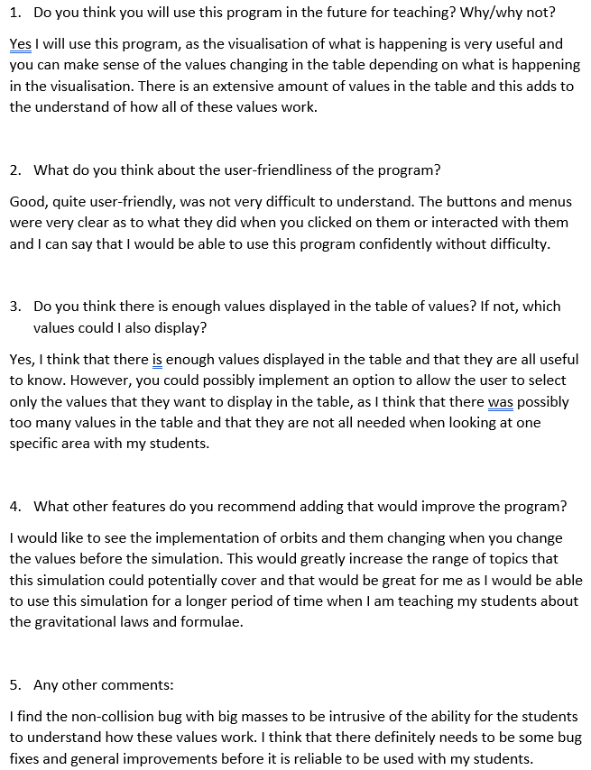

In this interview, I asked the end user and physics teacher Dr. Corrigan about her opinion on my simulation when I showed it to her.

The *non-collision* bug that Dr. Corrigan mentions is a bug that results from the objects not colliding immediately when they have a relatively large mass. I believe that this is due to the fact that the objects are initialised using coordinates that are attached to the coordinates of the four coordinates of the corners of the circle – this is the boundaries in which the object is required to be defined. Therefore, due to the fact that the simulation checks for when only one of those corners has collided with the other object’s same corner, the objects will overlap when they are big enough before they collide. This creates some problems with the visual explanation element for the students – this is not what should realistically happen.

As for the request for the implementation of orbits – this is another potential improvement that I could make to the program that will greatly increase the range of topics that the program can cover. This would involve using vectors to calculate the direction of motion for the objects which would increase the complexity by a significant factor.

*Improvements to be made*

The first thing that I think could be improved about the program is the fact that it is a two-dimensional representation of the effects of gravitational fields. The program could potentially become a lot more effective as a visual aid for the physics students if I had included a third dimension into the canvas which would display the objects in a three-dimensional space. This would also enable me to make the canvas itself more interactive as I could have a camera that could be panned around the objects by the mouse. Including three dimensions would also make the coordinates of each object contain three different values as well (x, y and z axes), and this would increase the complexity of my program substantially.

The second thing that could be done to improve the program is to include the use of vectors in my calculations for each frame. With the inclusion of vectors, I can calculate the realistic next position of the object after 1 frame and therefore effectively animate the objects so that they follow a path that they would approximately follow in real life in such as situation. Of course, this would be massively beneficial to the students and it would help them understand further the topic of gravitational fields when they are shown this simulation. To include vectors, I could have used the Python module Numpy**[A23]**as this module allows me to use many advanced mathematical functions such as trigonometric functions and, of course, vectors.

The third thing that could be done to improve this program is to fix the existing bugs – some of the bugs that came up were things such as the objects not immediately colliding if they were a relatively large size, and the fact that it was impossible to start the simulation after stopping it once without quitting the program and starting the simulation once the program had started up again. This would also greatly increase the level of understanding that the students could get out of the simulation as there would be nothing that would confuse the students and everything would be true-to-life.

The final thing that I think could improve the program if it were added is the addition of multiple objects instead of just two. Of course, this would greatly increase the complexity of the calculations involved when updating the canvas in each frame, and it would involve adding a system to allow the user to select the amount of objects they would like and possible place them themselves in the canvas using the mouse. This functionality would allow the end user and the students to go into much greater detail with the simulation about how the different calculations work and how having more than 2 objects in the same area will affect the change in values for each of the objects.

*Final Overview*

Overall, I think that this project has successfully set out to achieve the task of acting as an easier learning tool for the physics students of Whitburn C of E Academy Sixth Form. I am confident that the end user, Dr. Corrigan, will appreciate and use this program when needed as it will be a great help to her when she is teaching this topic to current and future physics students. Although having a few things that could potentially be improved upon in order to enable this program to be more effective, I believe that this program will allow Dr. Corrigan and her students to do the things that I originally set out to solve when looking into the problem in the analysis section.

***Appendix***

Reference format: (note)**[A1]**

*Table of secondary research resources*

|  |  |  |  |
| --- | --- | --- | --- |
| Reference Number | Resource Name | Description | Link |
| A1 | Tkinter | Python library that allows the creation of GUI in a window through a class. | <http://effbot.org/tkinterbook/tkinter-whats-tkinter.htm> |
| A2 | Pygame | Downloadable Python modification that allows you to create more complex graphical programs with relatively simple code. | <https://www.pygame.org/> |
| A3 | Draw.io | An online flowchart creation tool. The flowcharts can be saved onto the hard drive as .xml files. | [<https://www.draw.io/>](https://www.pygame.org/) |
| A3 | SurveyMonkey | An online survey creator which has a lot of customisable options; allows me to create a questionnaire for my physics peers to answer. | <https://www.surveymonkey.co.uk/> |
| A4 | PhET | A website which contains a variety of physics-based simulations that are interactive and can be downloaded. | <https://phet.colorado.edu/> |
| A6 | Codecademy | Online service for learning the basics of certain programming languages, for example Python. | <https://www.codecademy.com/> |
| A7 | YouTube | Online video sharing platform. | <https://www.youtube.com/> |
| A10 | Nice pendulum pattern effect (Python and Tkinter with source code) | YouTube video showcasing a Tkinter creation which simulates a pendulum swinging. | <https://www.youtube.com/watch?v=t3-QYefoJ9k&feature=youtu.be> |
| A11 | Planets Orbiting the Sun in Python | YouTube video showing a Tkinter simulation of the solar system’s orbits. | <https://www.youtube.com/watch?v=nkaCXS5EGRE&feature=youtu.be> |
| A12 | Gravity Simulator – Episode 1 (Sun and Earth) | YouTube video running through how to create a gravitational simulation in Python. | <https://www.youtube.com/watch?v=XmgWNk2en5s&feature=youtu.be> |
| A13 | Thonny | A free Python integrated development environment. | <http://thonny.org/> |
| A14 | Learn to Program 20: Tkinter Tutorial  1 & 2 | A YouTube tutorial video on the basics of different widgets and settings in Tkinter. | Tutorial 1: <https://www.youtube.com/watch?v=-tbWoZSi3LU>  Tutorial 2: <https://www.youtube.com/watch?v=Mim5tTSf05E&feature=youtu.be> |
| A15 | 1000-Particle Solar System Simulation with Source Code | A YouTube video showcasing a program made with Python which simulates a solar system with 1000 bodies orbiting each other. The source code for this is provided in the description of the video. | <https://www.youtube.com/watch?v=ykwF_AYT2Rs> |
| A16 | TkDocs Tutorial for Tkinter | A tutorial series from the website TkDocs for the Python Tkinter module. | <http://www.tkdocs.com/tutorial/> |
| A17 | Learn Tkinter in 20 Minutes | A YouTube tutorial video on the Python Tkinter module. | <https://www.youtube.com/watch?v=_lSNIrR1nZU&feature=youtu.be> |
| A18 | Making Widgets Look Nice | A tutorial on how to make the Python Tkinter widgets look visually appealing. | <http://usingpython.com/making-widgets-look-nice/> |
| A19 | Object Oriented Programming Crash Course with Tkinter | A tutorial on how to use Tkinter with object-oriented programming to create programs. | <https://pythonprogramming.net/object-oriented-programming-crash-course-tkinter/> |
| A20 | How to draw a circle in Tkinter | A tutorial on how to draw a circle using Tkinter (i.e. an object in a gravitational field). | <https://stackoverflow.com/questions/17985216/draw-circle-in-tkinter-python> |
| A21 | Gravitational Simulation Source Code | Source code for a gravity simulation that MJSprengel made. | <https://github.com/mjsprengel/GravitySim/blob/master/GravitySim.py> |
| A22 | Gravity Force Simulation | PhET simulation of the forces of gravity of two objects. | <https://phet.colorado.edu/sims/html/gravity-force-lab/latest/gravity-force-lab_en.html> |
| A23 | Numpy | Python module that enables the use of advanced mathematical functions, such as trigonometric functions. | <http://cs231n.github.io/python-numpy-tutorial/> |
| A24 | OBS (Open Broadcaster Software) | Software that allows for streaming and/or recording. Used in testing to record clips. | <https://obsproject.com/> |
| A25 | VideoPad | Software that allows me to edit clips and make a video to upload to YouTube. | <https://www.nchsoftware.com/videopad/index.html> |

*Primary research resources*

**A8**

Questionnaire for my physics class peers:

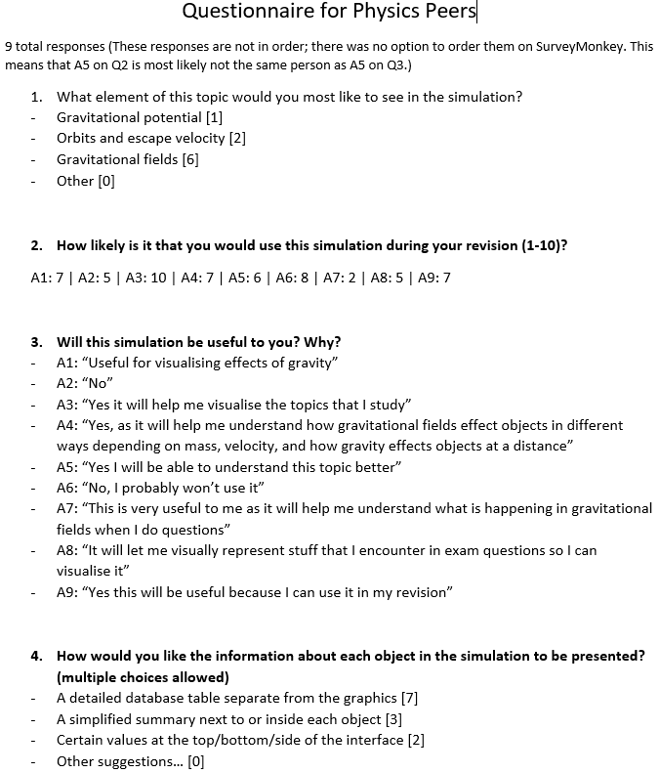

**A9**

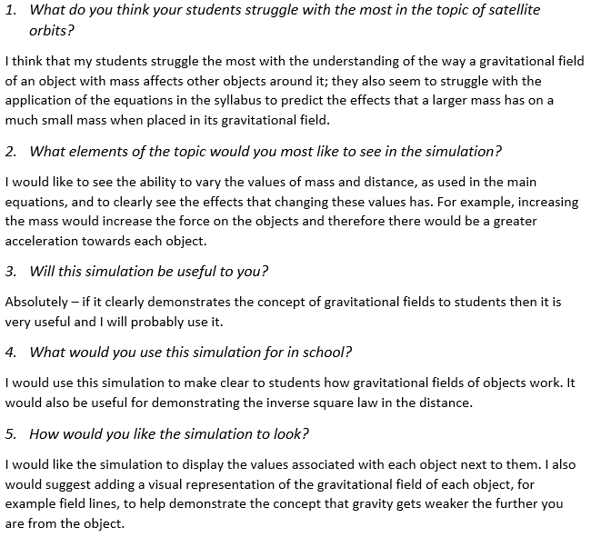Interview 1 with Dr. Corrigan (pre-development):